**Lab-2**

**Name: Vedant Ulhas Shete**

**SJSU ID: 011412141**

**Github link:** https://github.com/vedantshete93/CMPE_273_Lab2

**Username:** vedantshete93

**Password:** vedant123

The document consists of:

* Introduction
* Screenshots of the application with RabbitMQ queues
* JMeter
* Mocha Test results output
* Architecture diagram
* System design
* RabbitMQ queues implemented
* Questions and Answers

**Part-1: Ebay Marketplace Application**

Introduction

In this application we are demonstrating REST web services

This application has these features

1. Basic user functionality:

* Sign up new users(First name, Last name, Email, Passwords which are encrypted)
* Sign in existing users
* Sign out

1. Profile:

* About user: Birthday, Ebay handle(which should be unique), contact information, location

1. System design

* User is able to view advertisements posted by other users(for selling and bidding)
* User should be able to post advertisement for selling or bidding. Advertisement holds data like name of product, description, quantity, seller information, price, shipped from.
* User can add products to shopping cart, the products in the shopping cart are stored unless user removes them by himself. In shopping cart user can also change quantity of any item to be bought. Minimum quantity cannot go below 1 and maximum quantity cannot go above the quantity of product available in the warehouse.
* When user checkouts the quantity of product is deducted in the sellers account.
* Users can bid on a product and whenever the time for bidding(4 days) ends, the product is added into the bought items of user who had the highest bid.
* User can see the advertisements that they have posted, the items that they have bought and the items that they have sold.
* User can see their last login and their complete profile details.
* User tracking is implemented to keep track of which user does which activity when using the application.

Initial landing page

User is asked to login

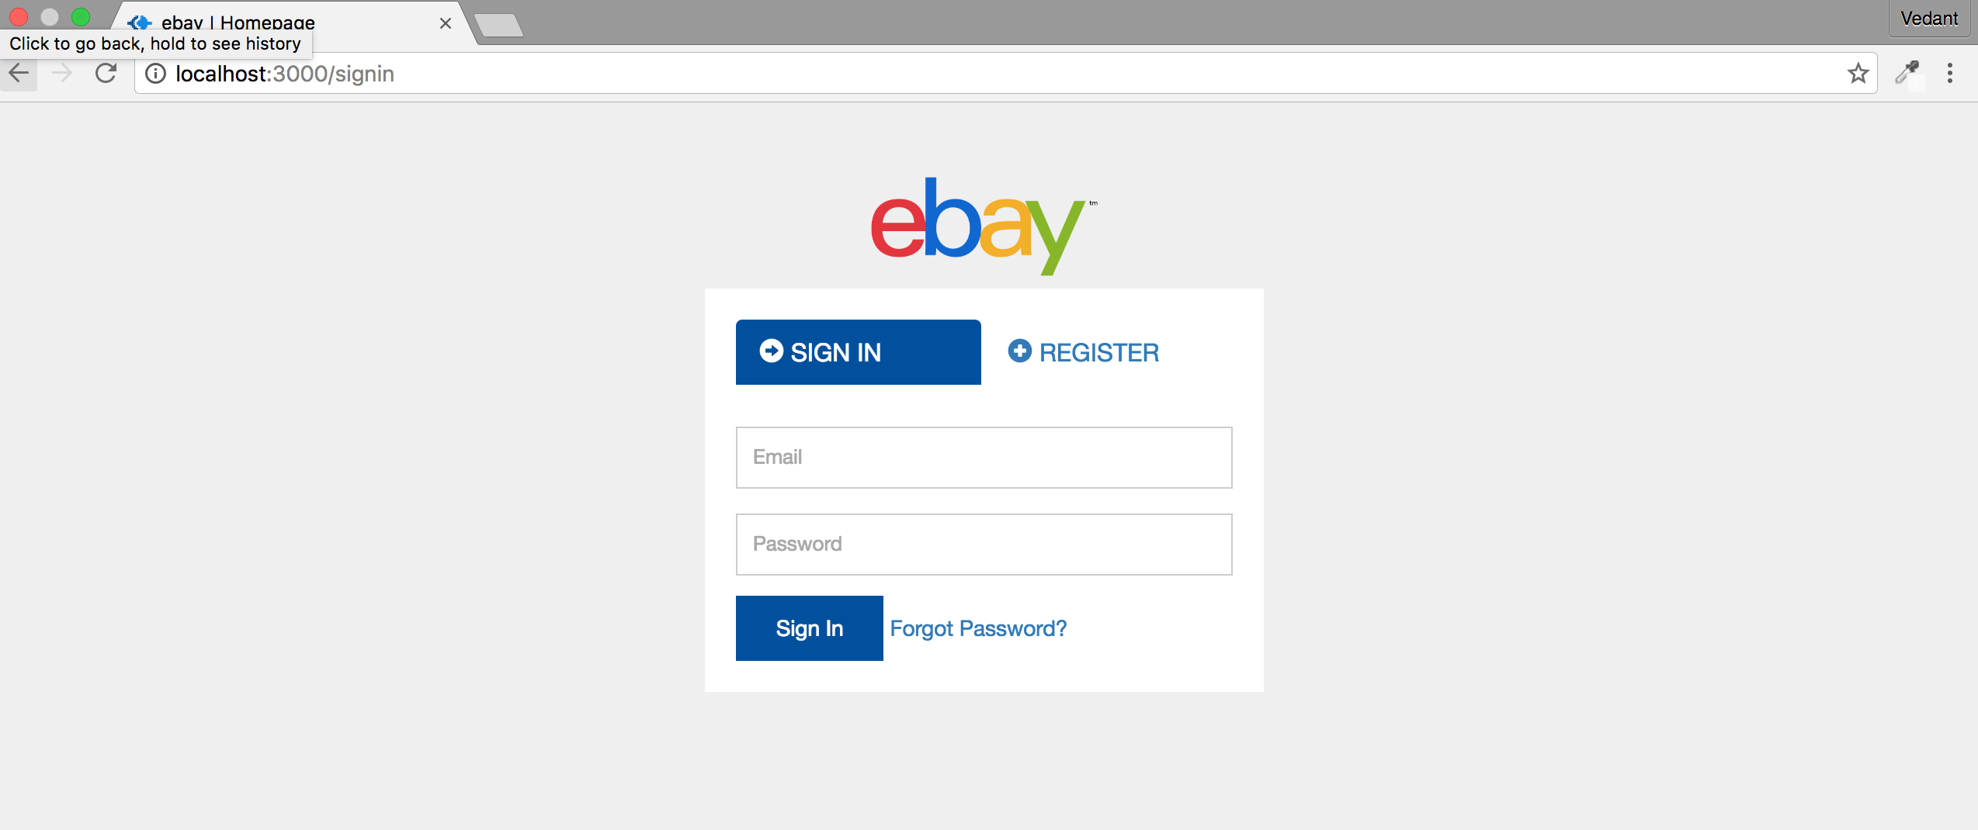

If user is not registered already, he is asked to register first.

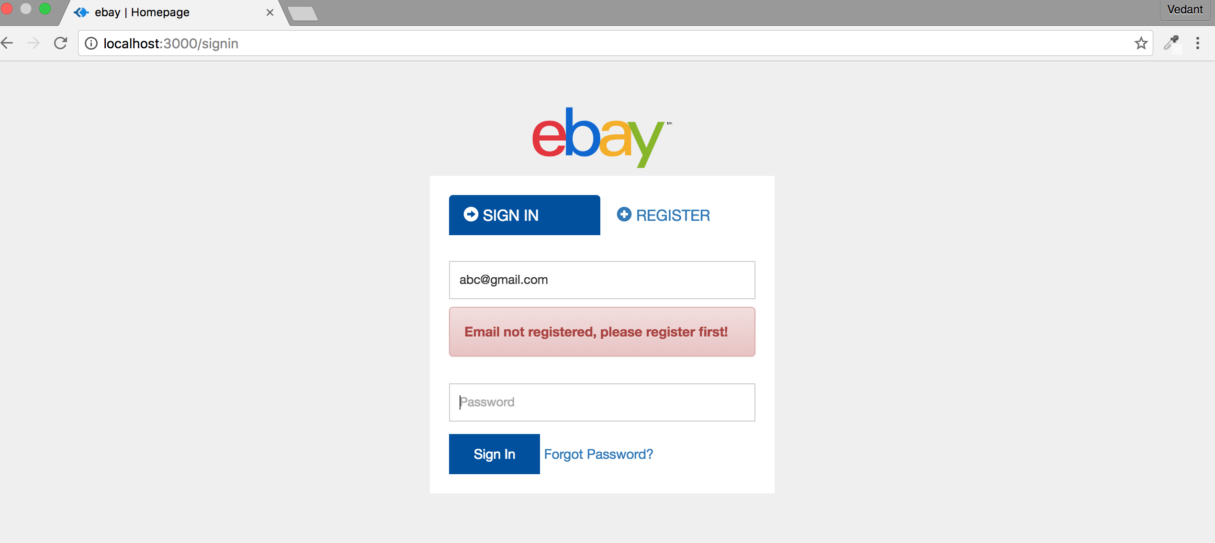

RabbitMQ login_queue

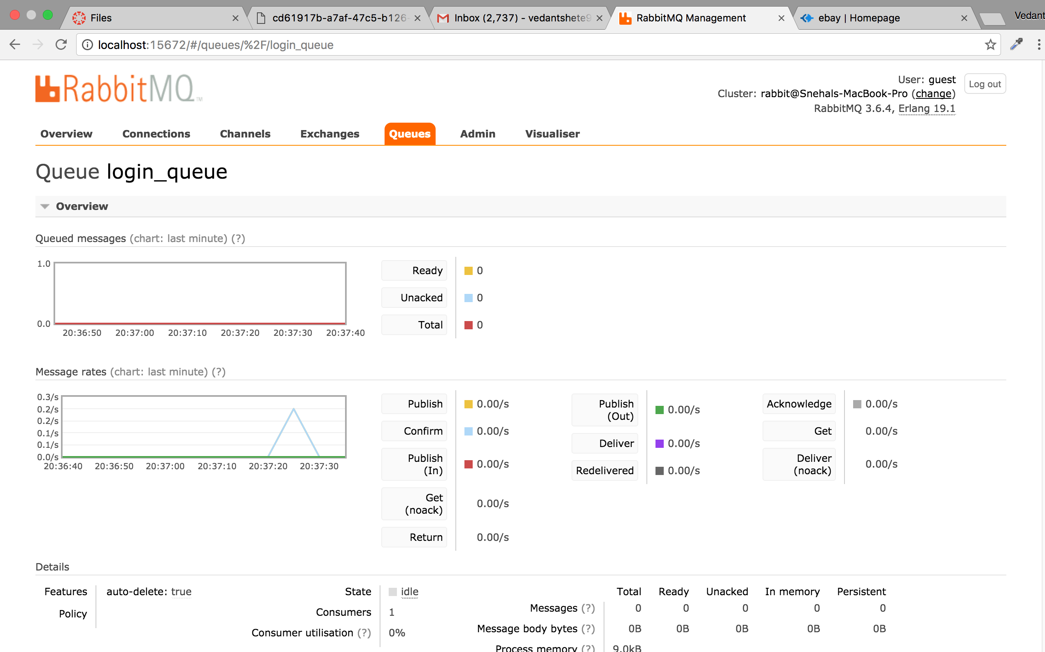

If a registered user enters incorrect credentials then he gets an error



A new user registers first

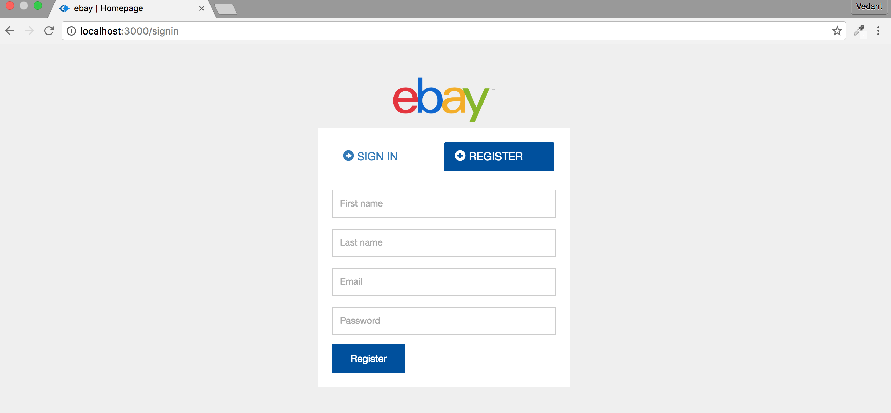

If an already registered user tries to register using the same email id then he gets an error

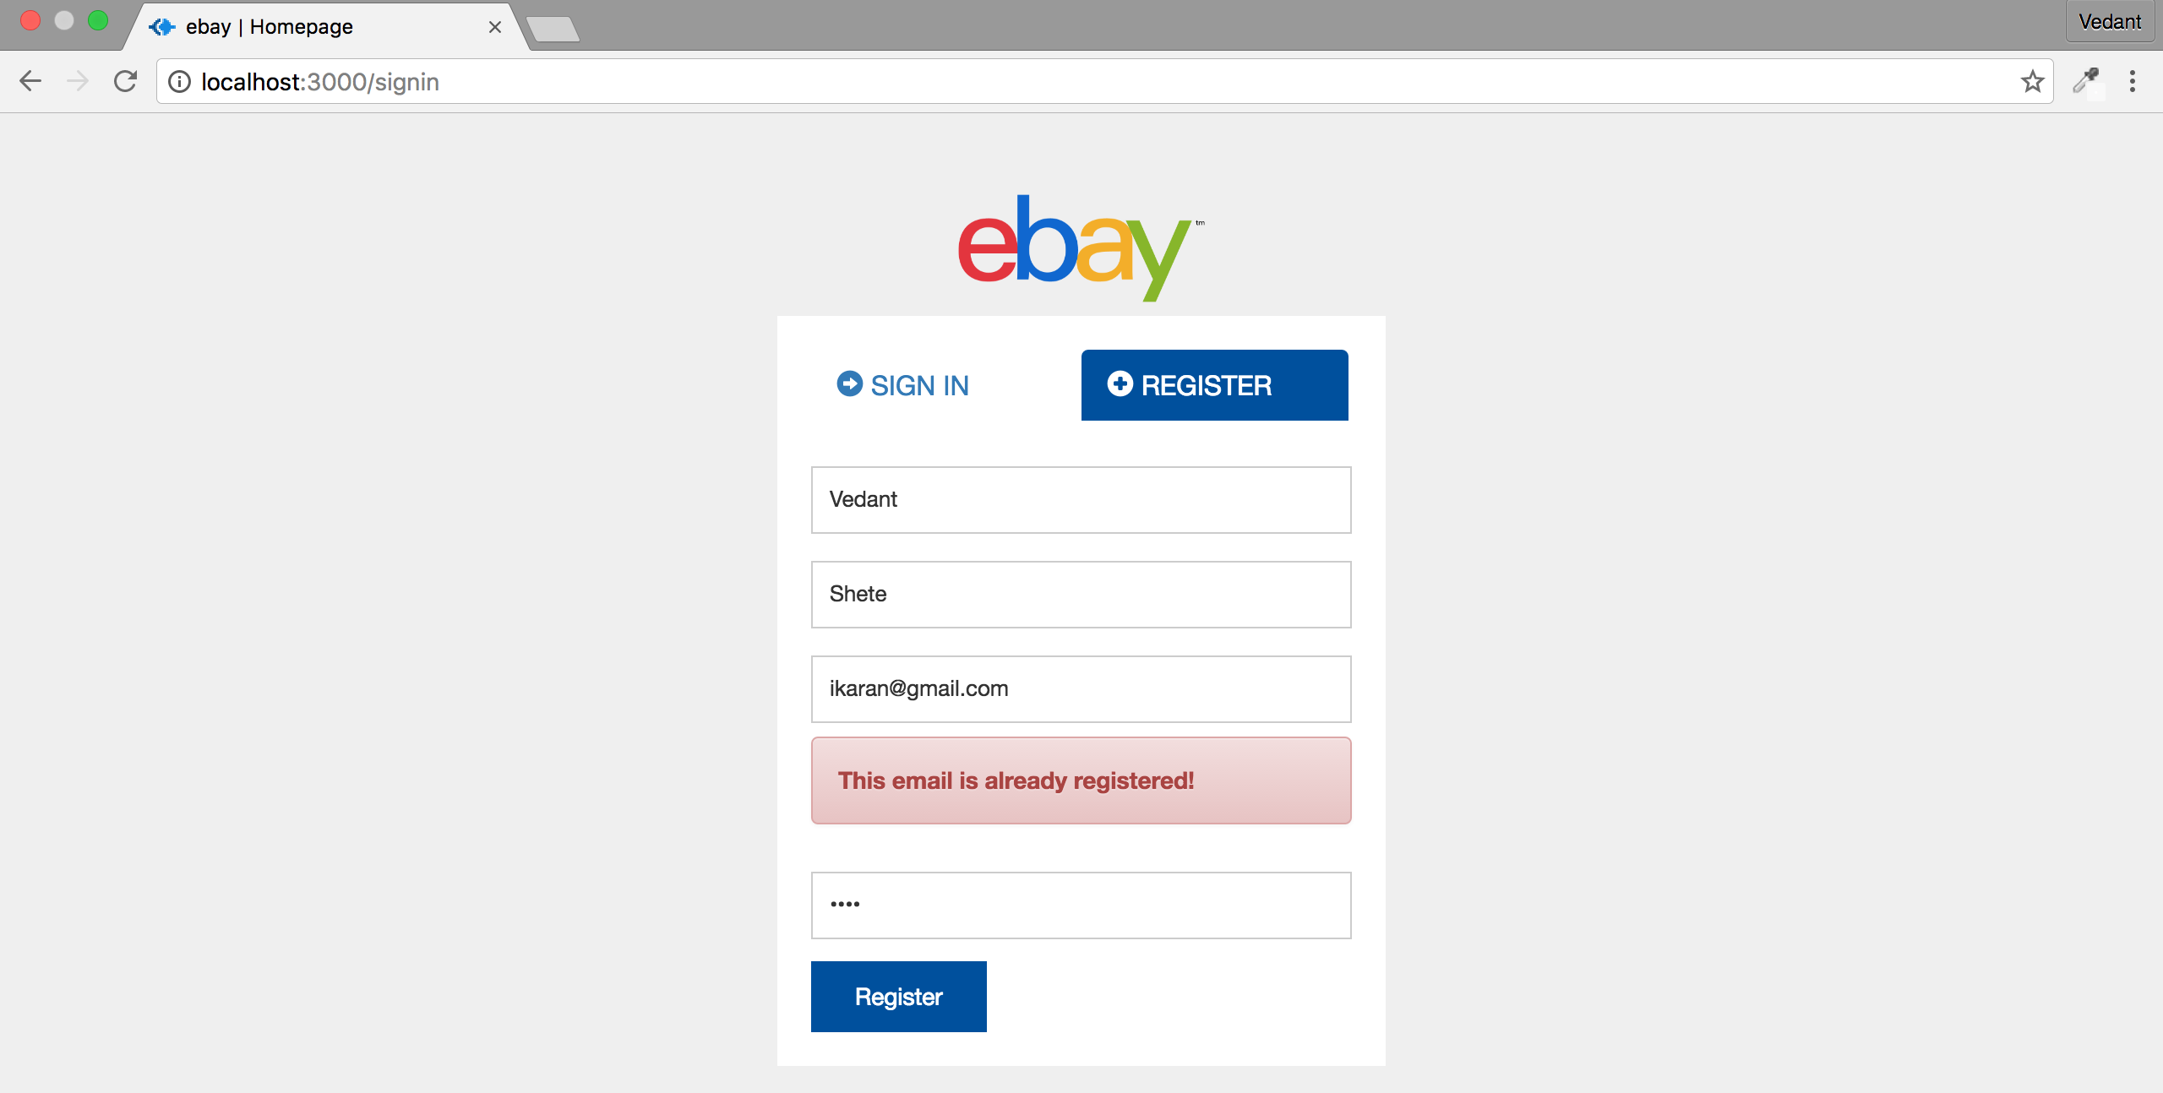

Register queue

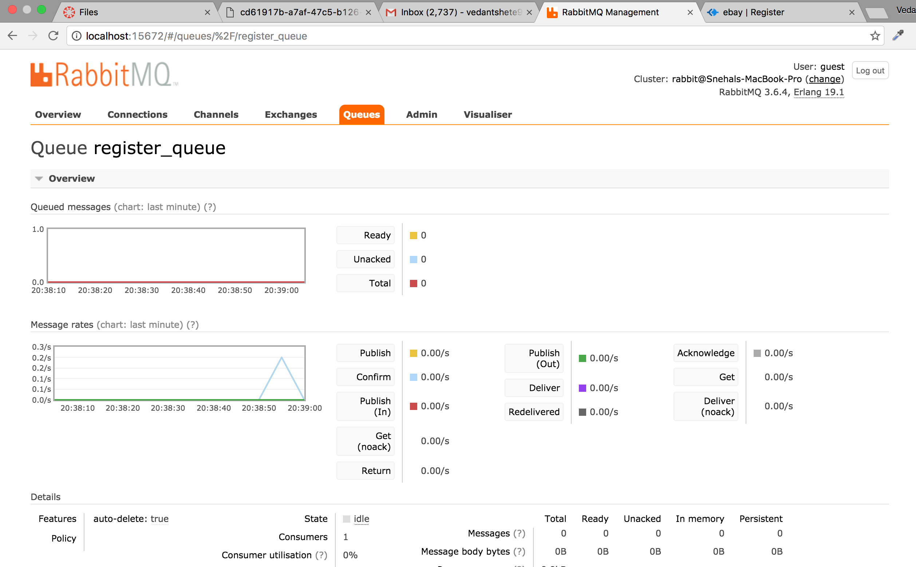

On clicking on register(after putting an unique email id which is not already in the system), the user is registered

Now user is asked for some more information

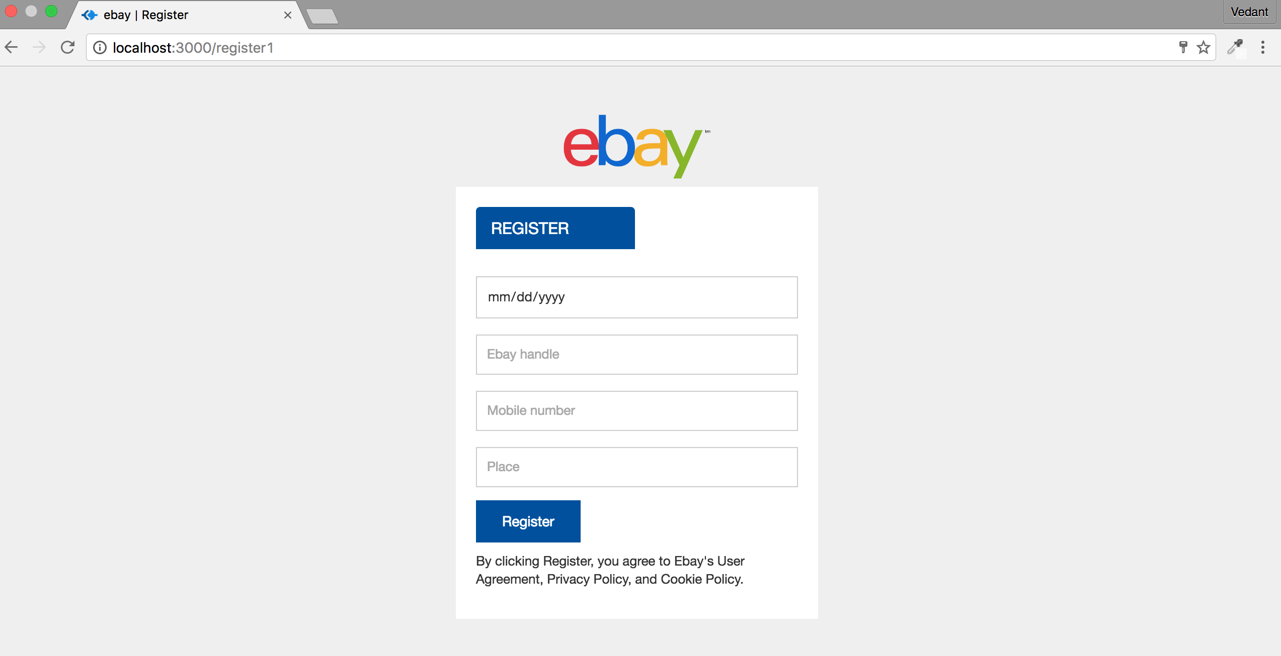

If user enter a handle which is already used then he gets an error

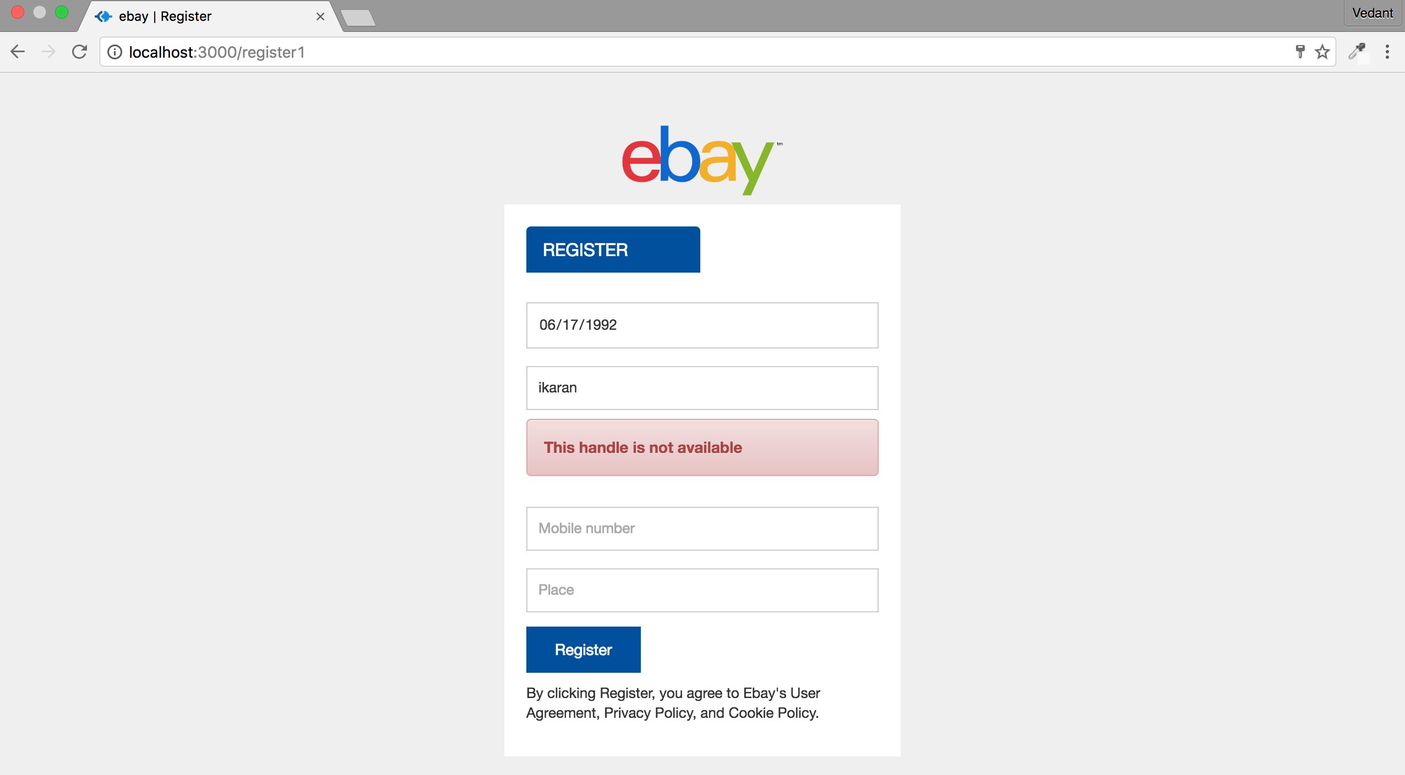

If user enters a unique handle he gets congratulations message.

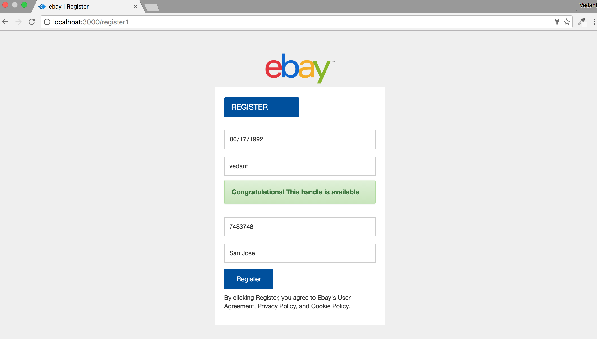

Register1 queue

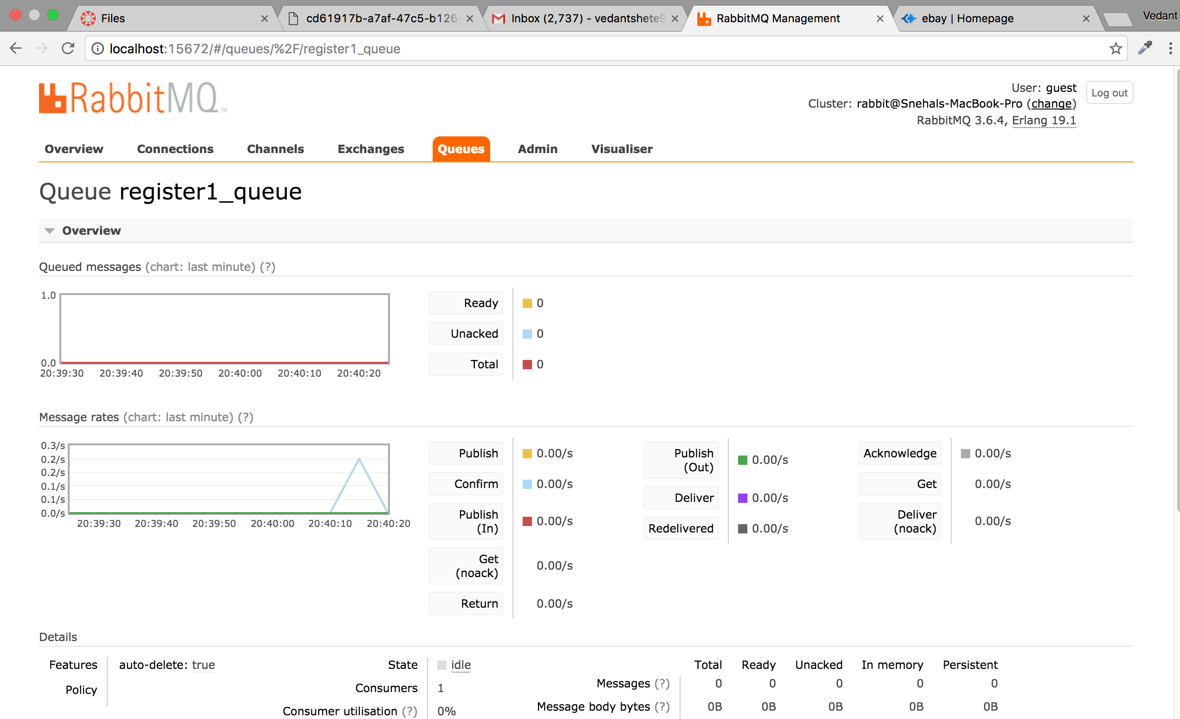

On clicking register user is taken back to Signin page

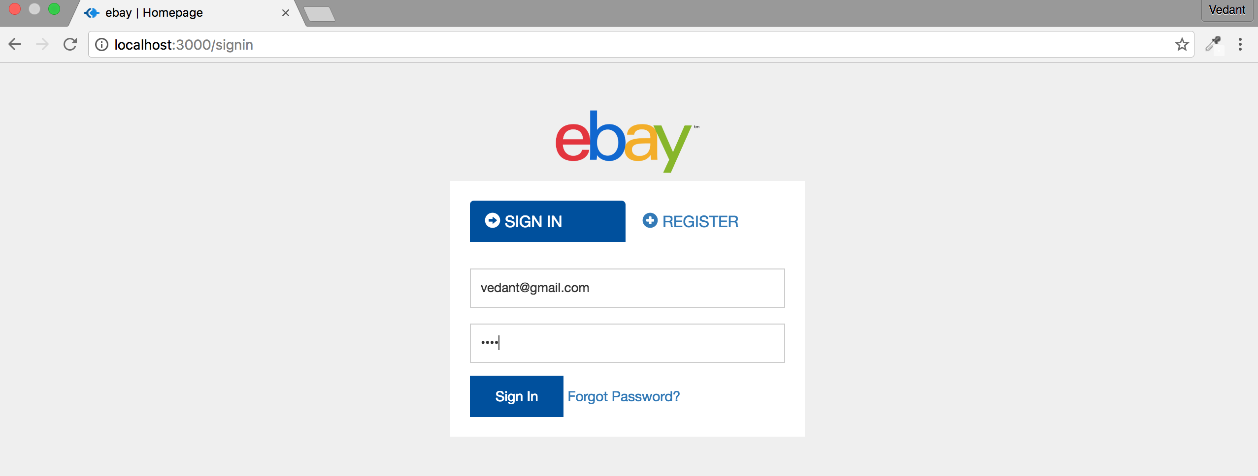

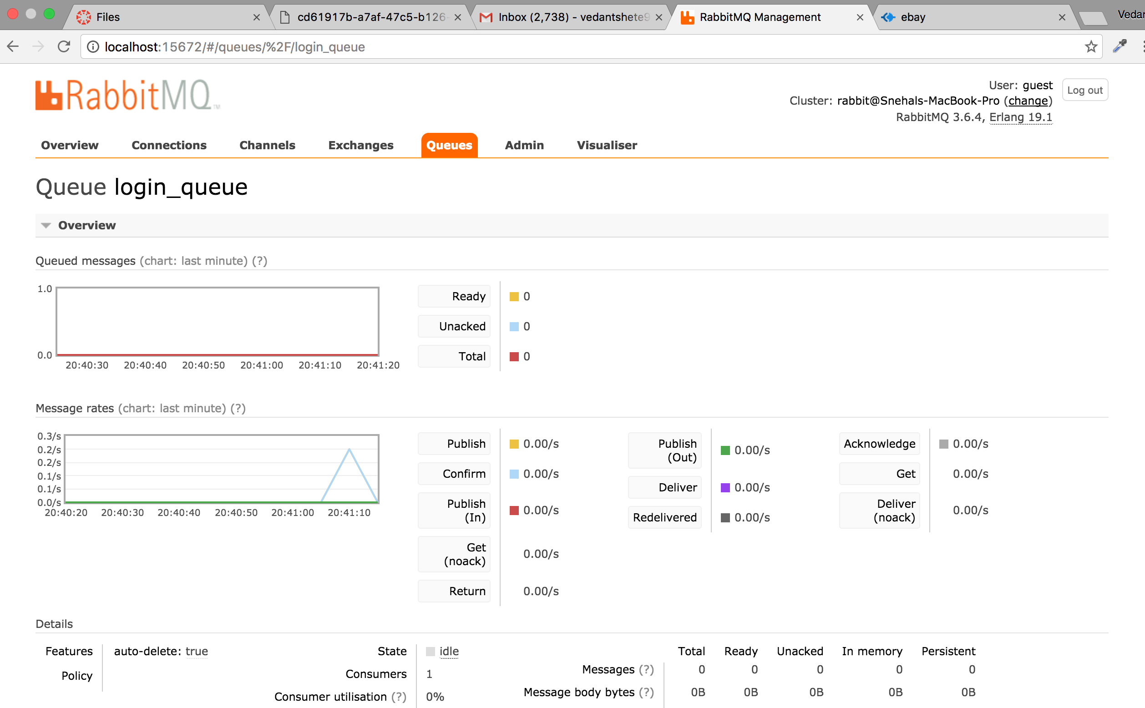

On sign in, user is directed to home page

Here the user can see products posted by other users for selling(green) as well as bidding(blue)

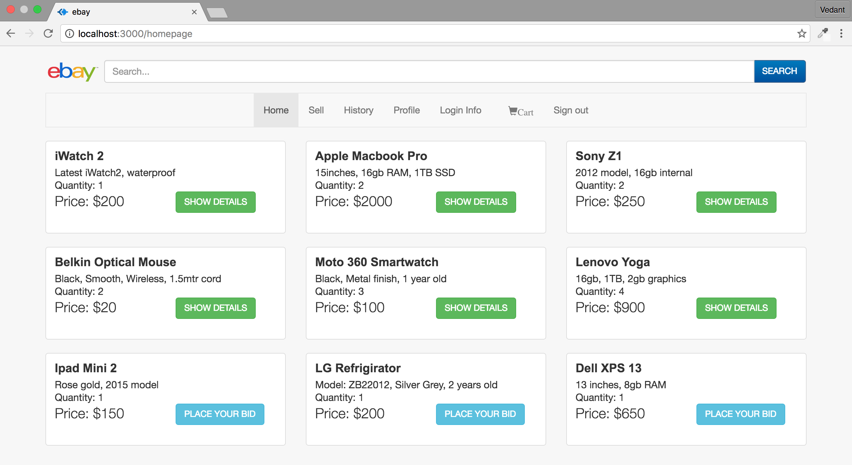

getproduct_queue

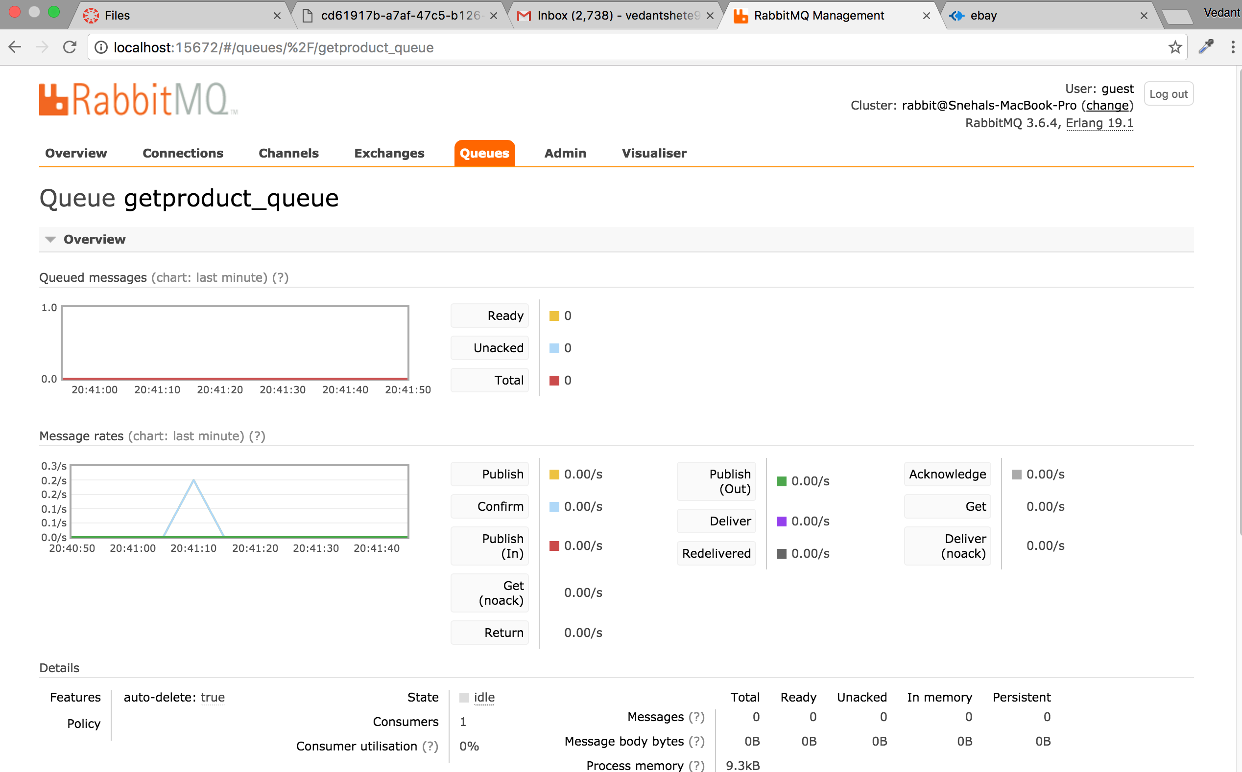

On clicking on “Show detail” button user is directed to product detail page

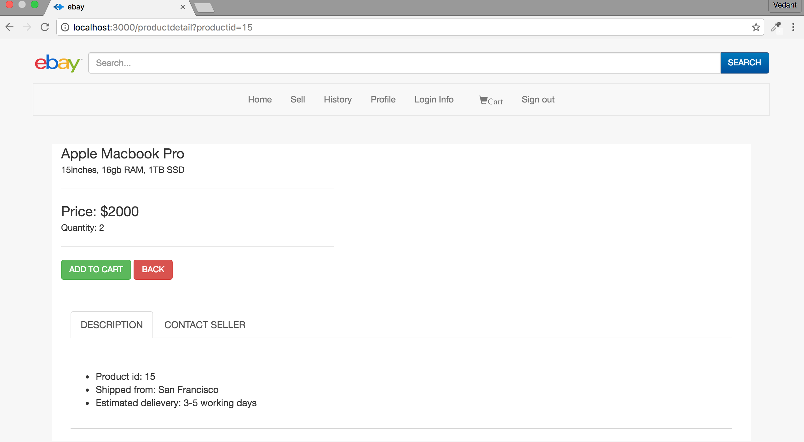

productdetail_queue

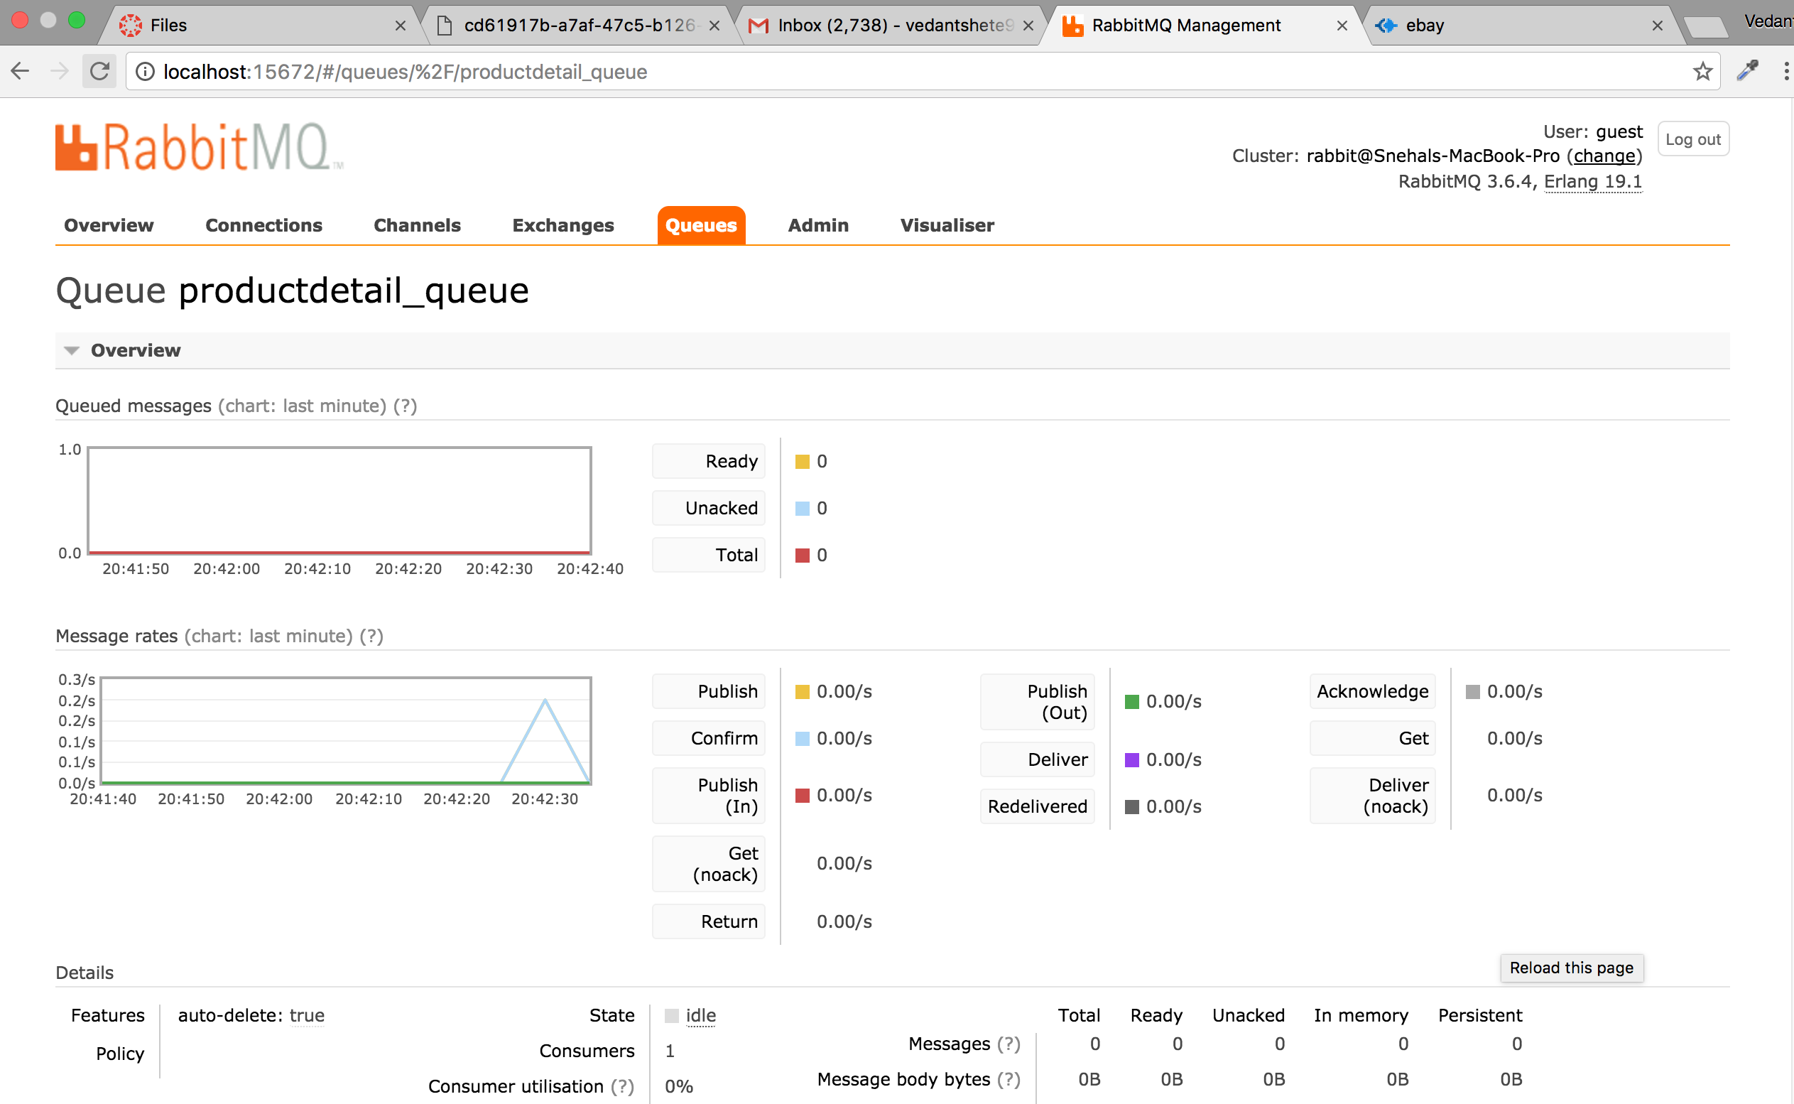

User can also check seller details in the “Contact seller” tab

On pressing “Back” user is taken back to the homepage

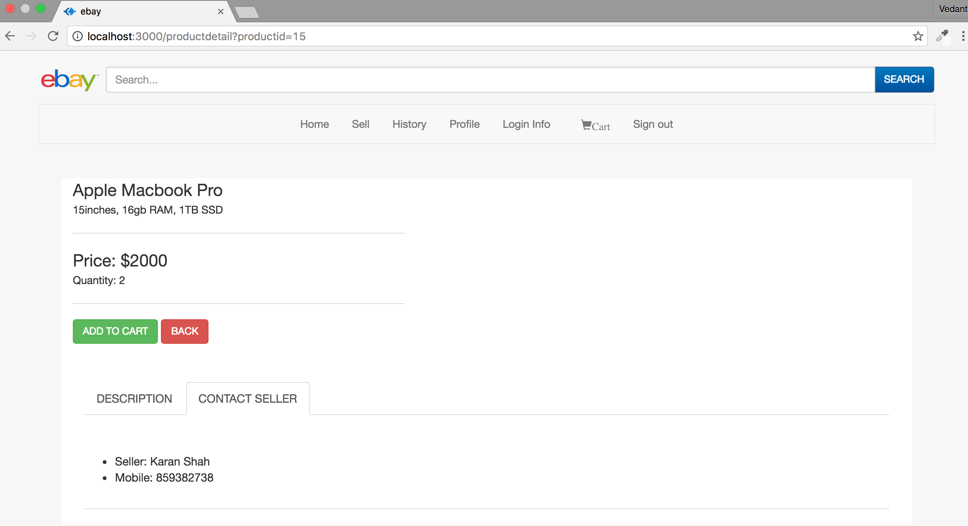

If user clicks on the “Place bid” button of any product, user is taken to product detail page and asked to bid.

**User cannot place a bid of amount lesser than the Base price**

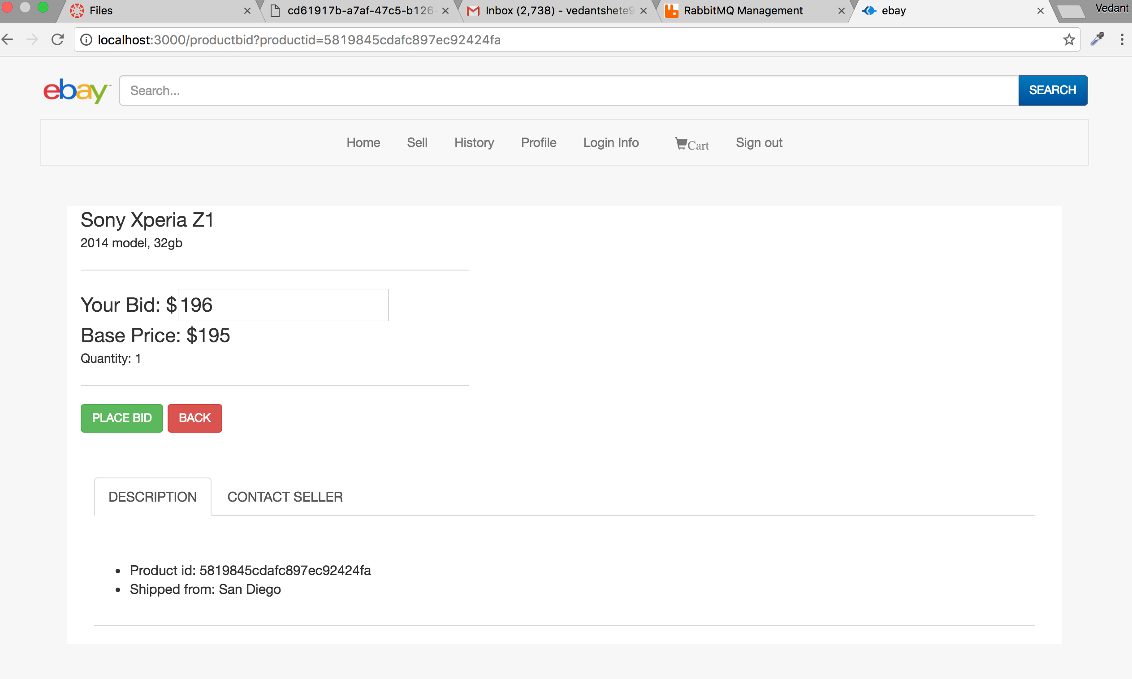

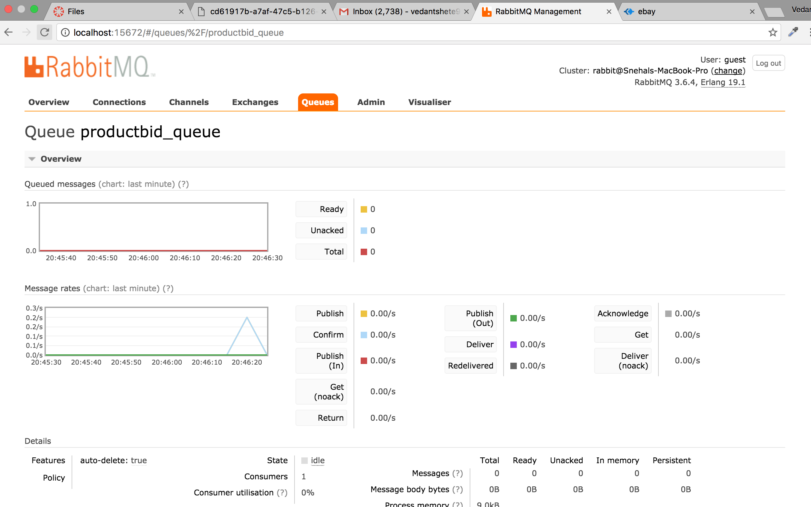

On clicking on “Add to cart” the product is added to user’s cart

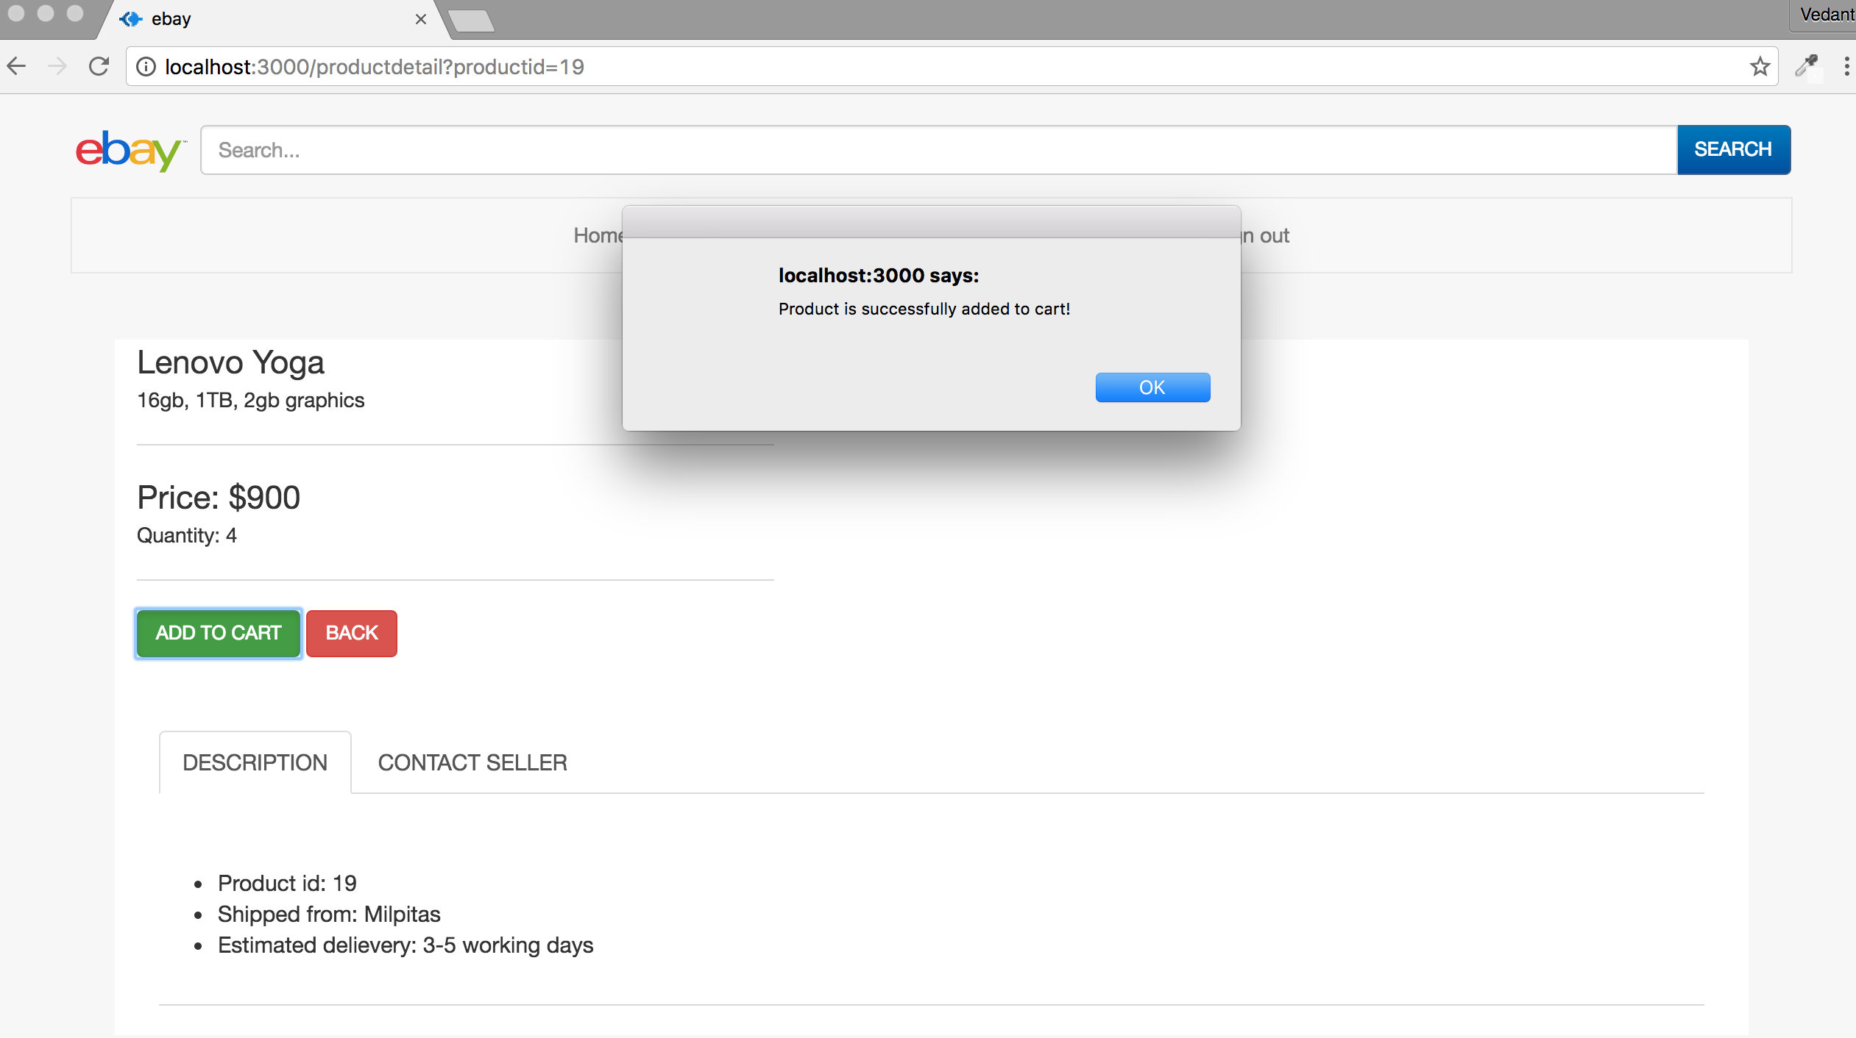

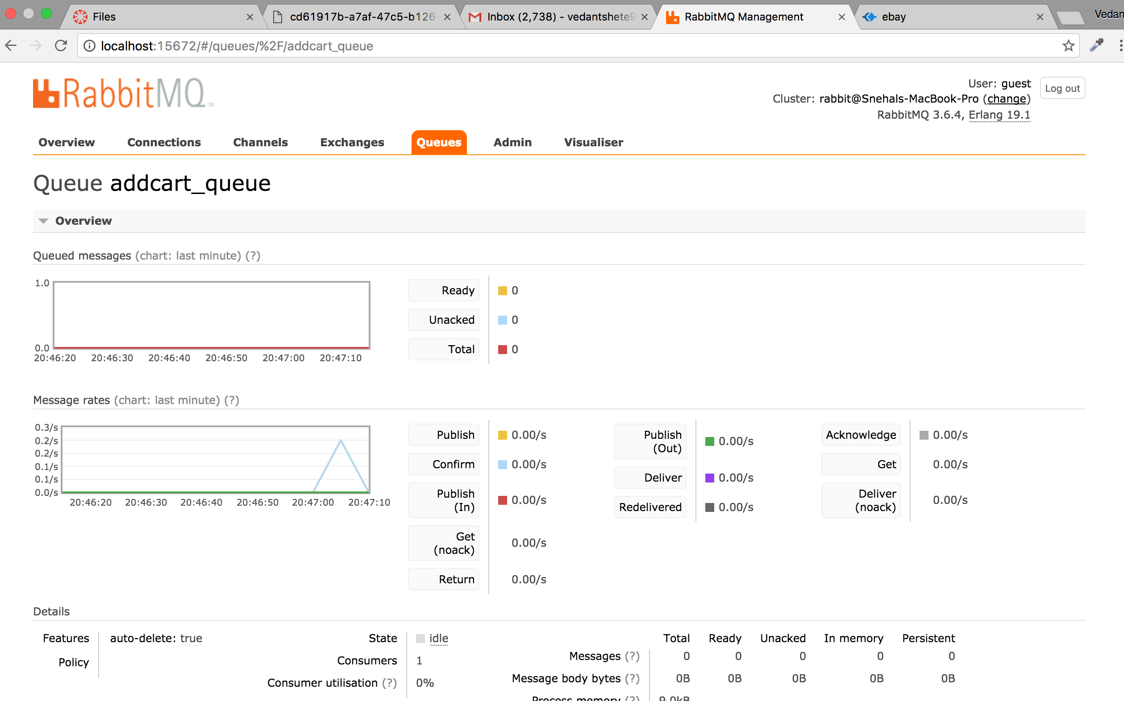

On clicking on “Place bid” the user’s bid is placed

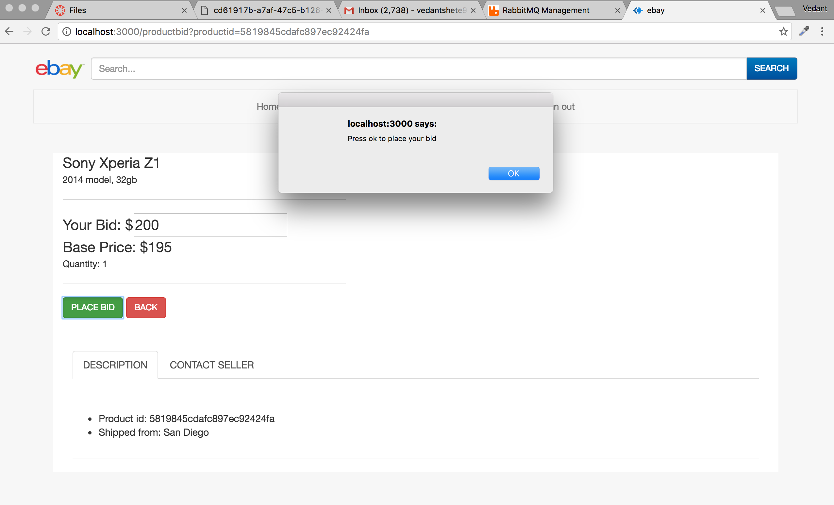

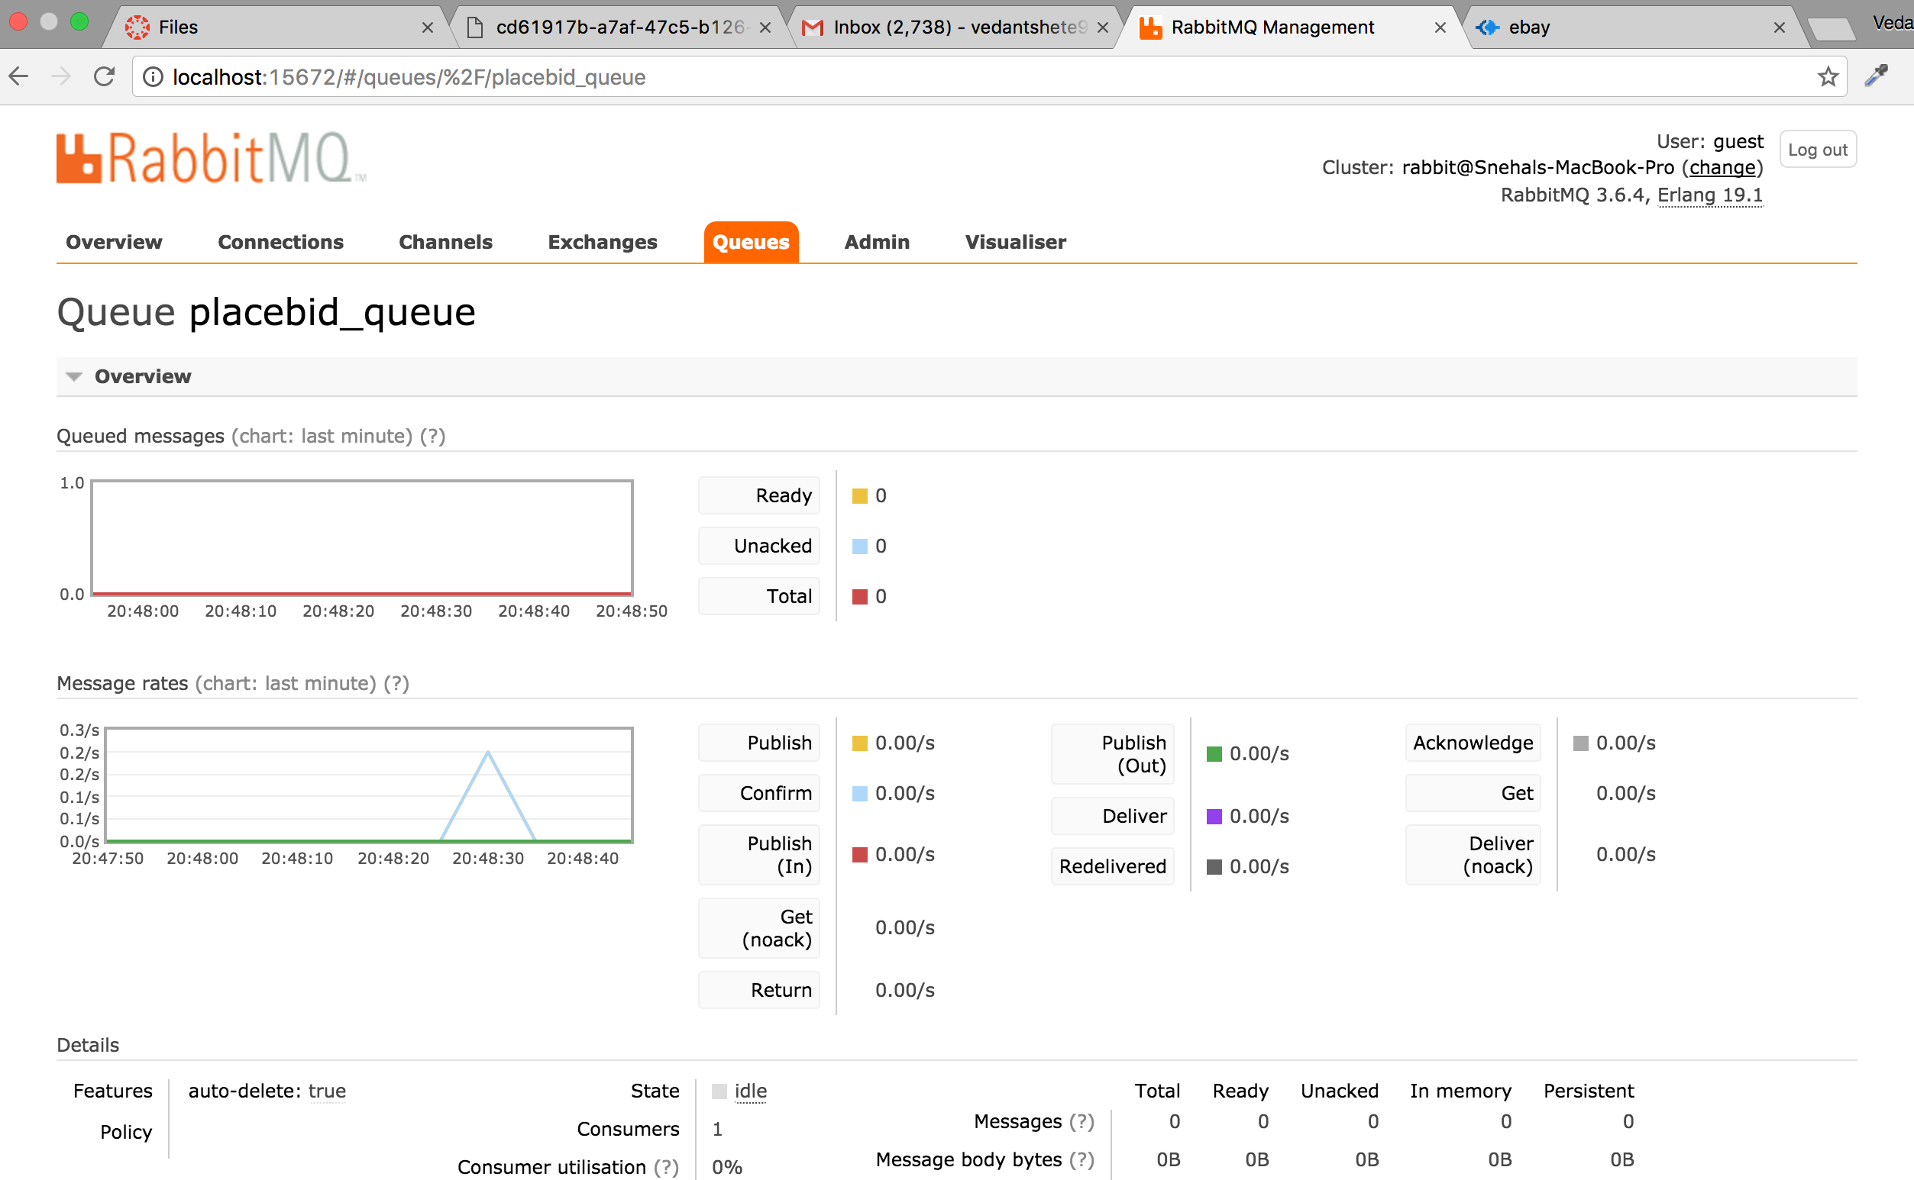

On clicking on “Cart” in the navigation bar, user is taken to his cart

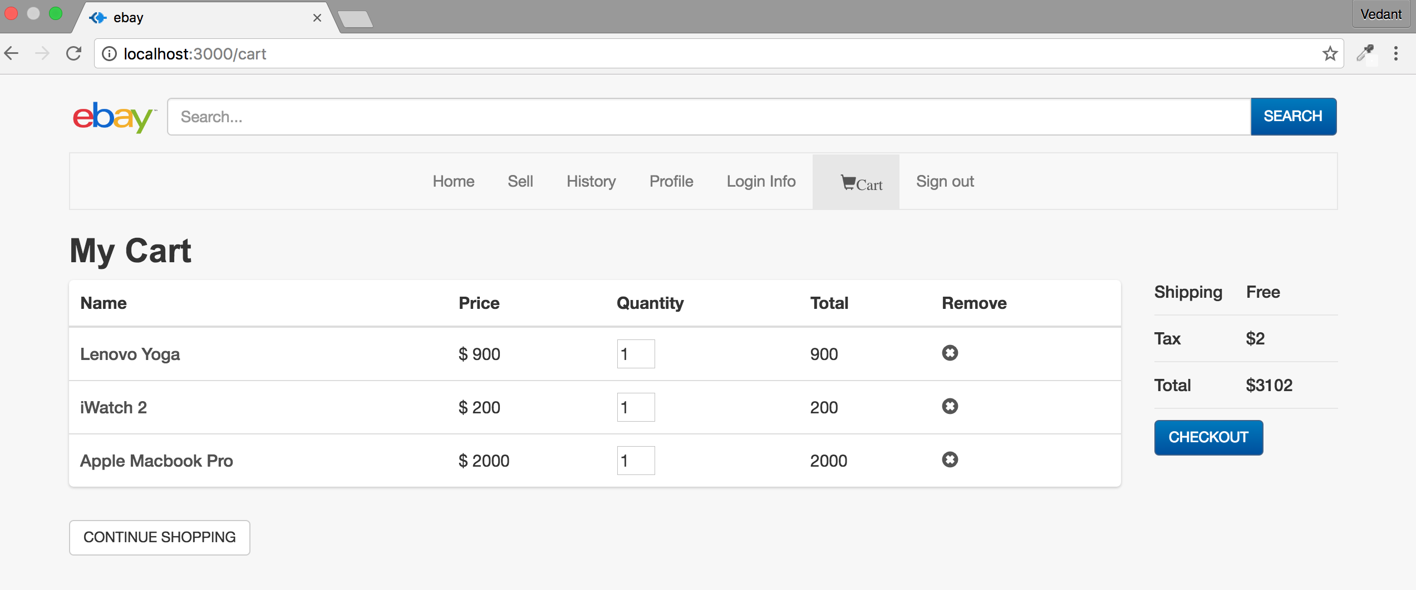

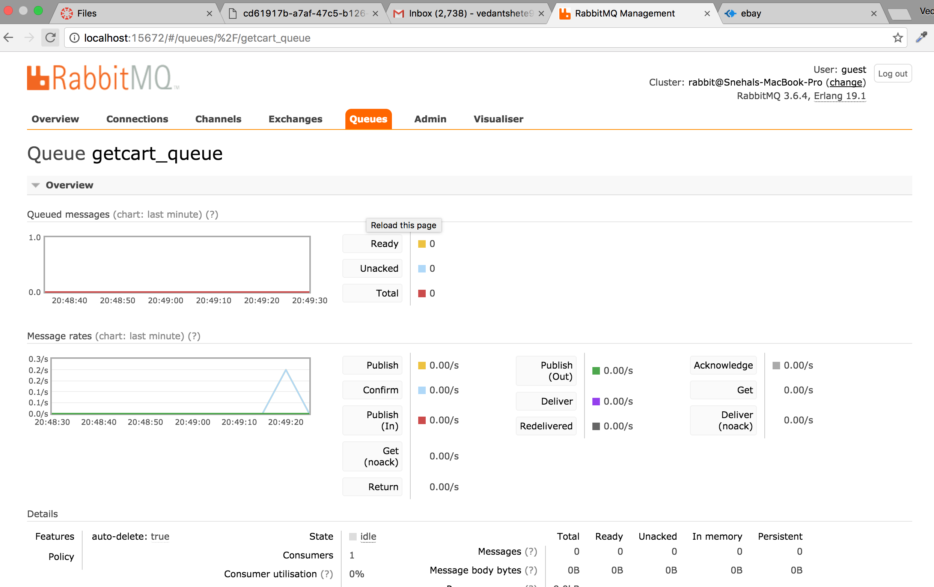

User can remove any item from the cart. The total amount is changed when a user removes any item

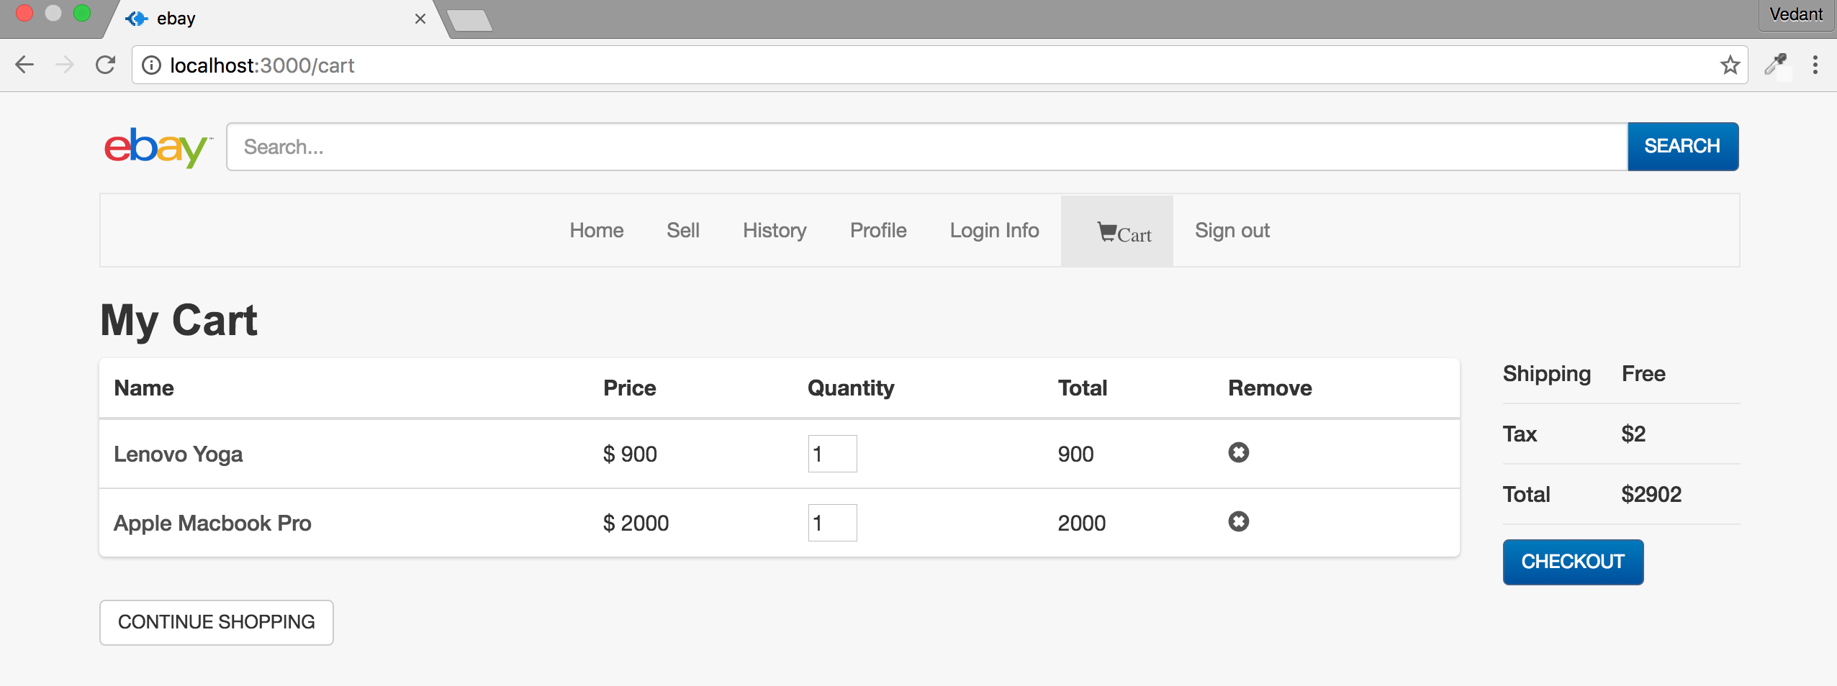

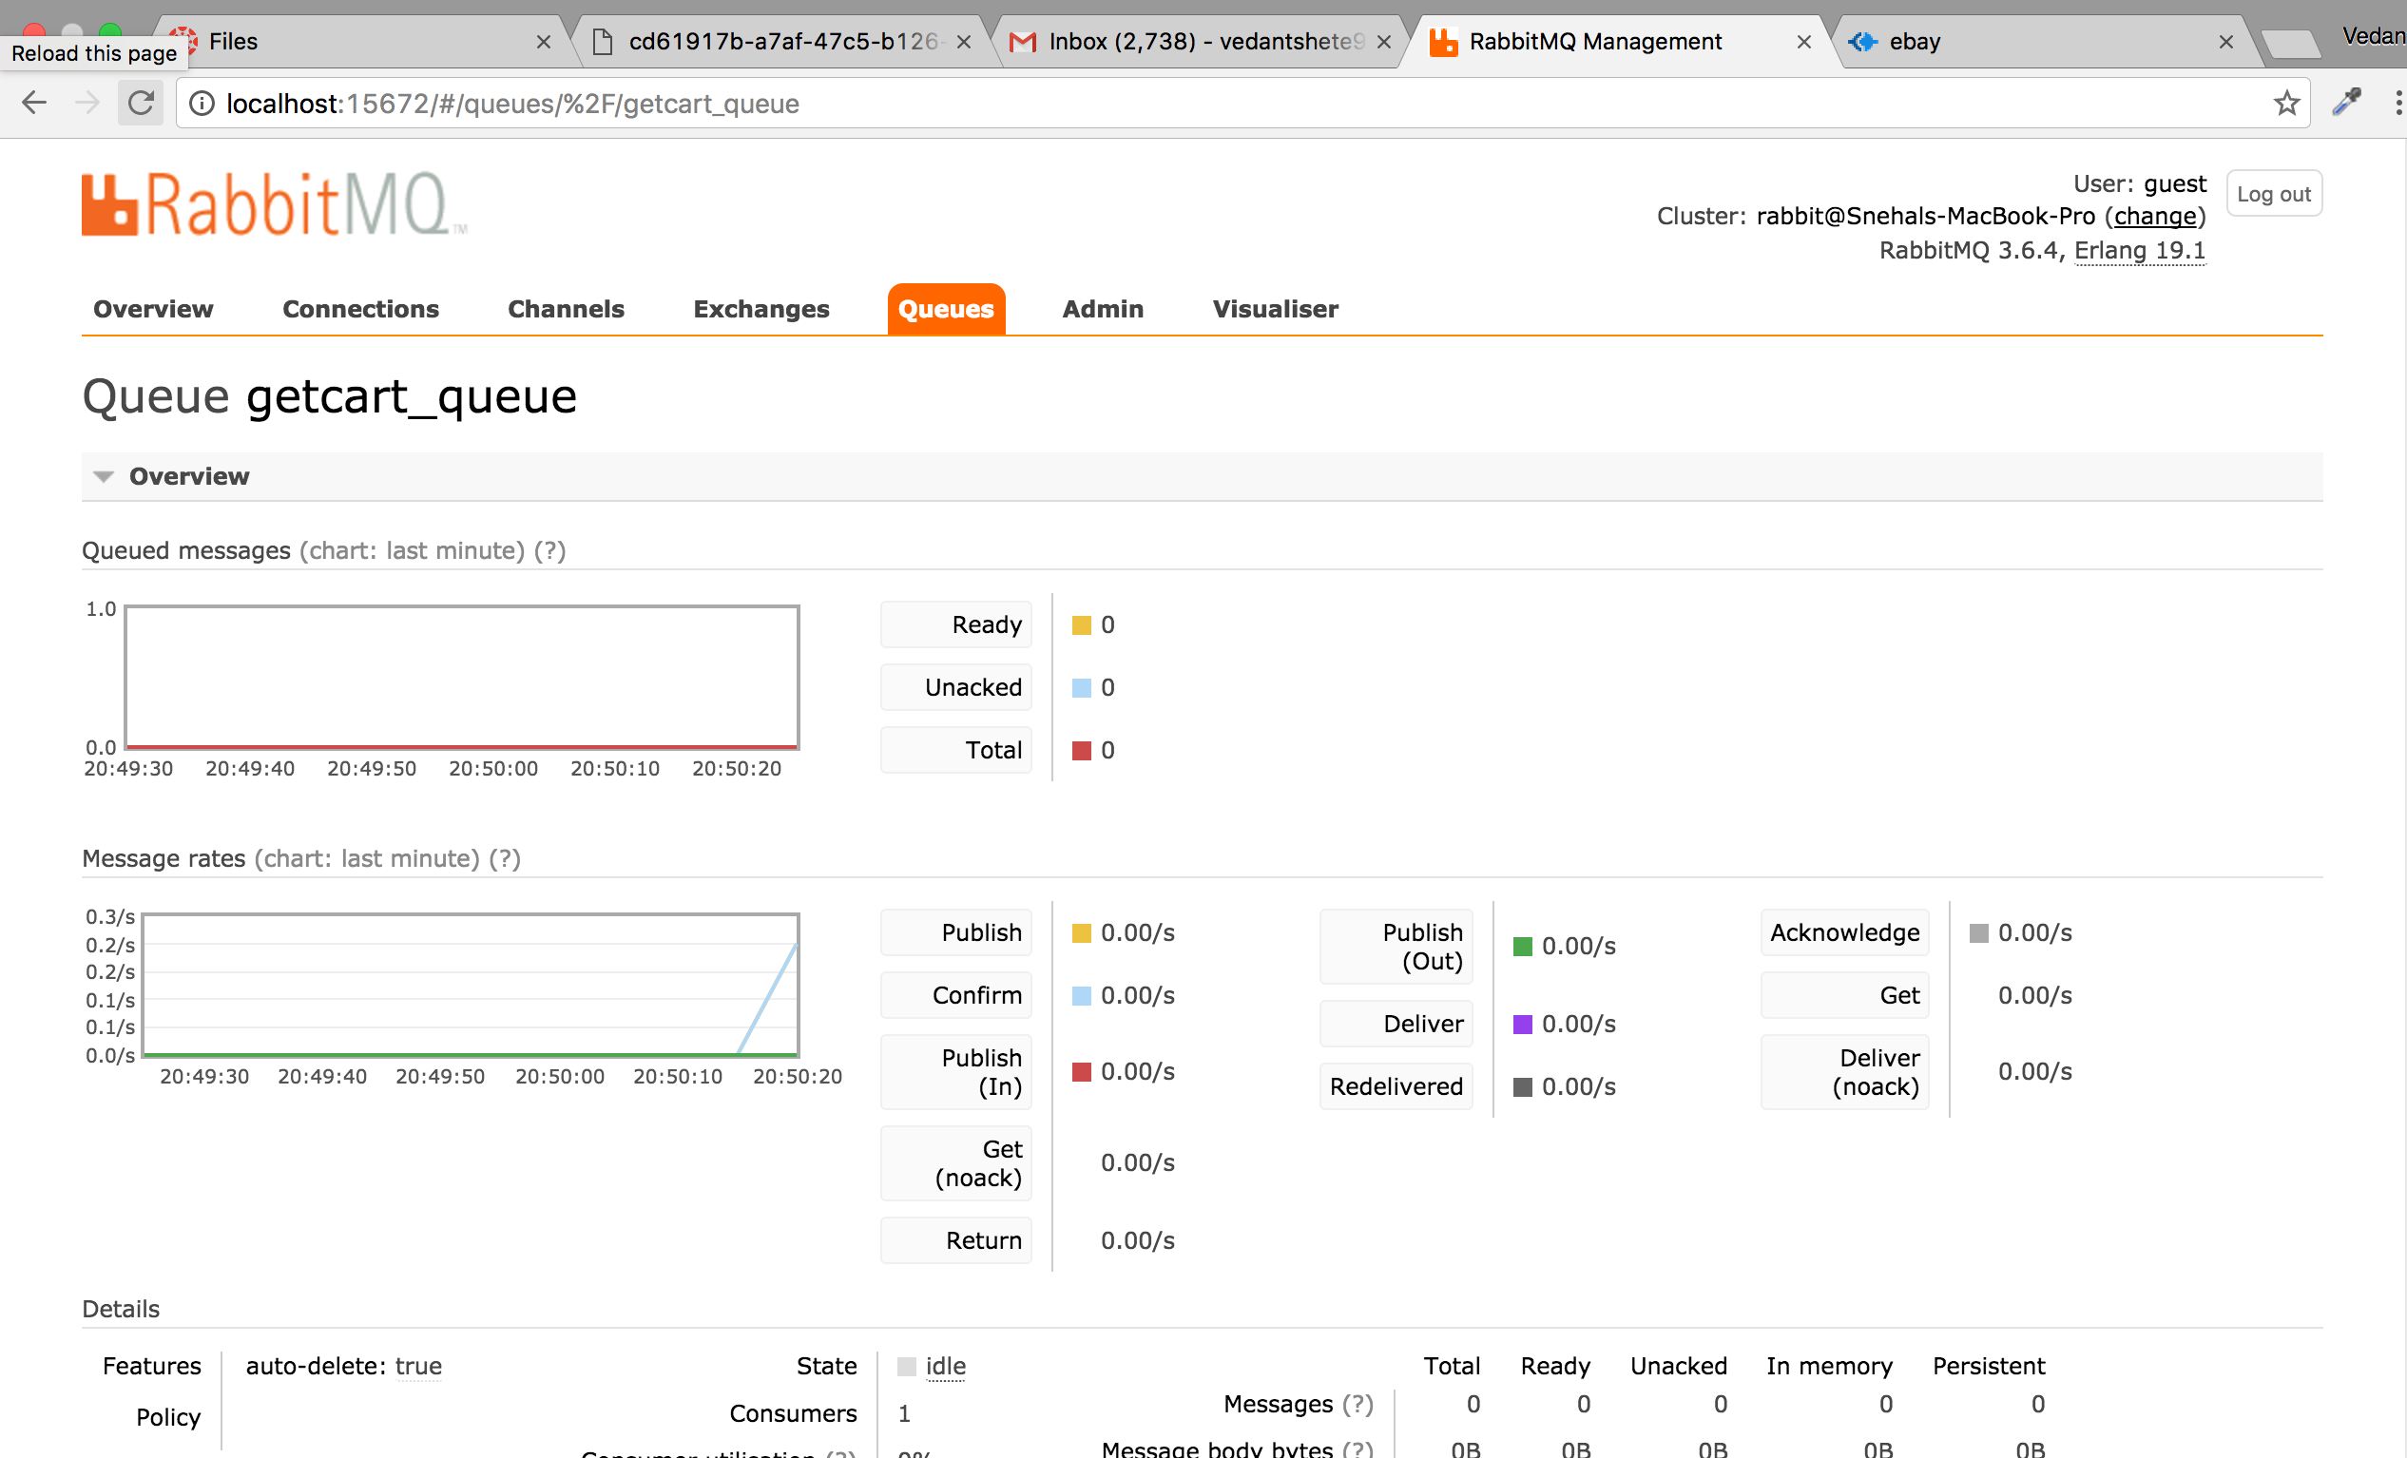

The user can change quantity of items he wants to add. The quantity cannot be less than 1 and cannot be greater than what is available in the sellers account.

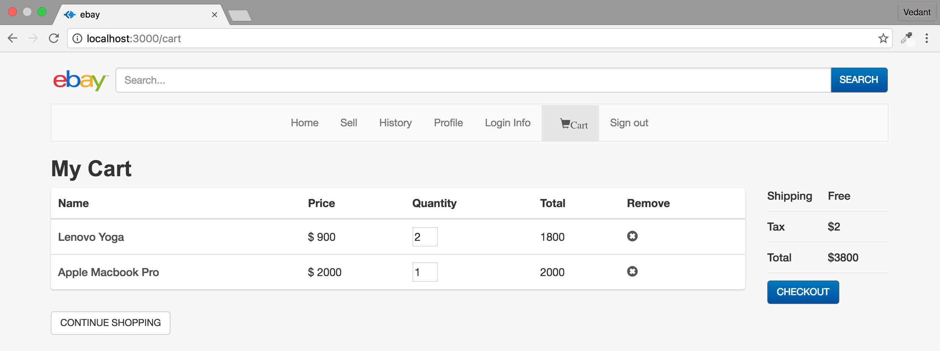

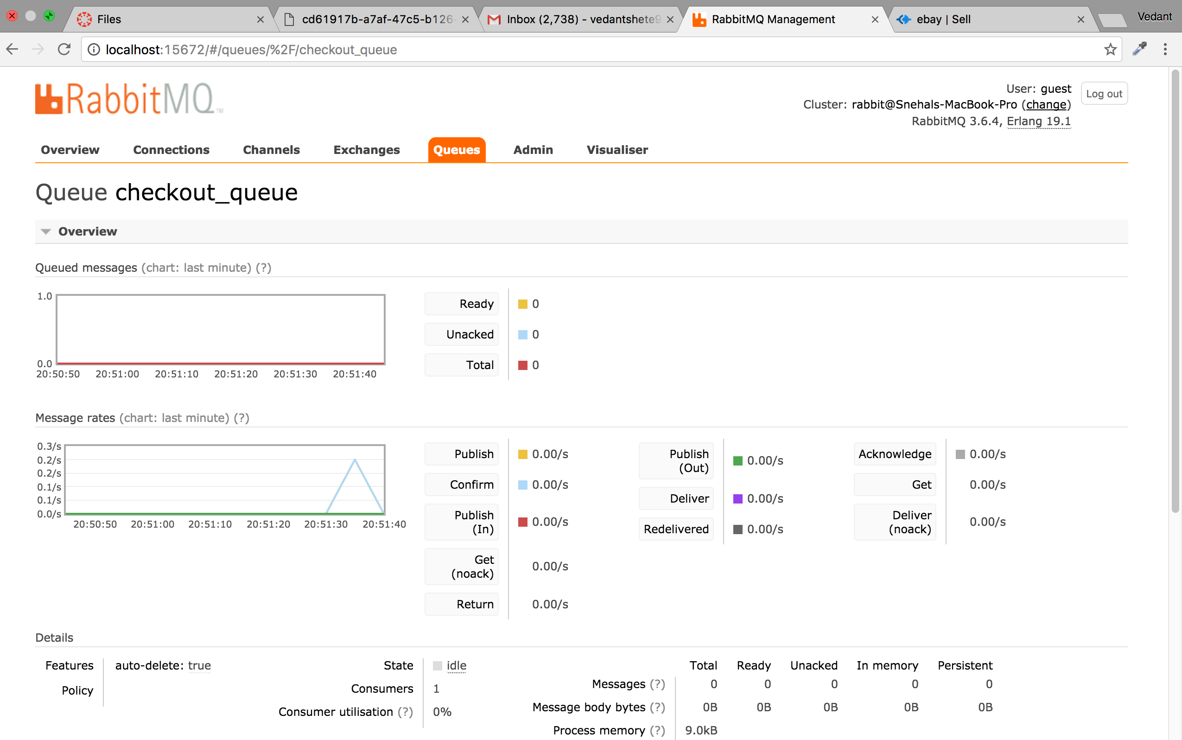

From the cart page user can click on “Continue Shopping” and go back to homepage

User can click on “Checkout” to get redirected to payment page

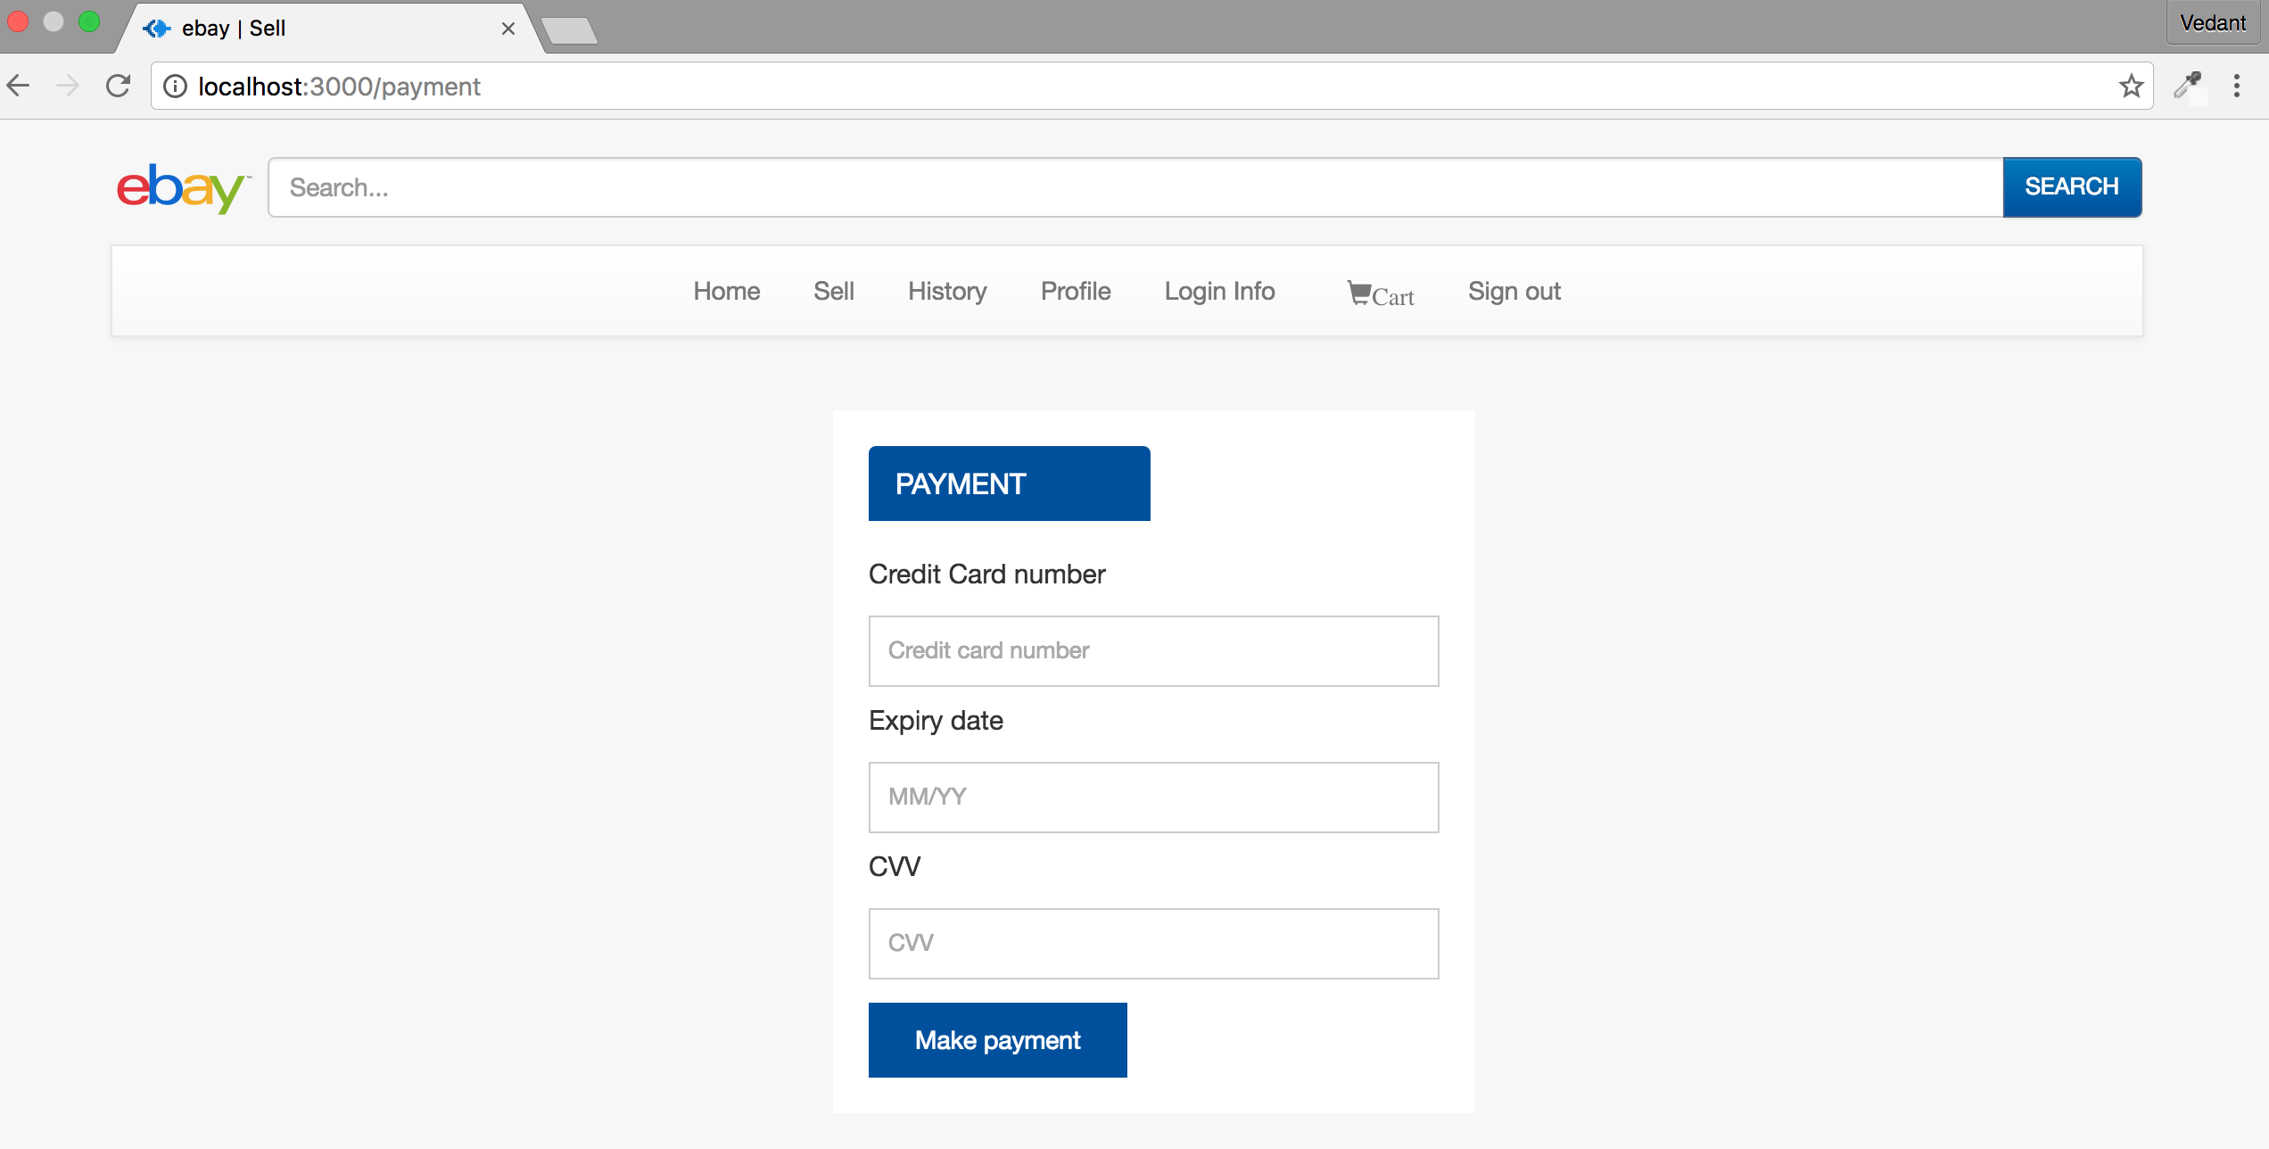

Here on the payment page user has to insert its 16-digit credit card number and 3-digit cvv and expiration date correctly, otherwise an error is shown

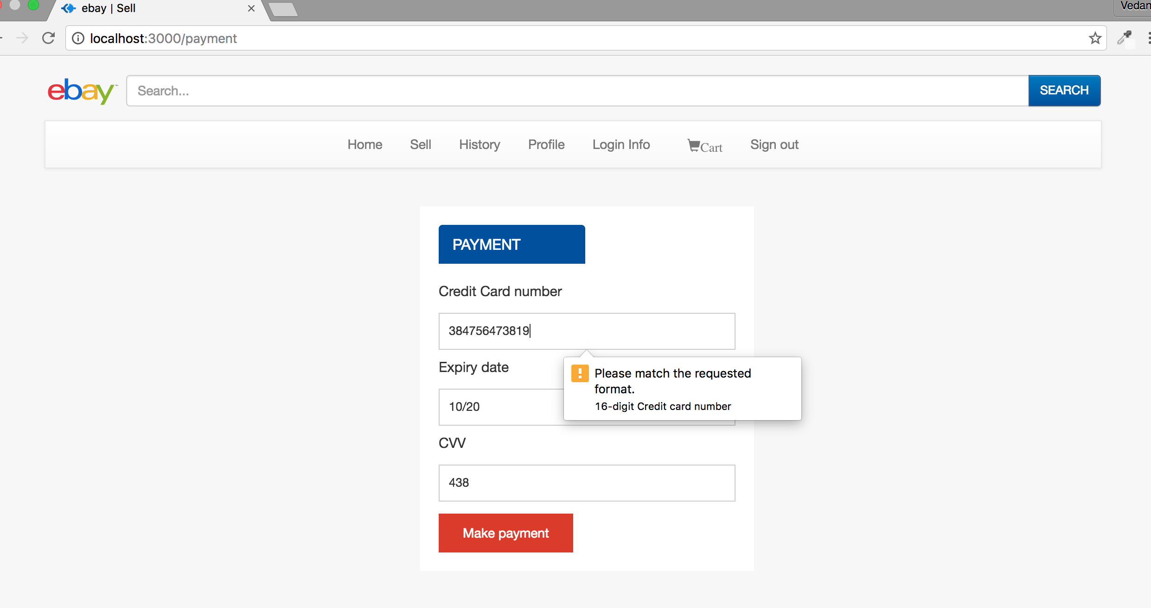

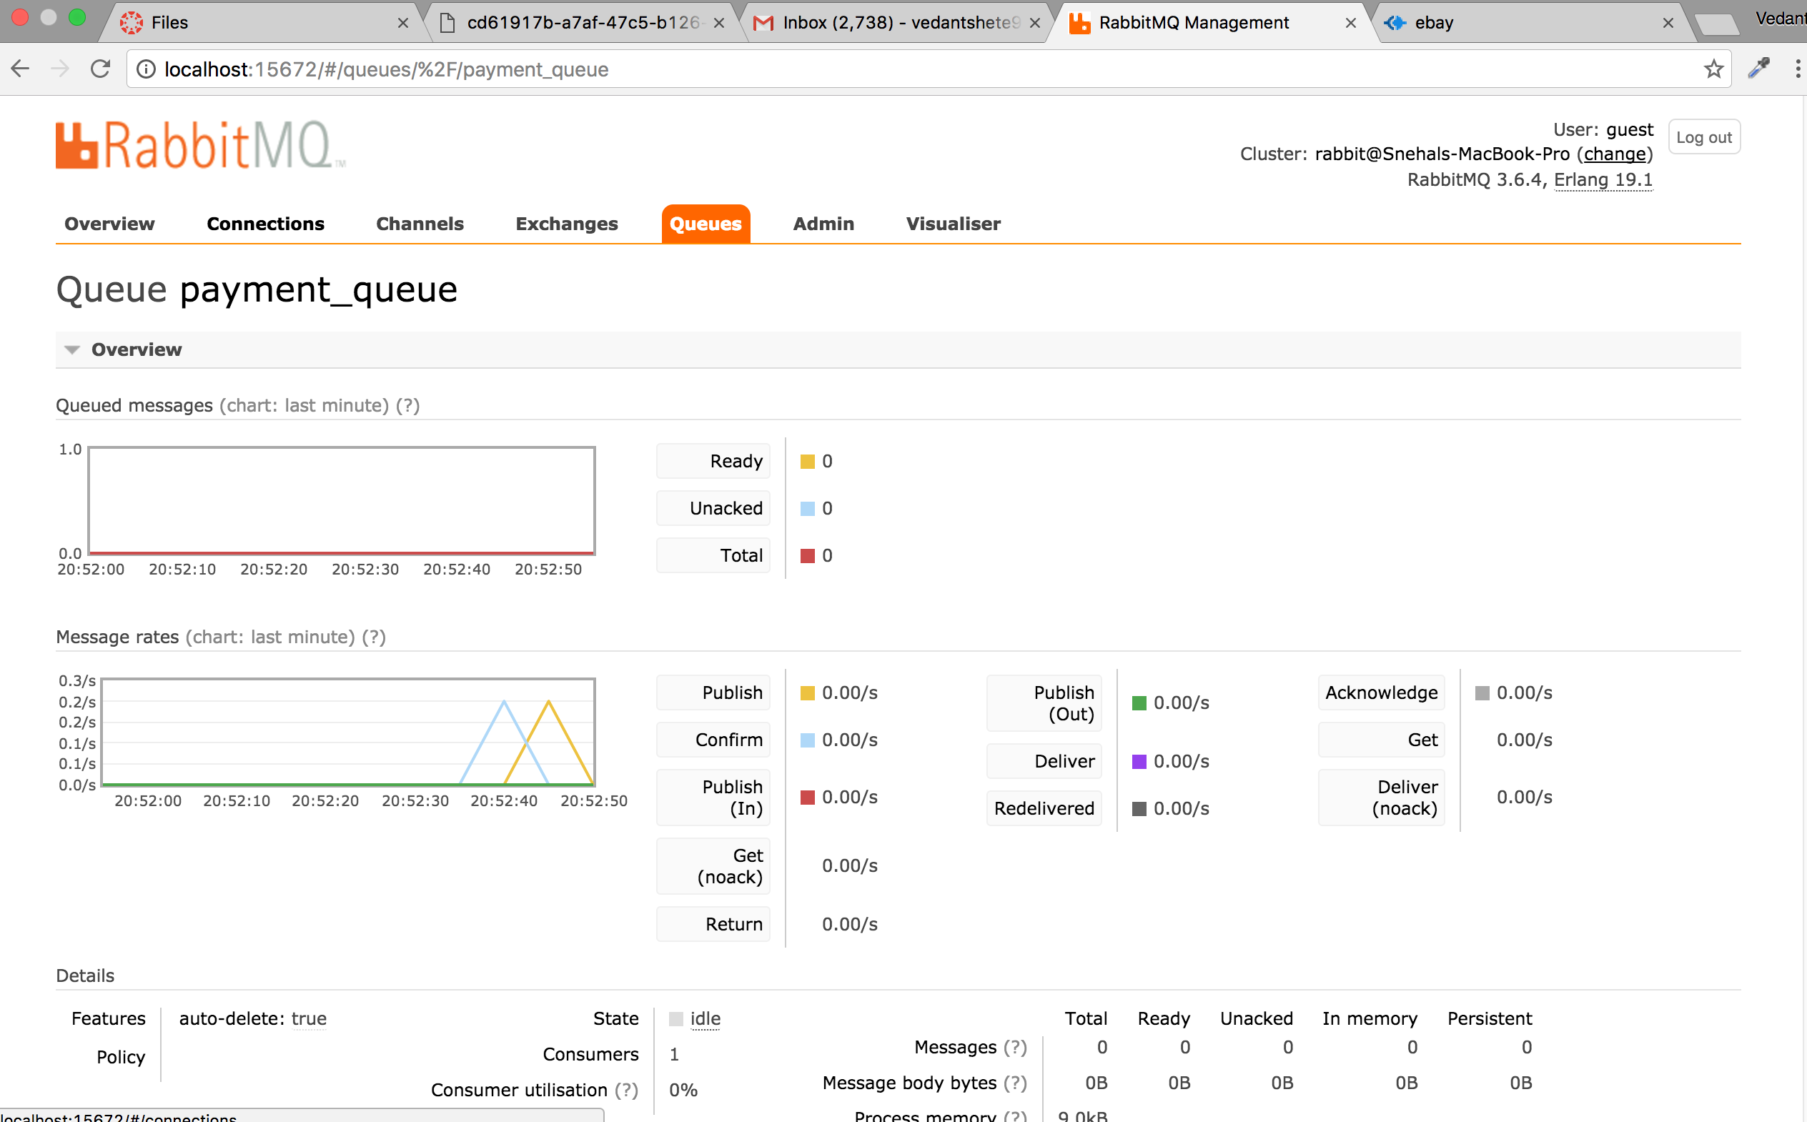

Here we can see that quantity of the products bought (Apple Macbook Pro – 1 and Lenovo Yoga – 2 ) has been reduced

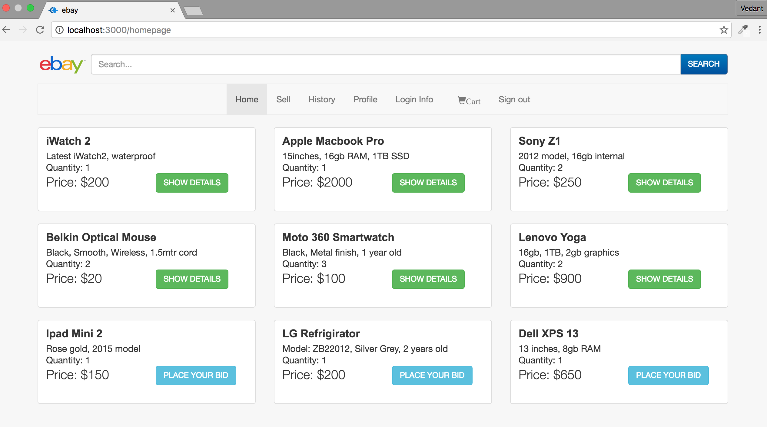

If quantity of any product become 0 then the product is no more shown for sale

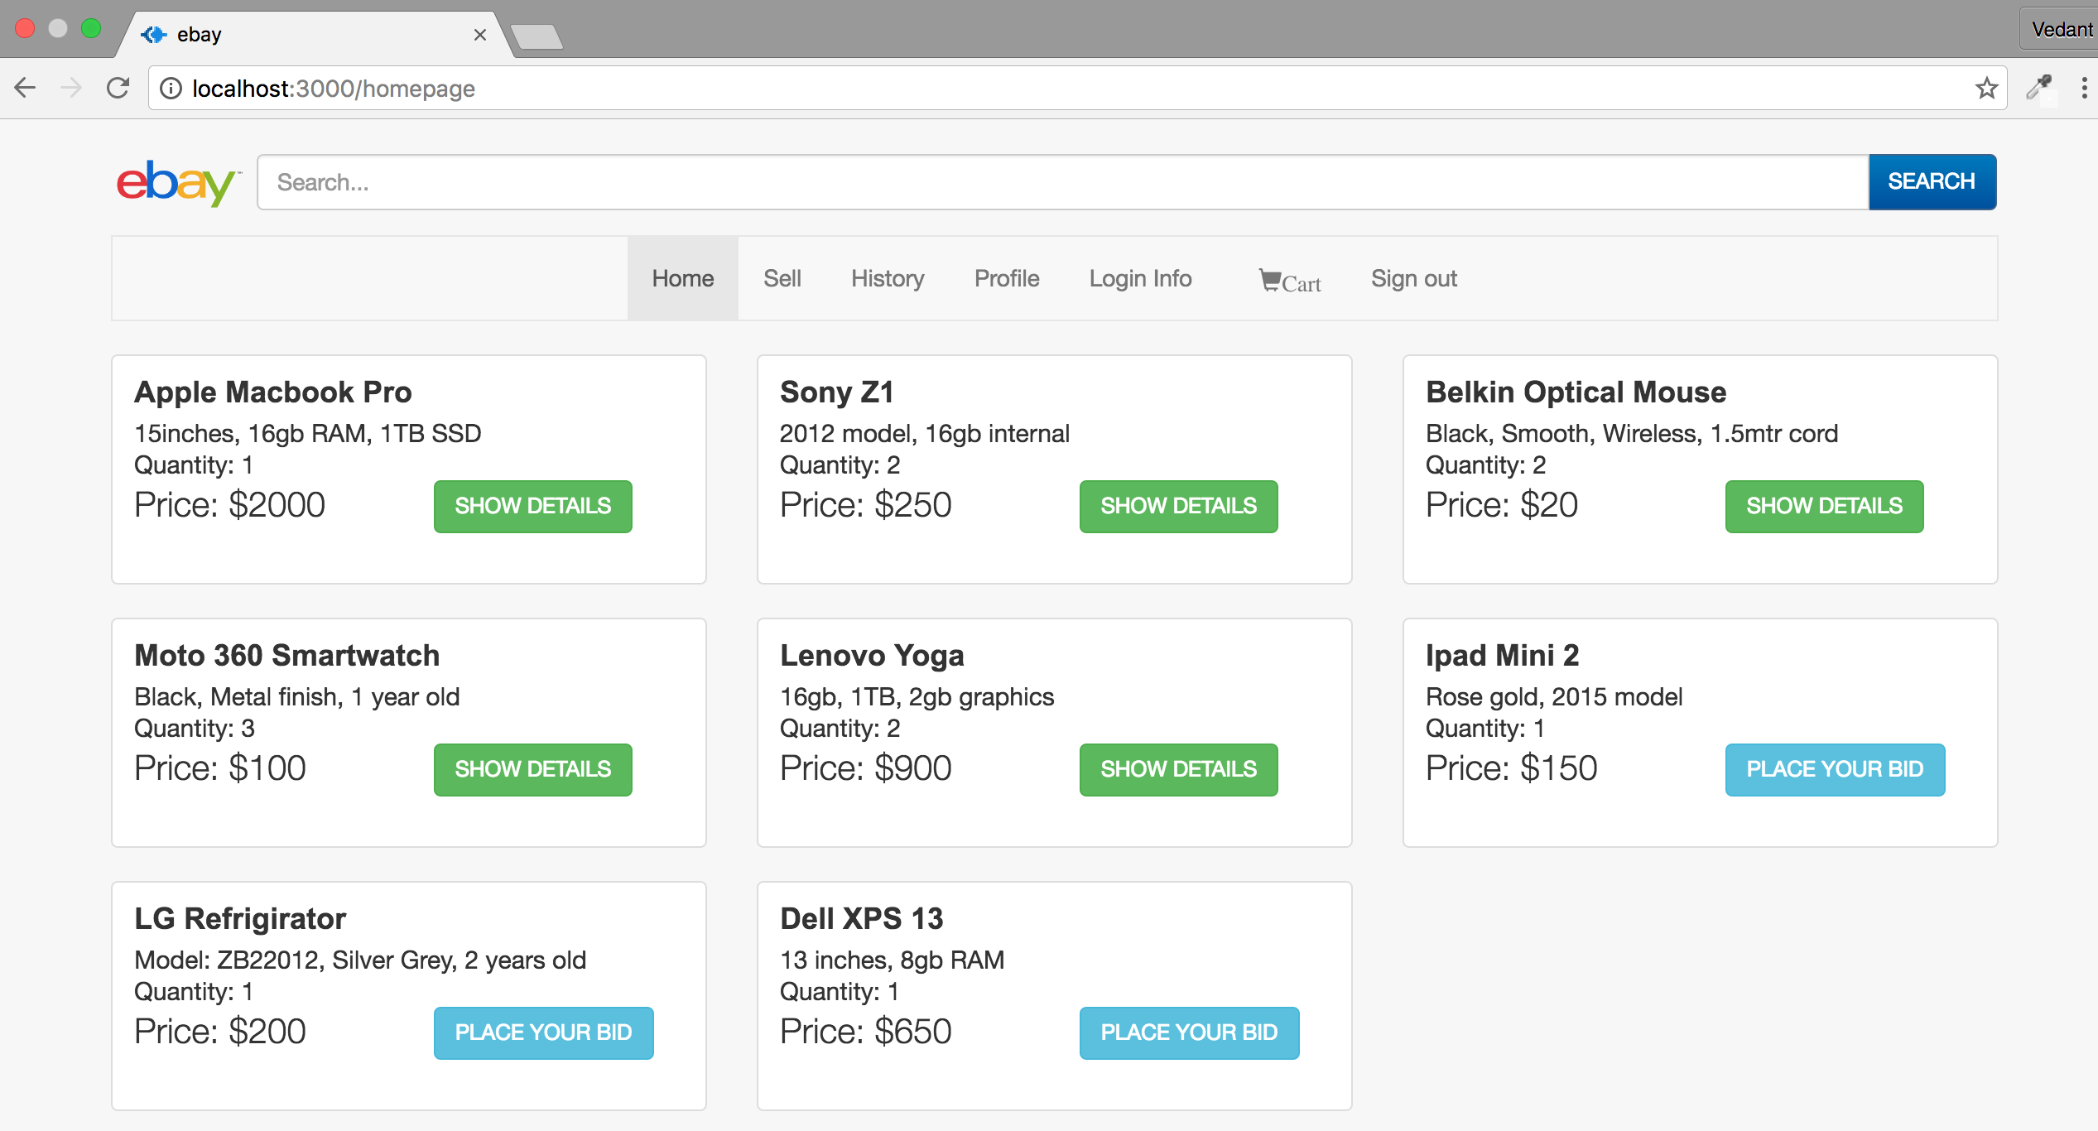

In the Sell page the user can either post an advertisement for selling product or for opening a bid on them

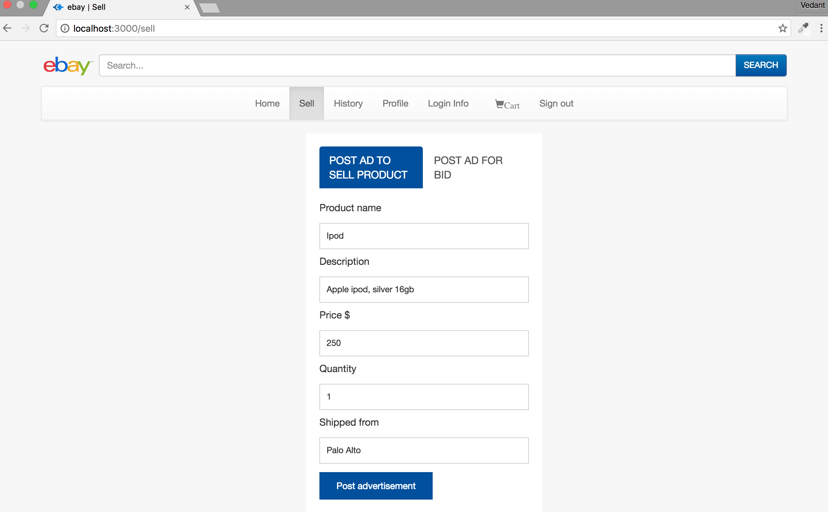

By clicking on “Post advertisement” the ad is posted and can be seen by other users

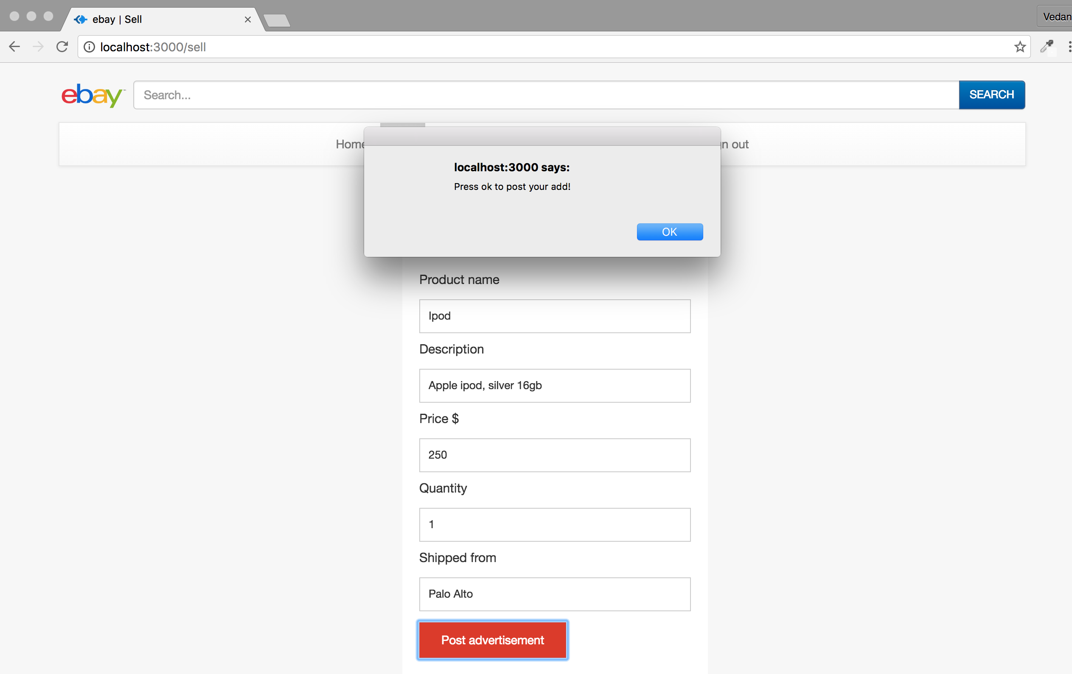

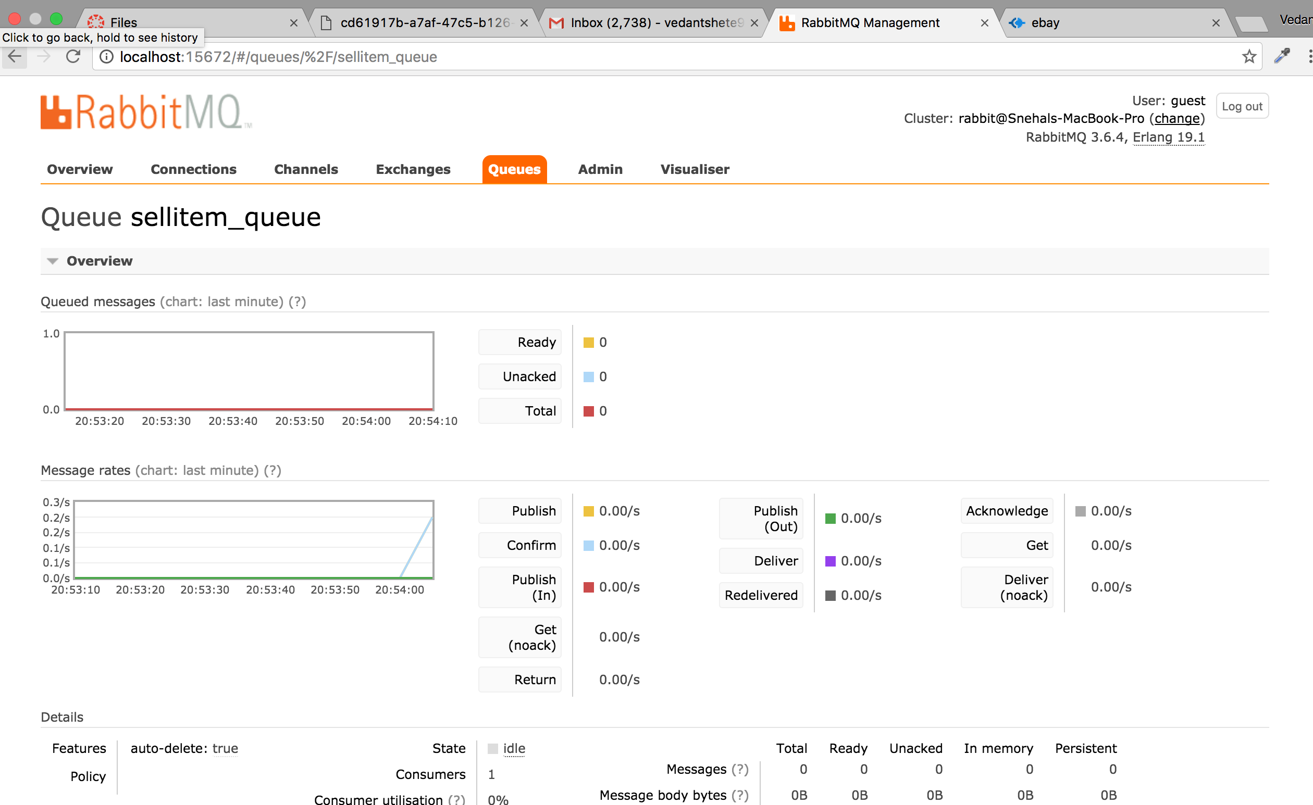

Similarly, for posting an item for bidding

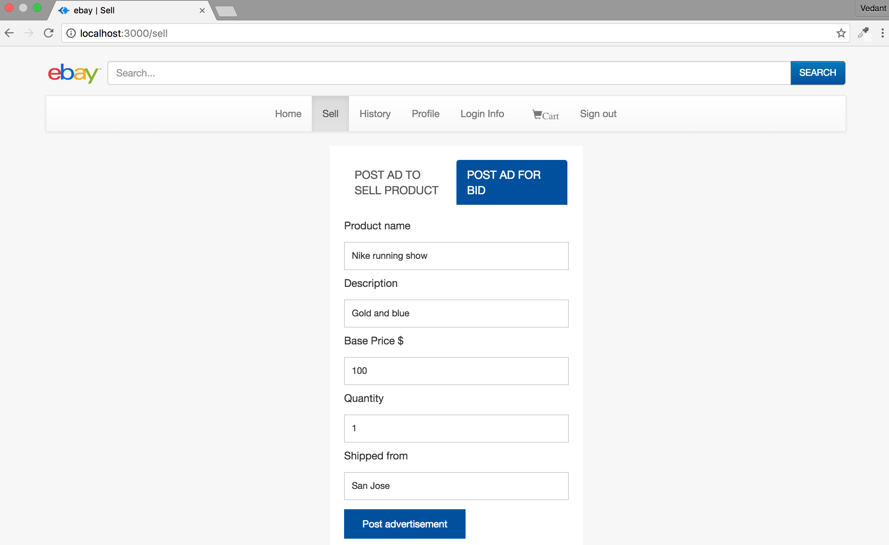

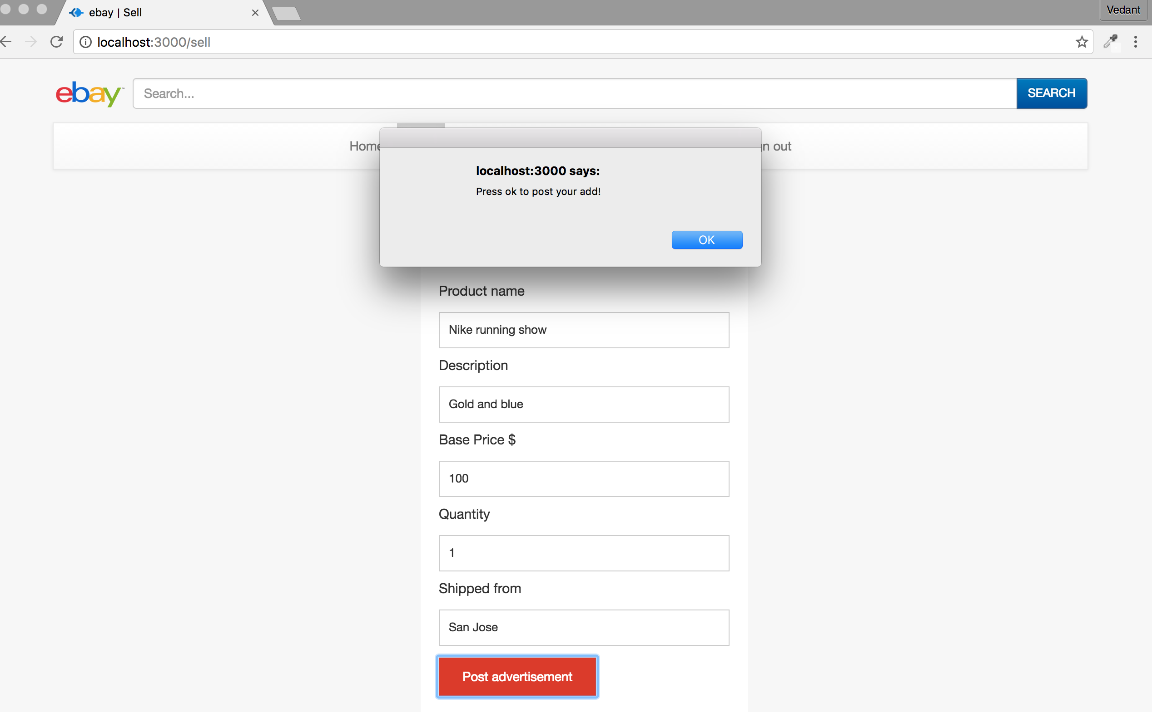

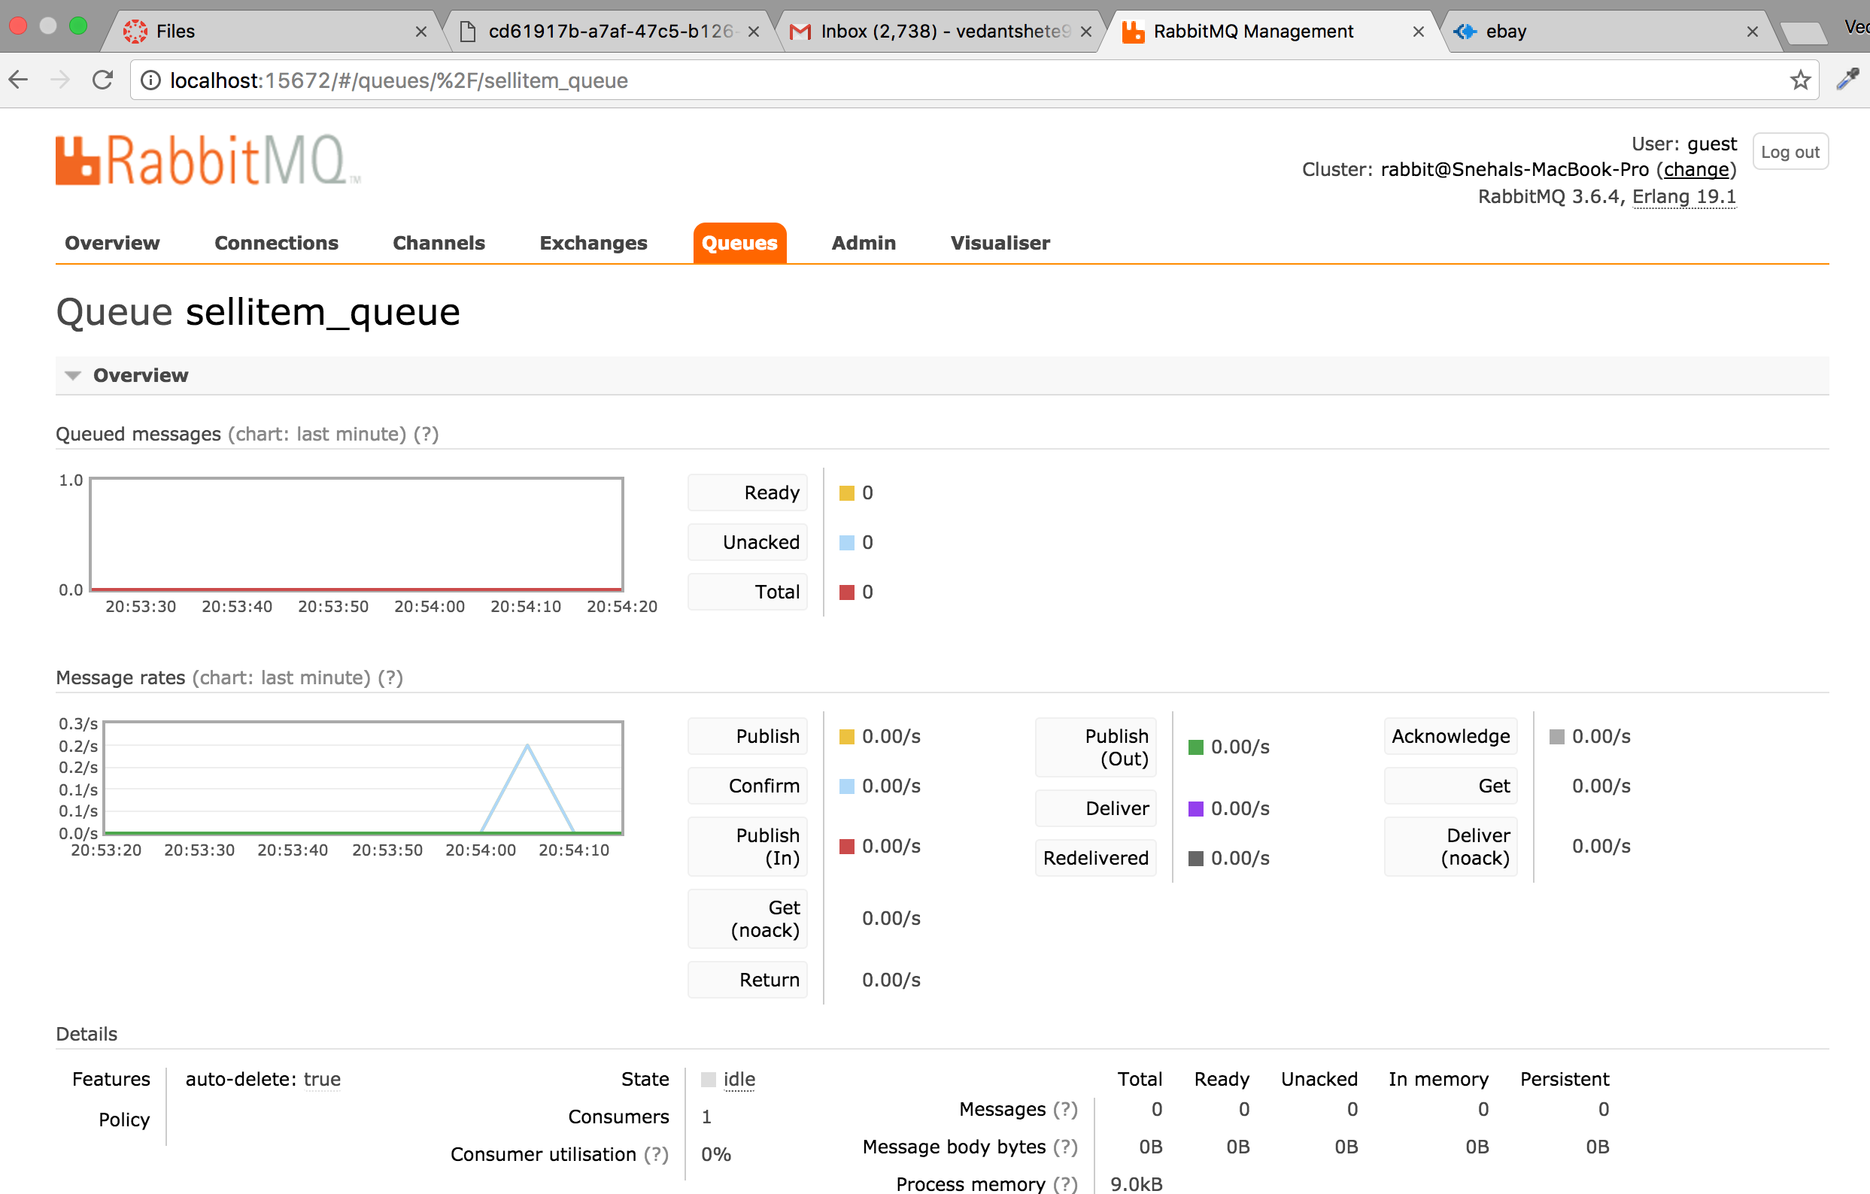

If any user wins the bid, i.e., has the highest bid when the time for bidding(4 days) ends then the product is added to users “bought items” list

(Screenshot of bidding logic on client-side)

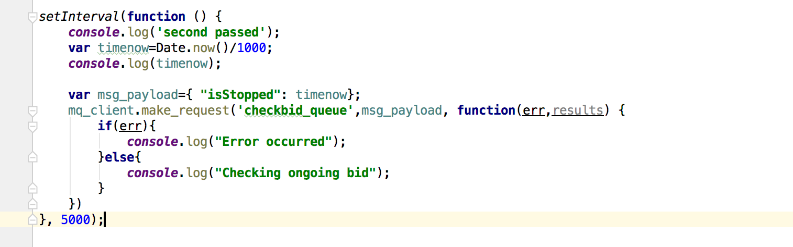

(Screenshot of bidding logic on server-side)

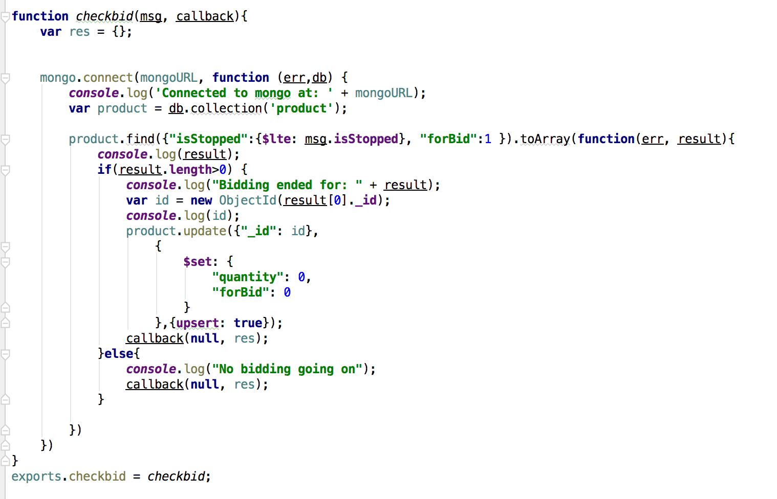

In the profile tab the user can see their own profile

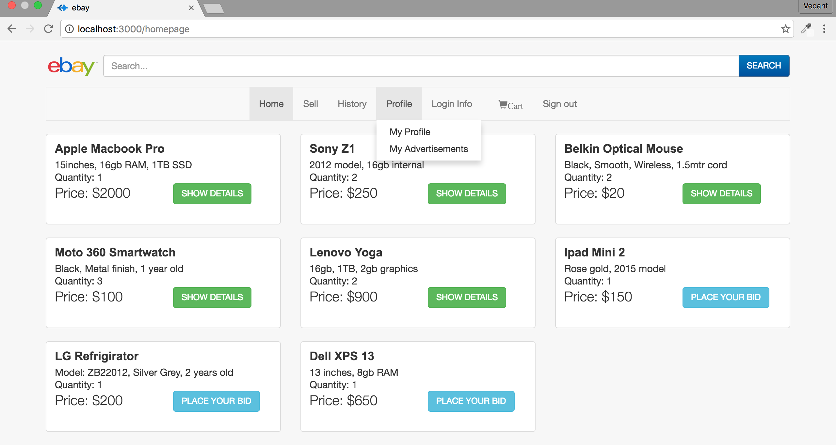

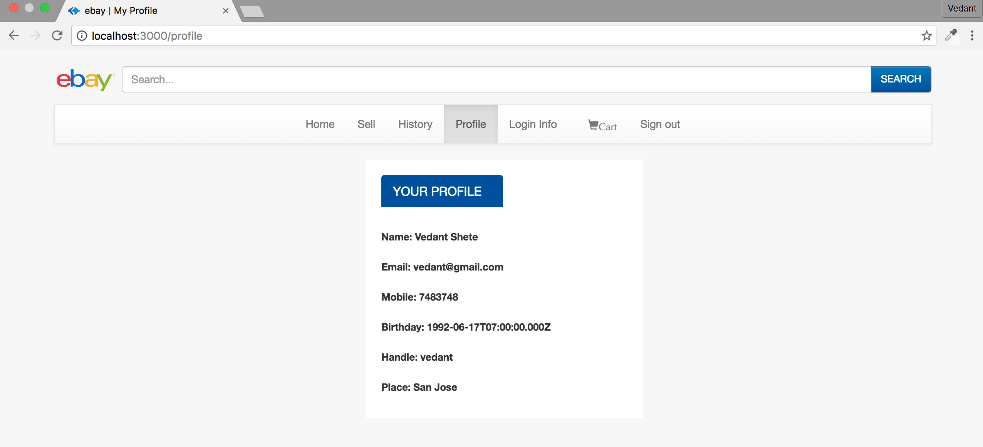

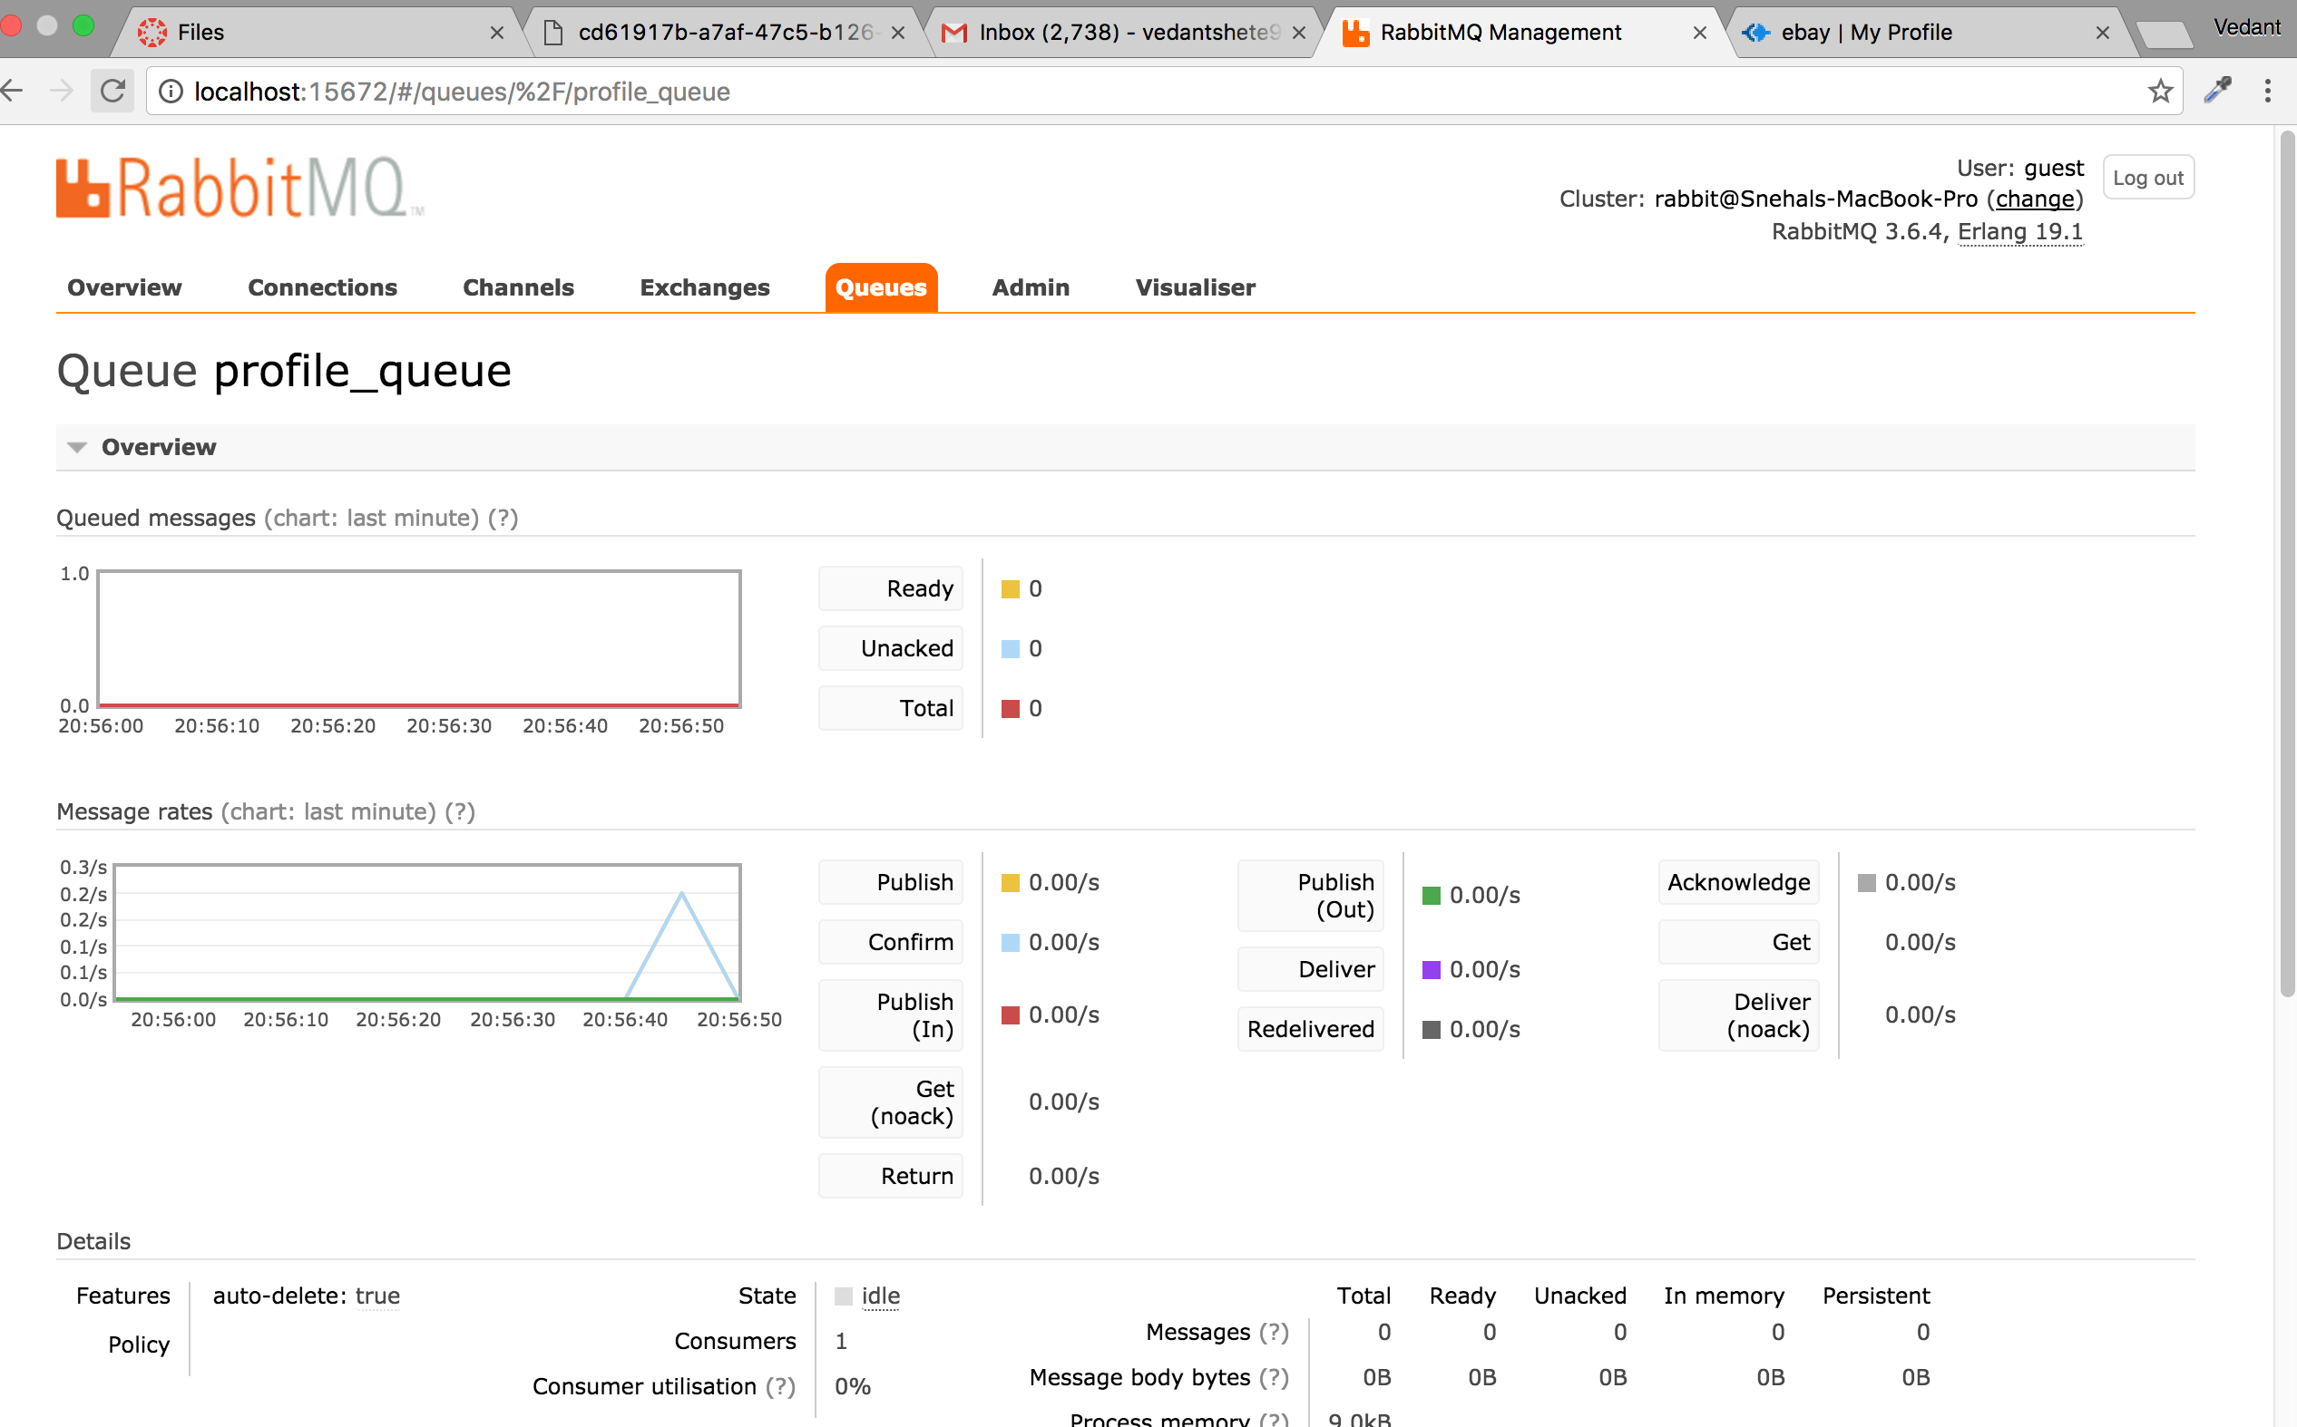

And also the advertisements posted by them

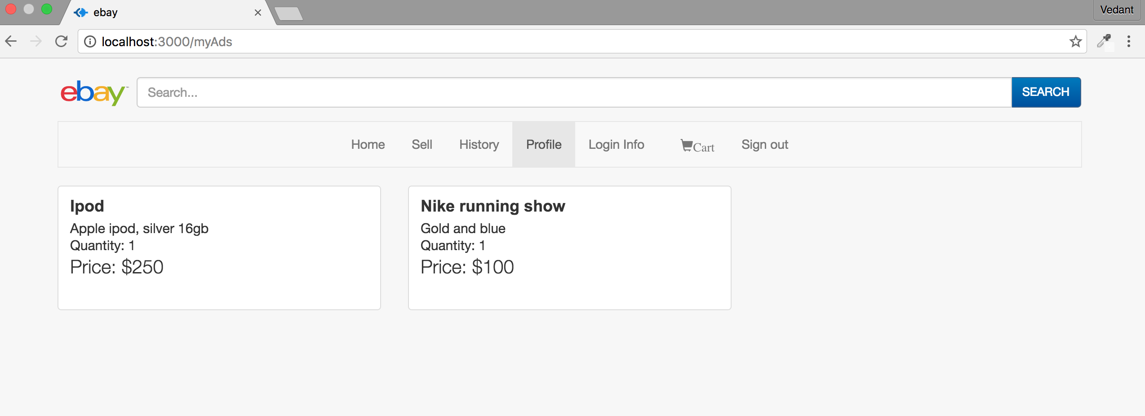

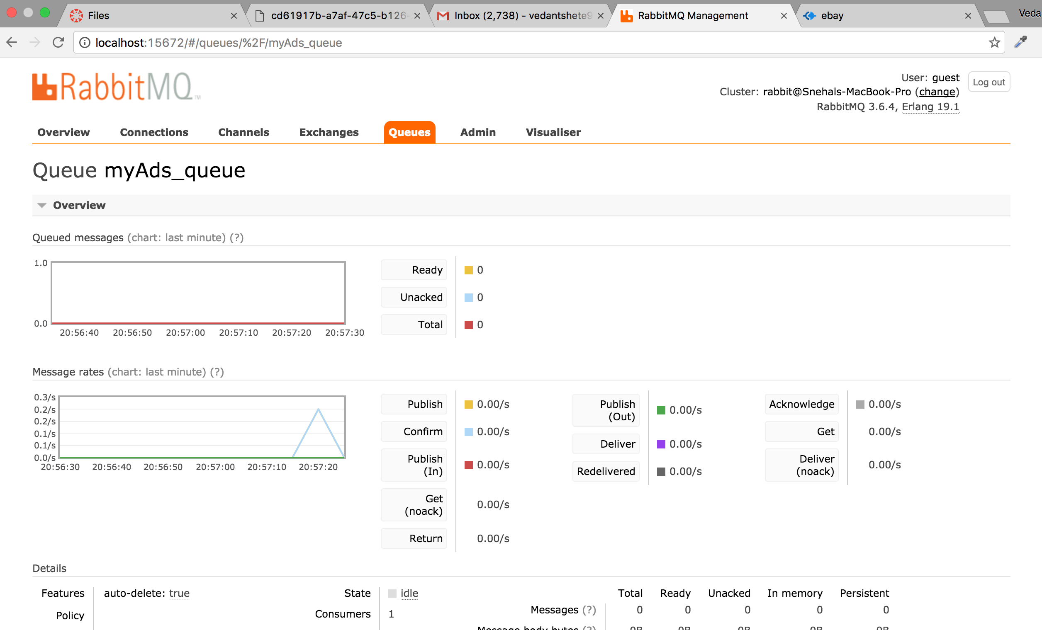

In the history tab, the user can see the products that they have bought and the products that they have sold

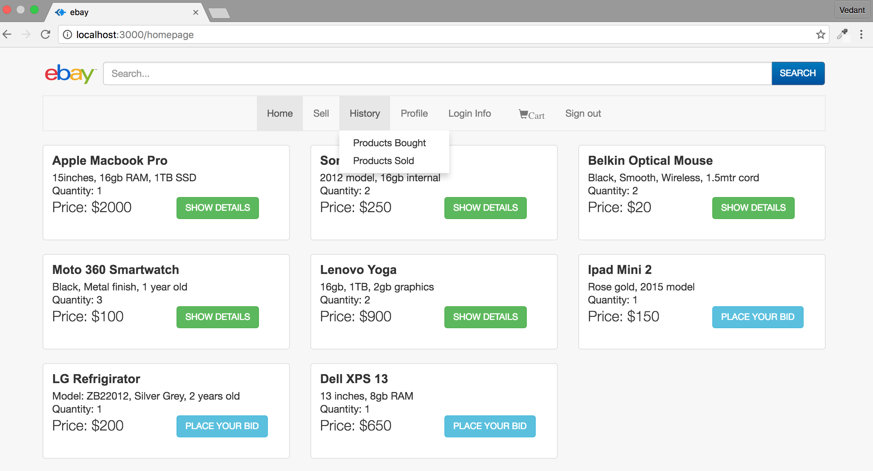

Product bought page

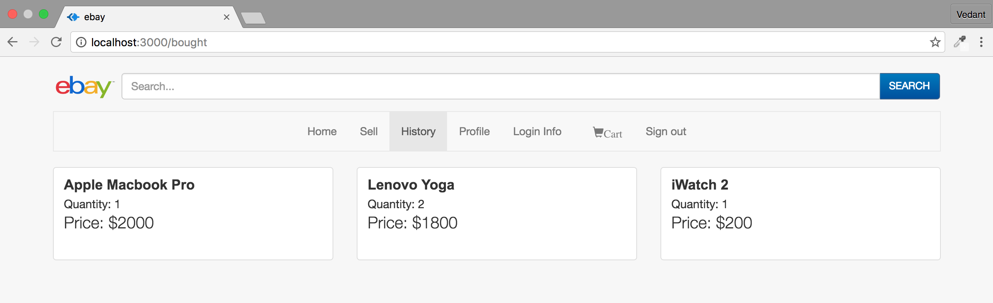

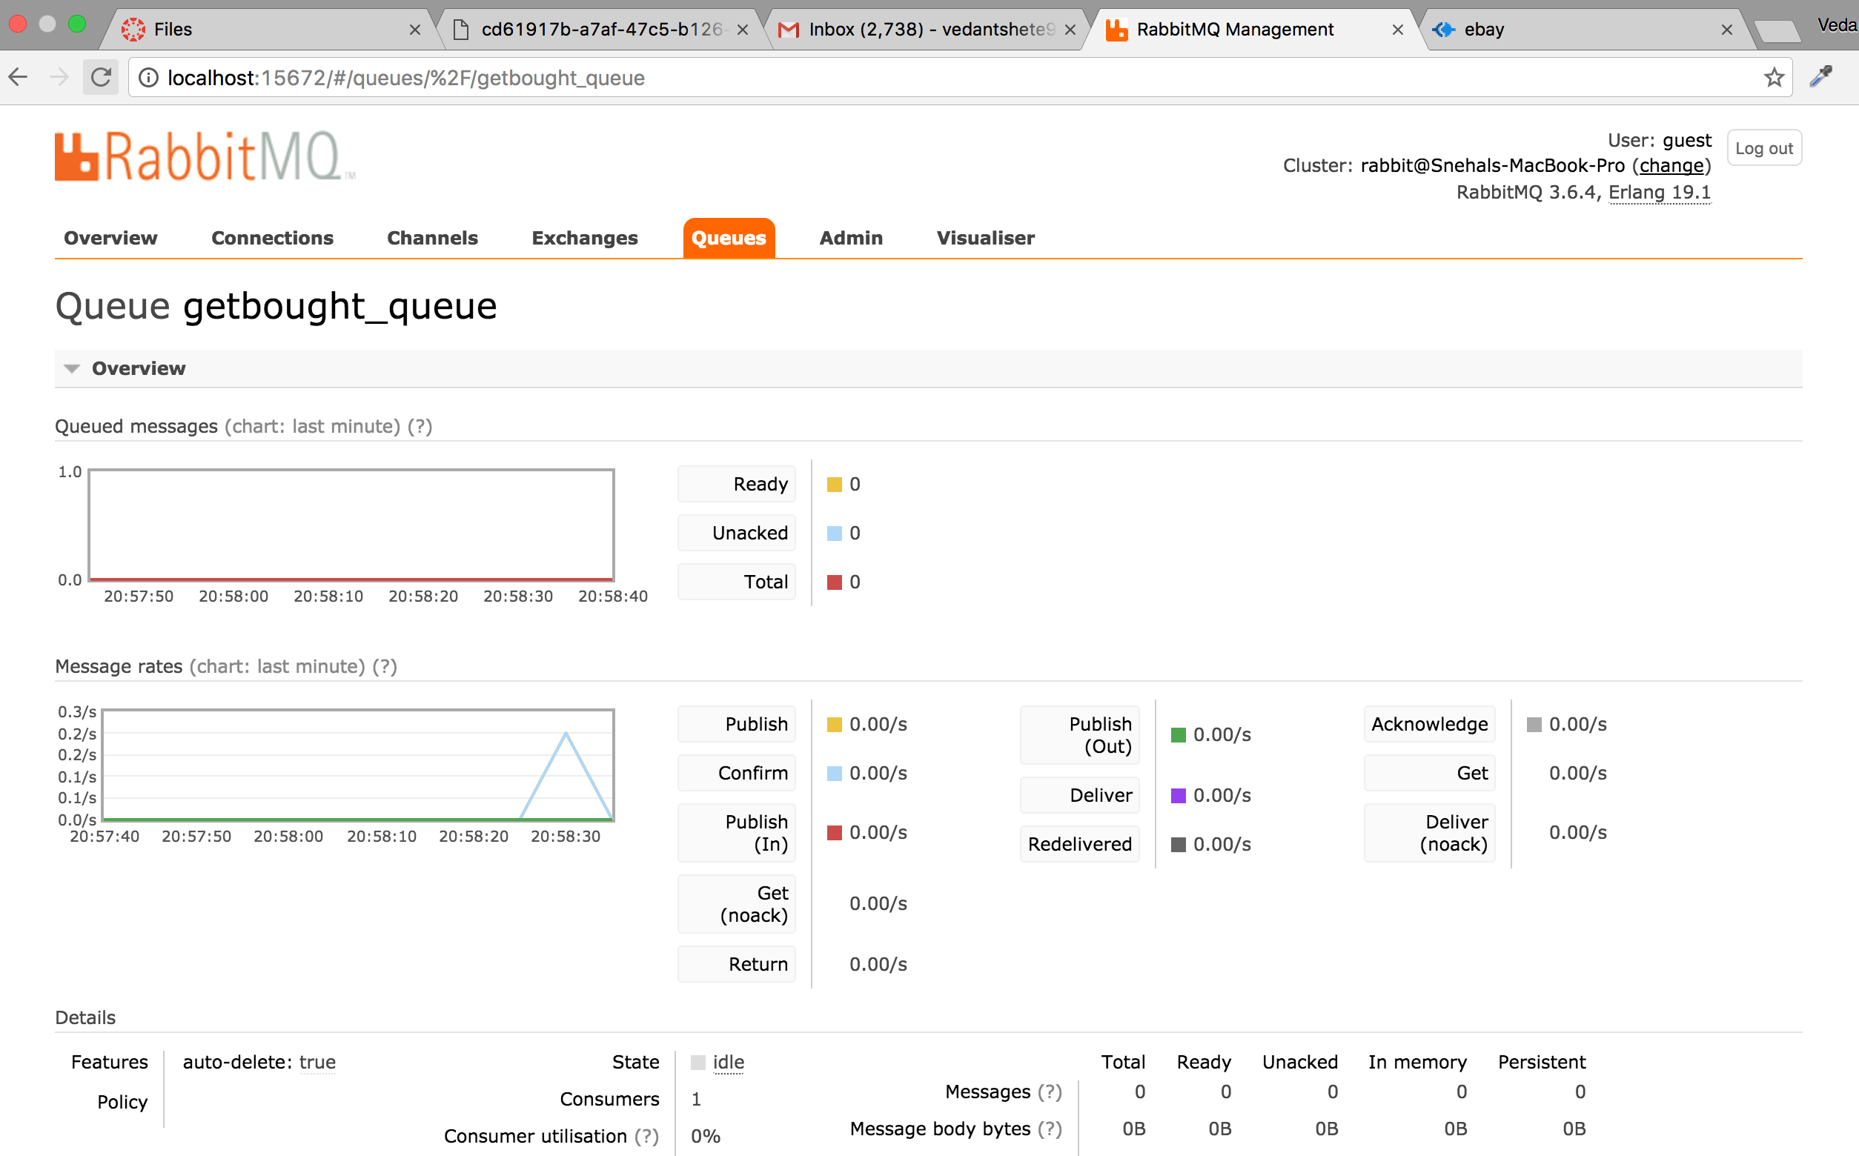

(Login using some other user) Other user can see the ads posted by someother users(Ipod, for selling, and Nike running shoe, for bidding)

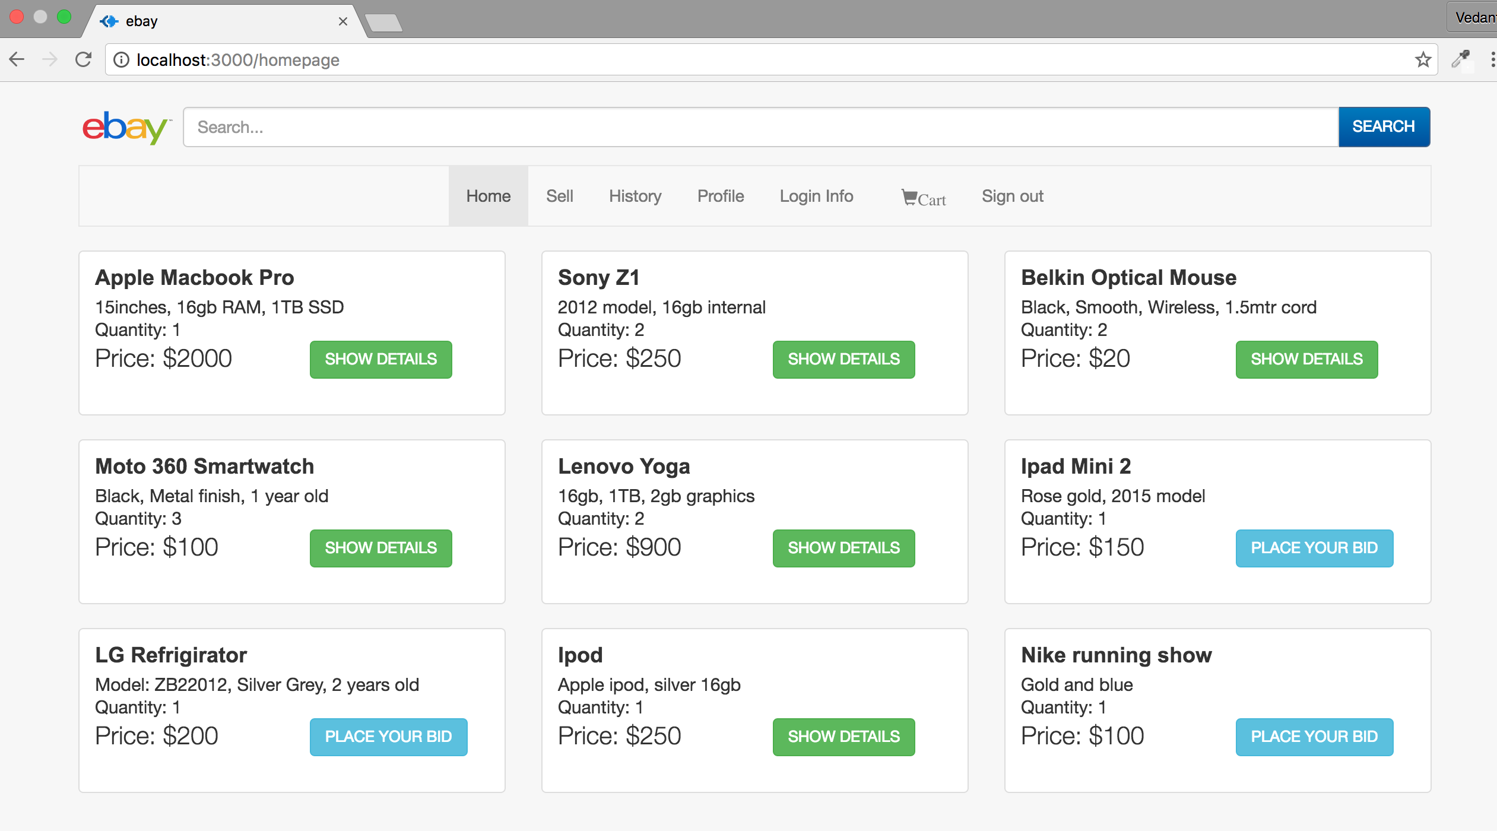

Now if this user buys the Ipod, the Ipod item can be seen in “History->Sold” tab of his account

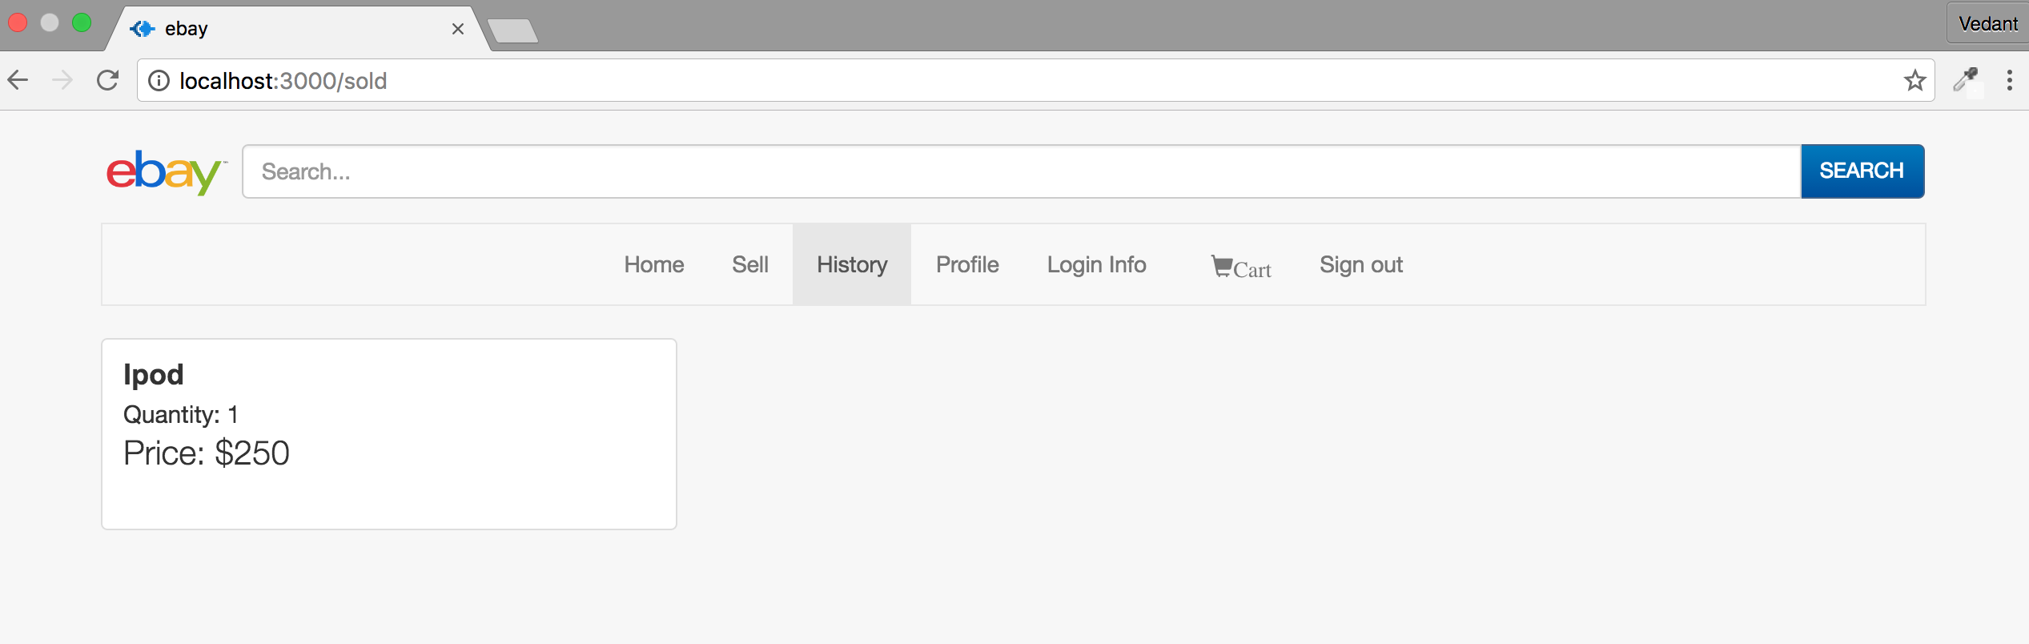

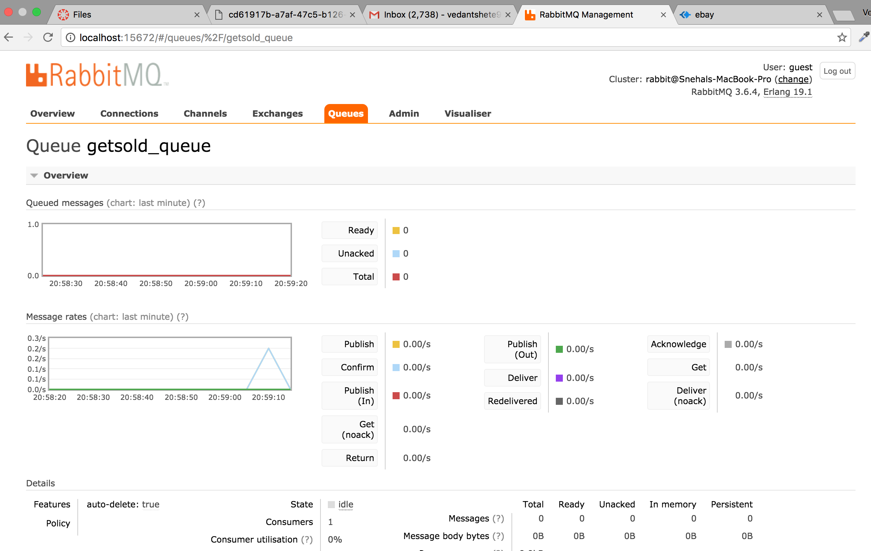

User can see their last login in “Login info” page

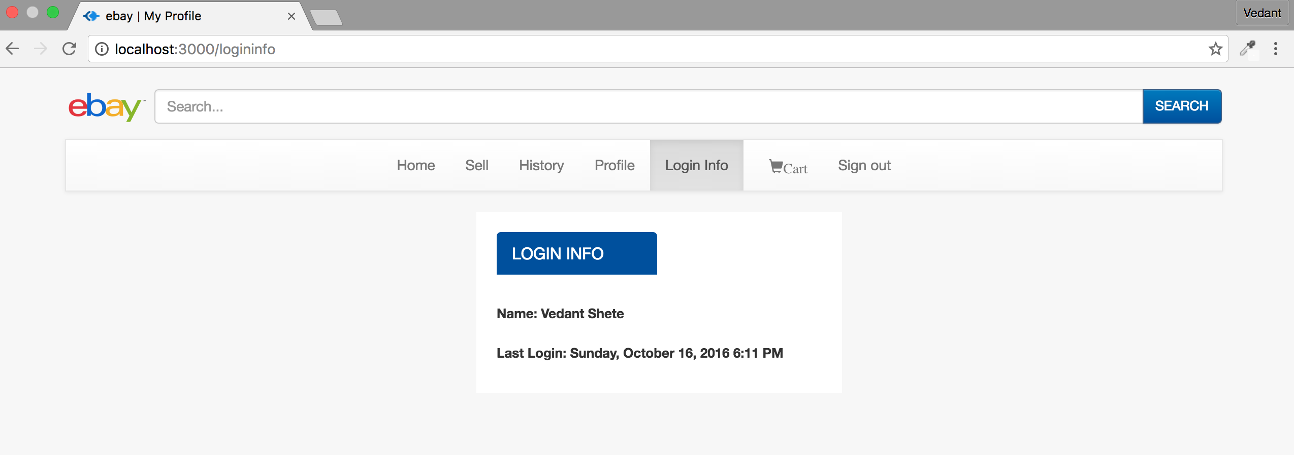

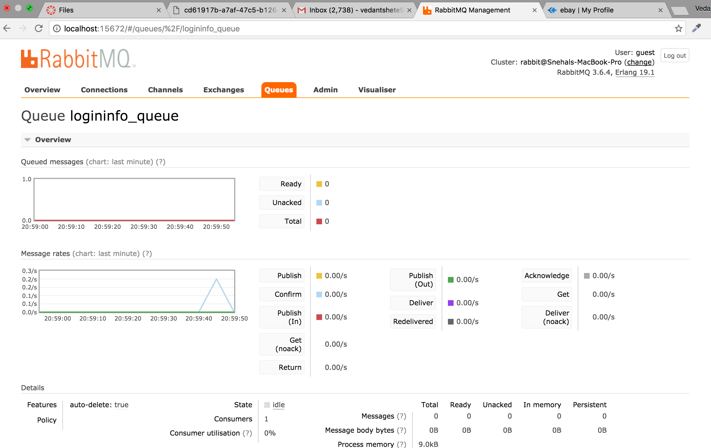

On clicking on sign out, user is brought back to the signin page and the session is destroyed

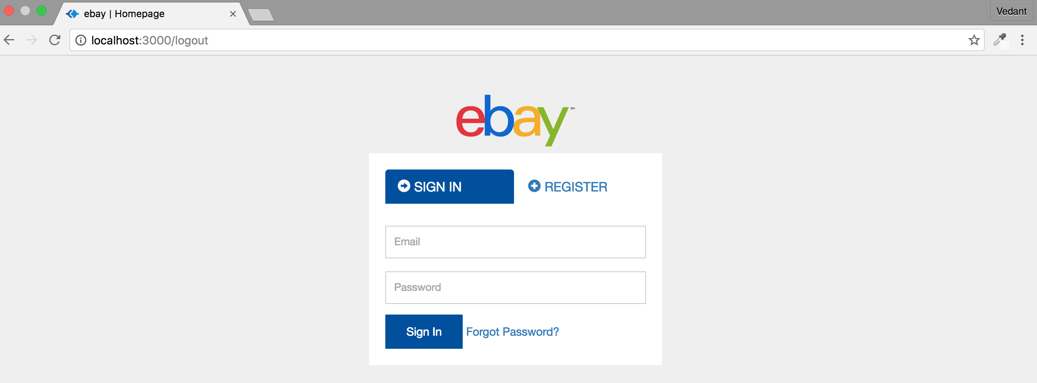

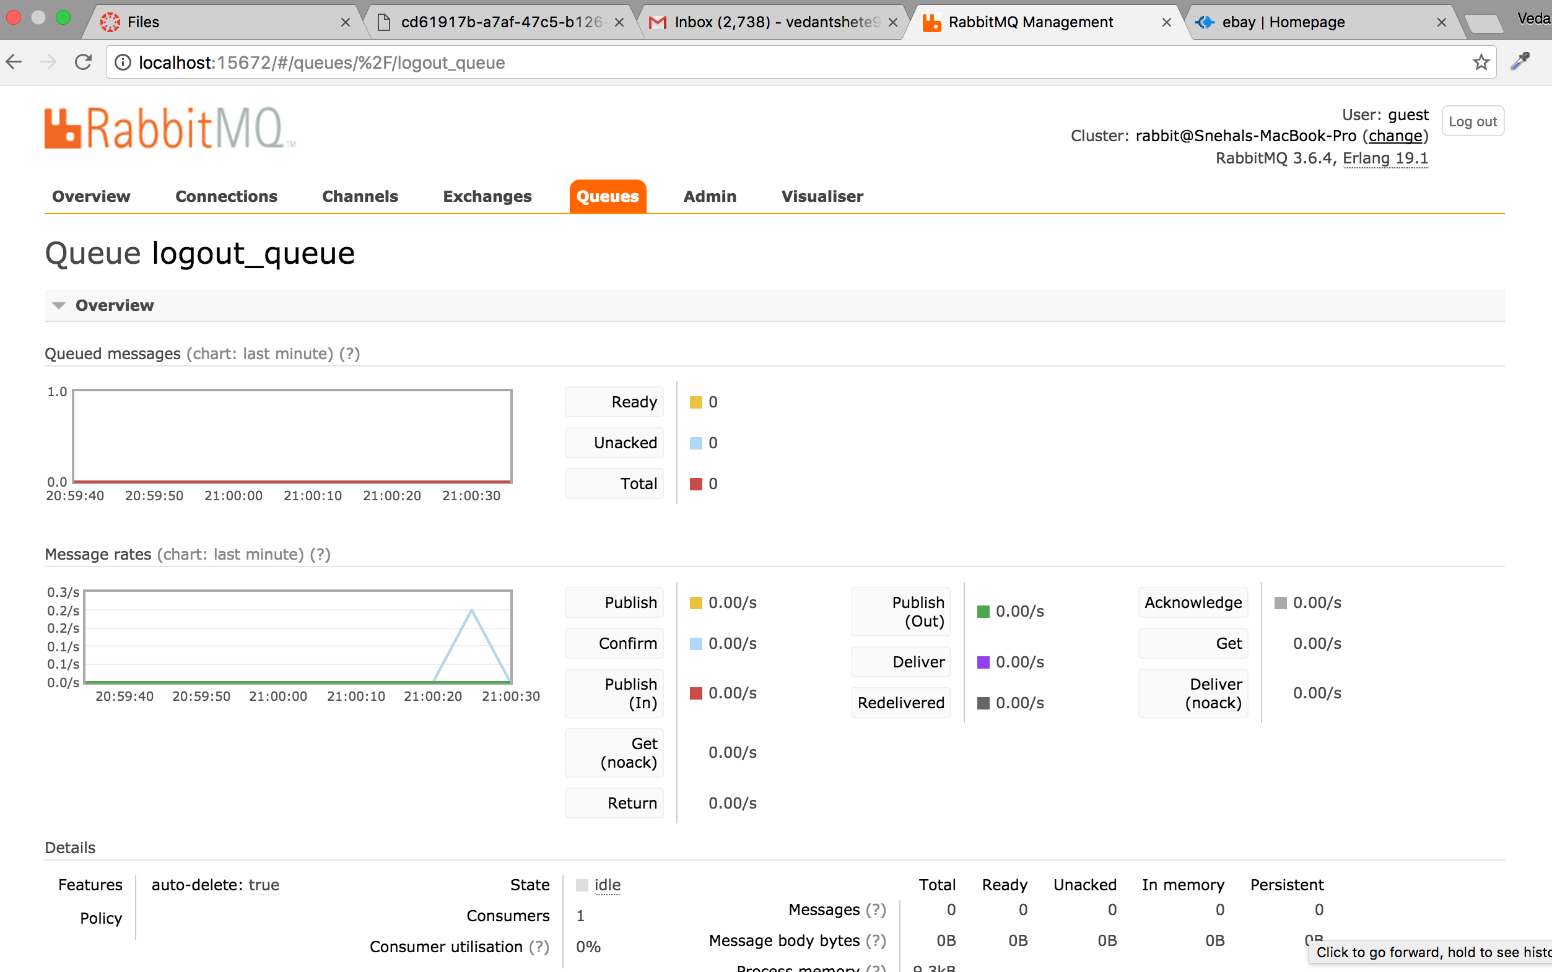

**(Note:Log files are inside the source code folder)**

JMeter:

**Without Connection pool:**

100 concurrent users

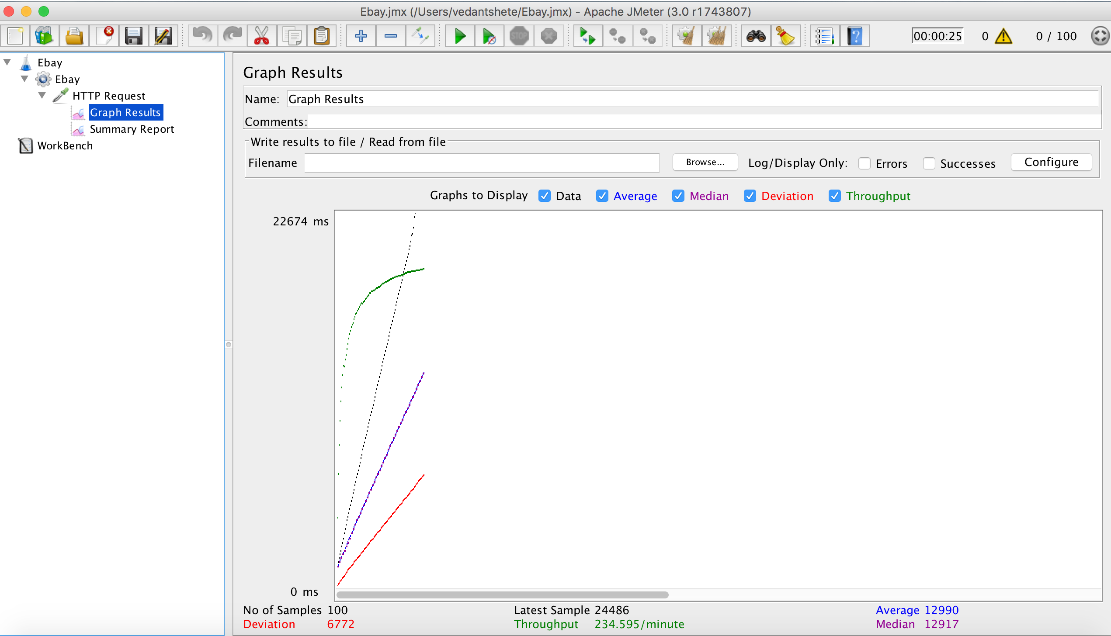

200 concurrent users

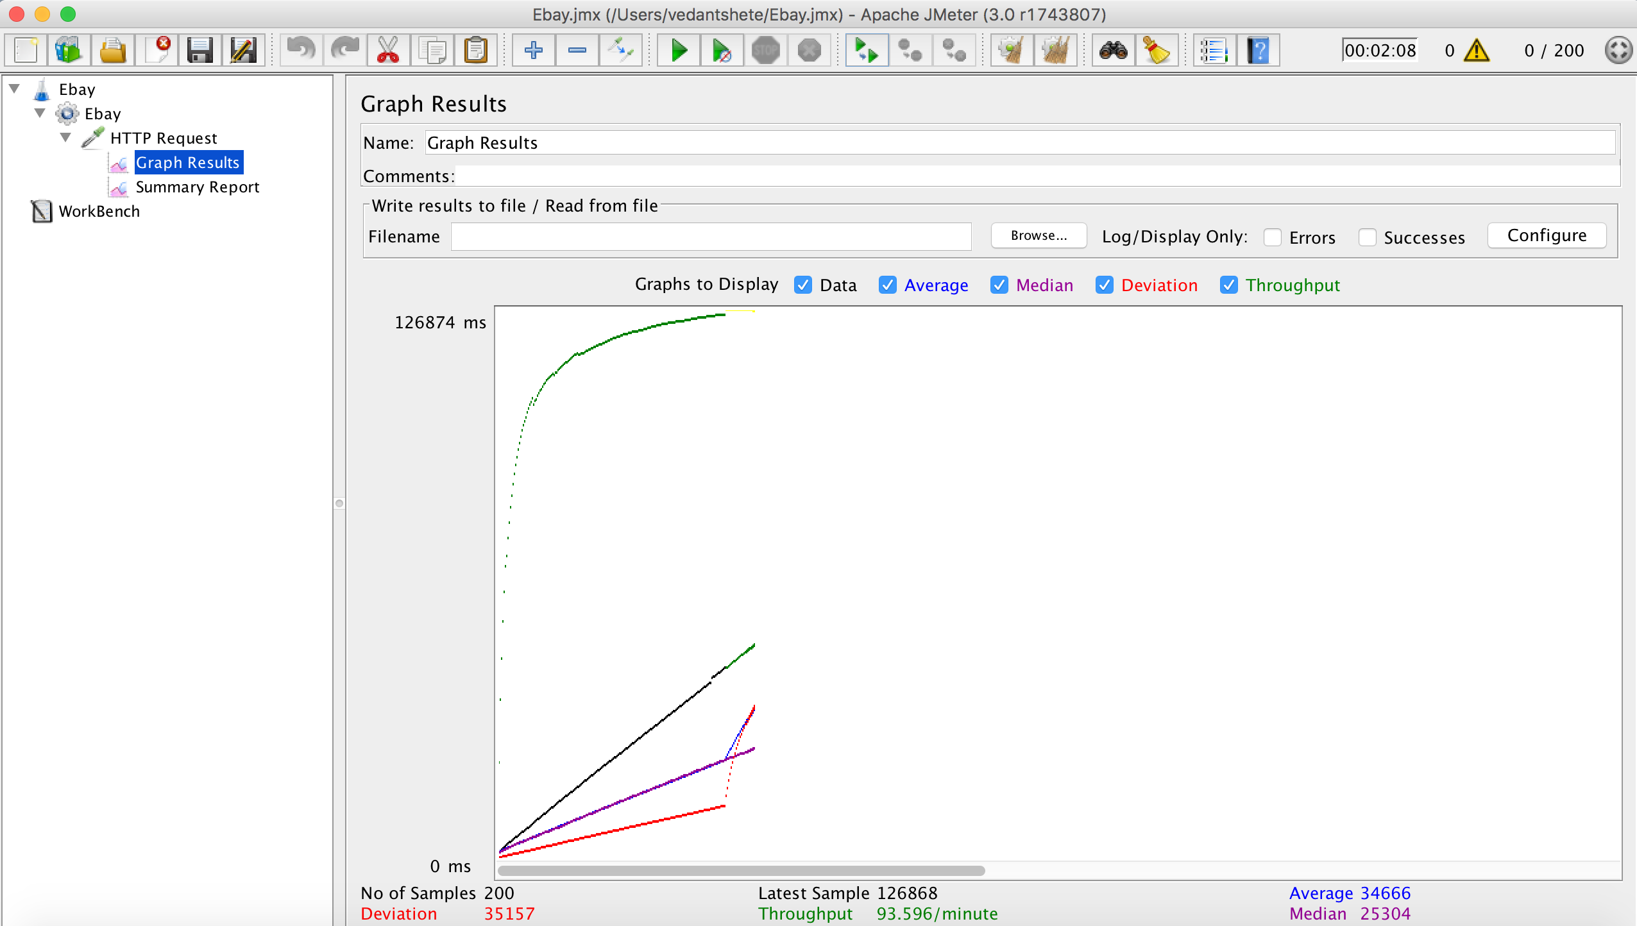

300 concurrent users

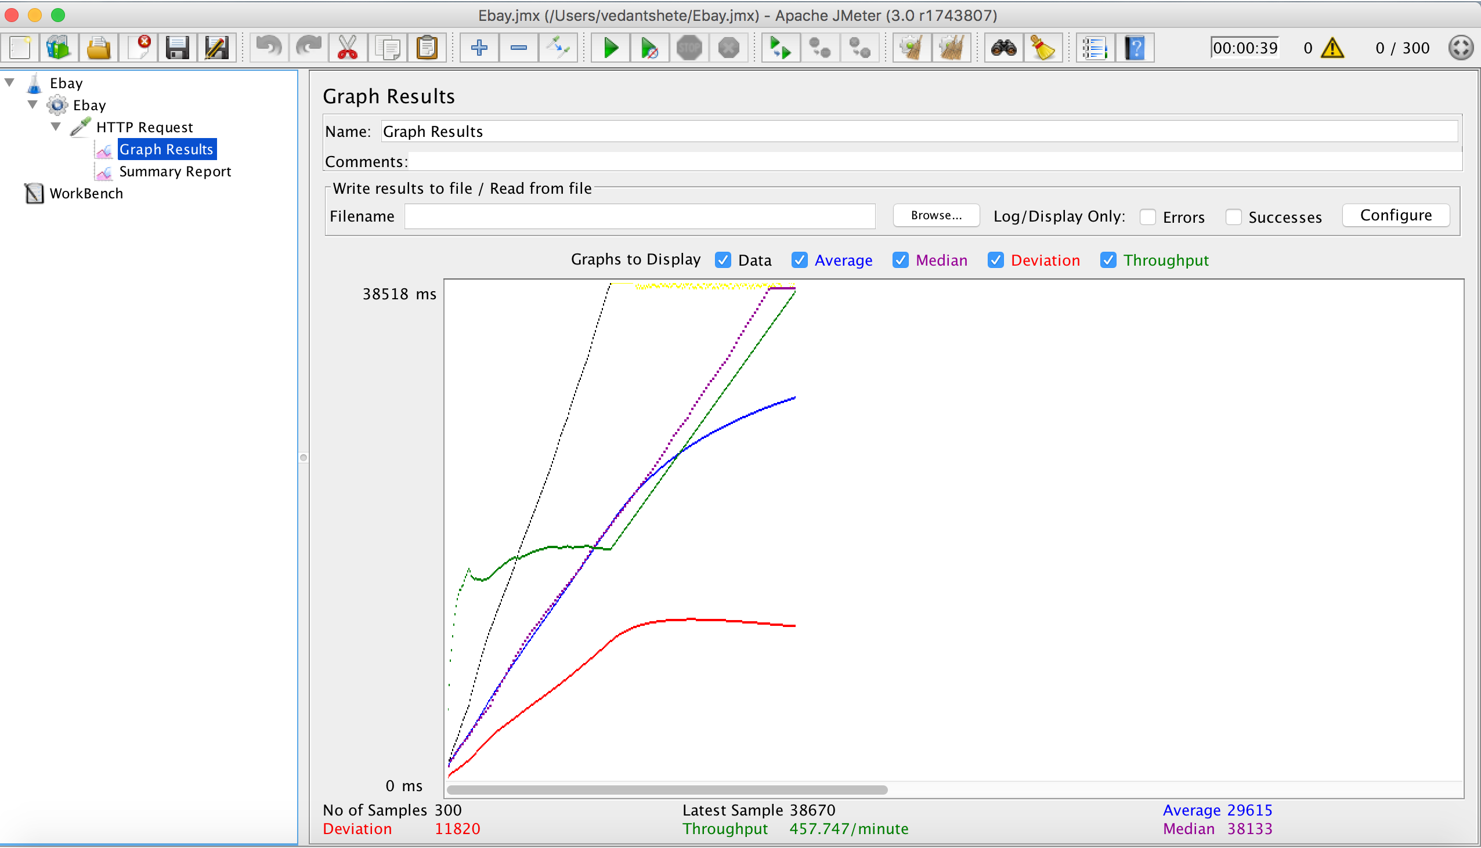

400 concurrent users

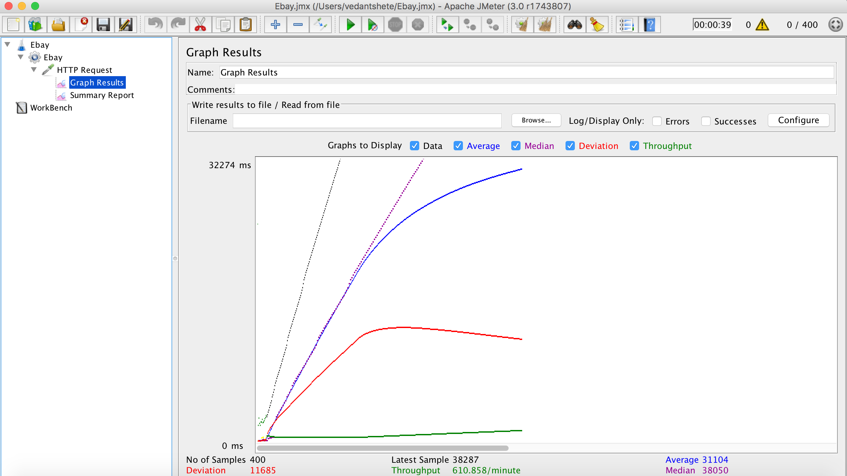

500 concurrent users

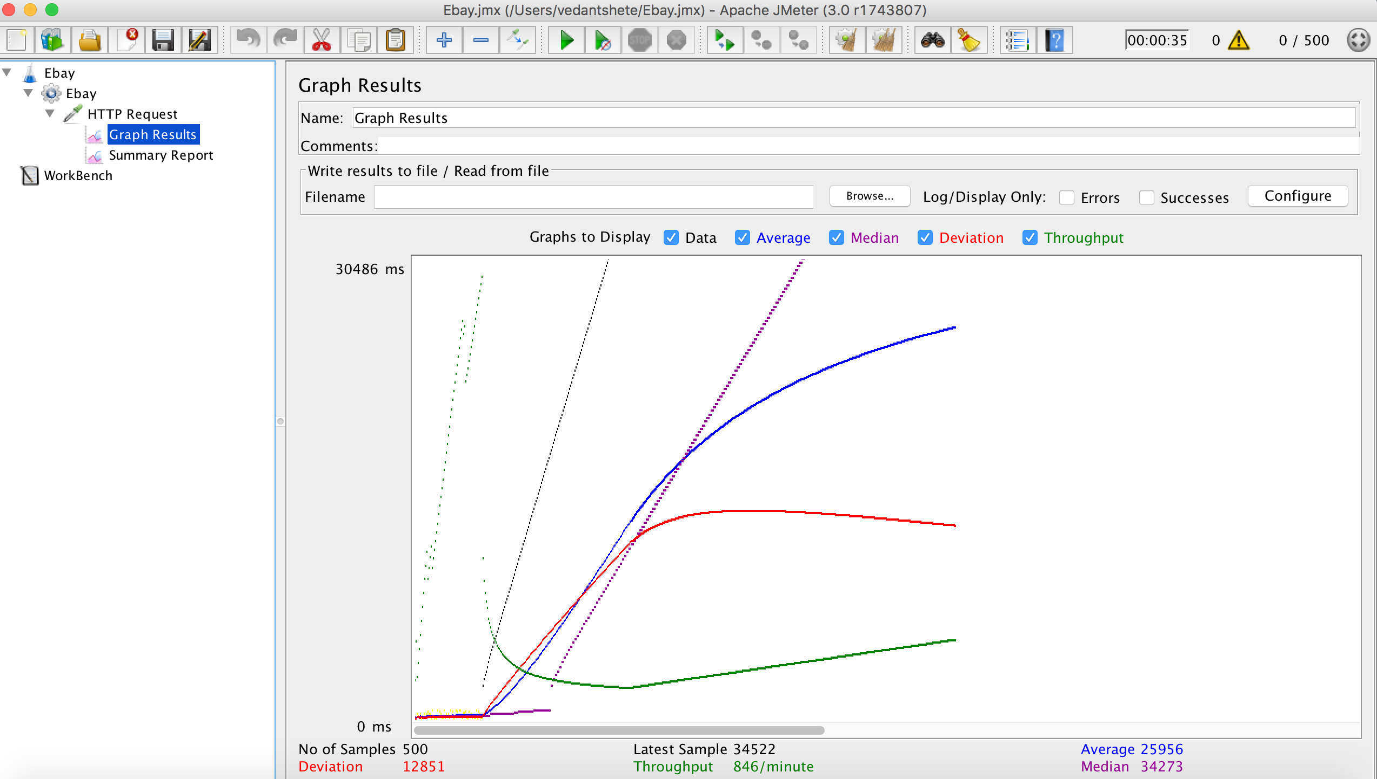

**With connection pool:**

100 concurrent users

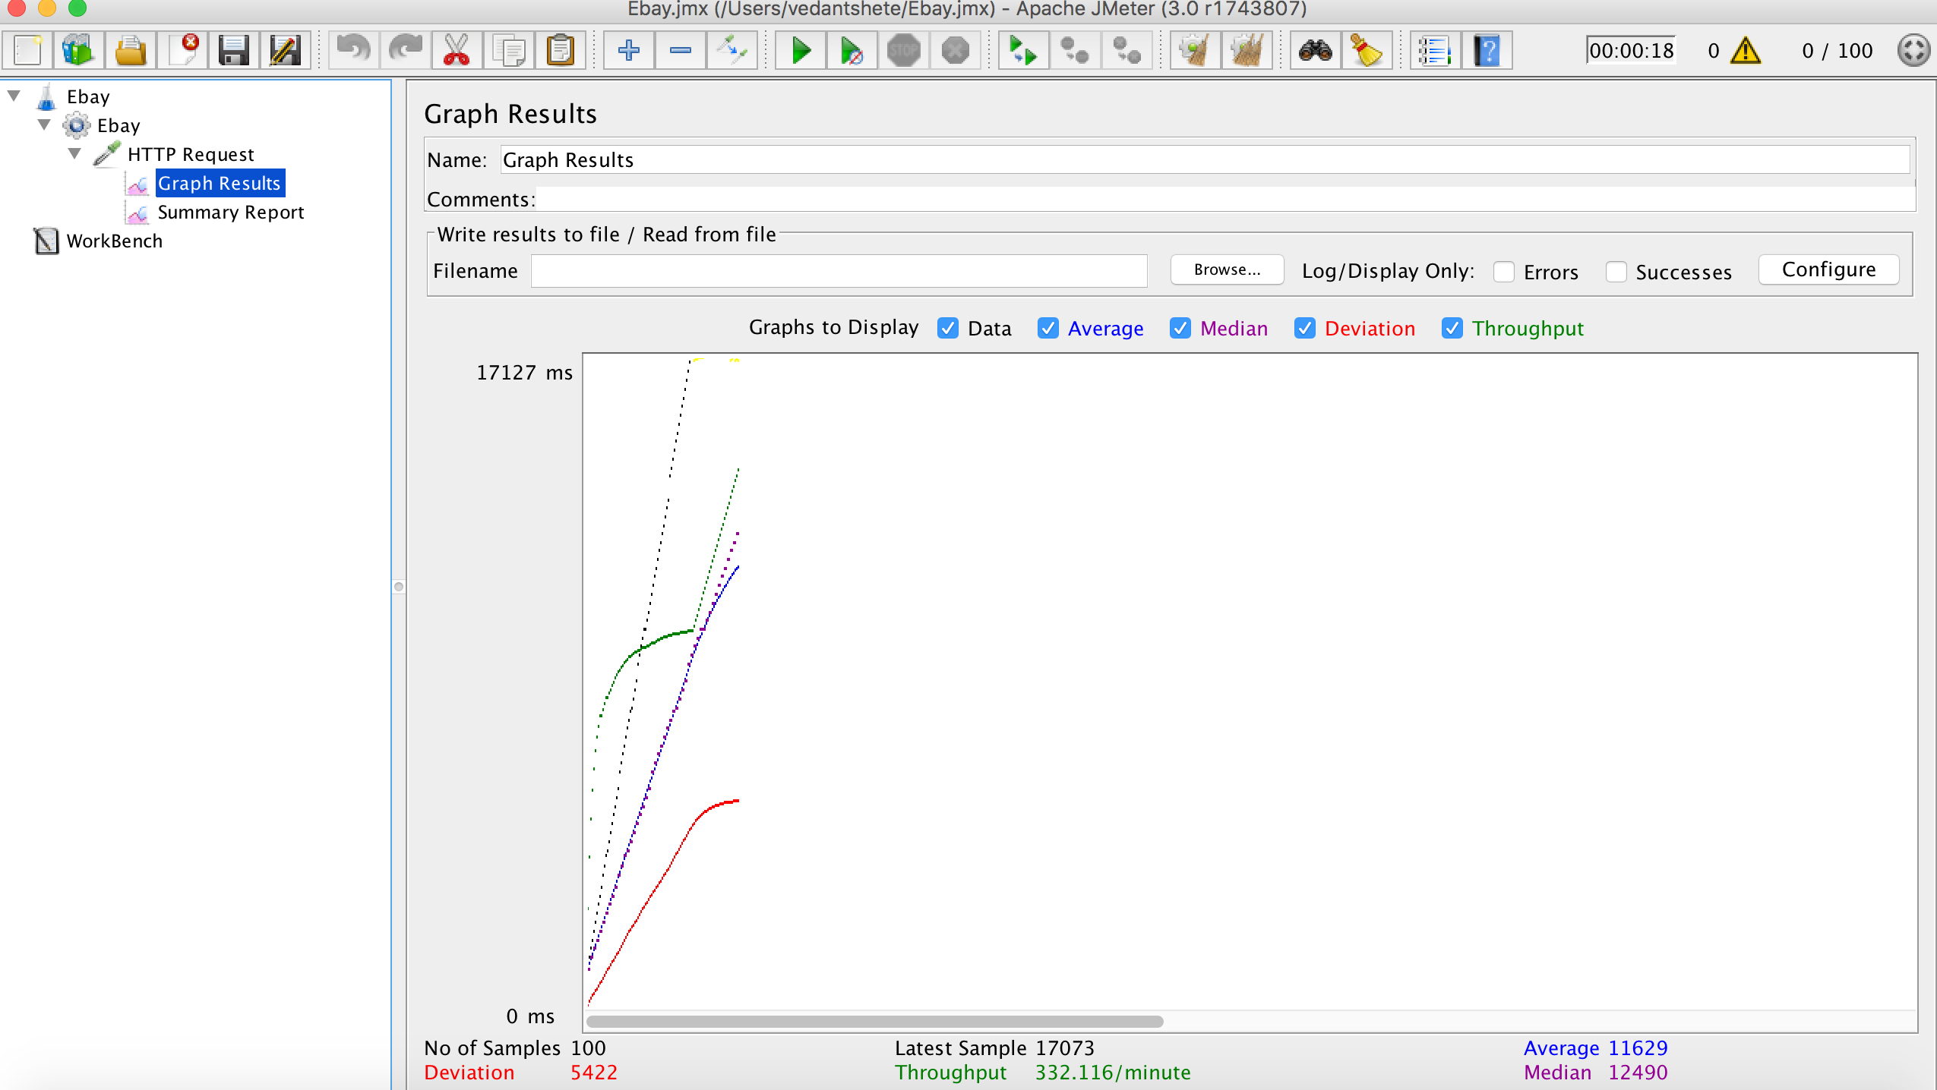

200 concurrent users

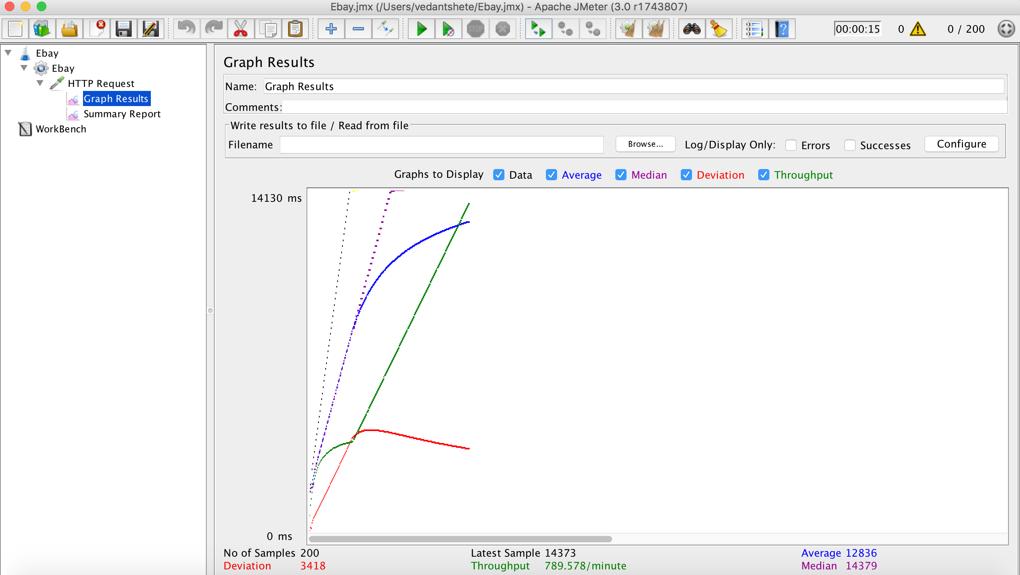

300 concurrent users

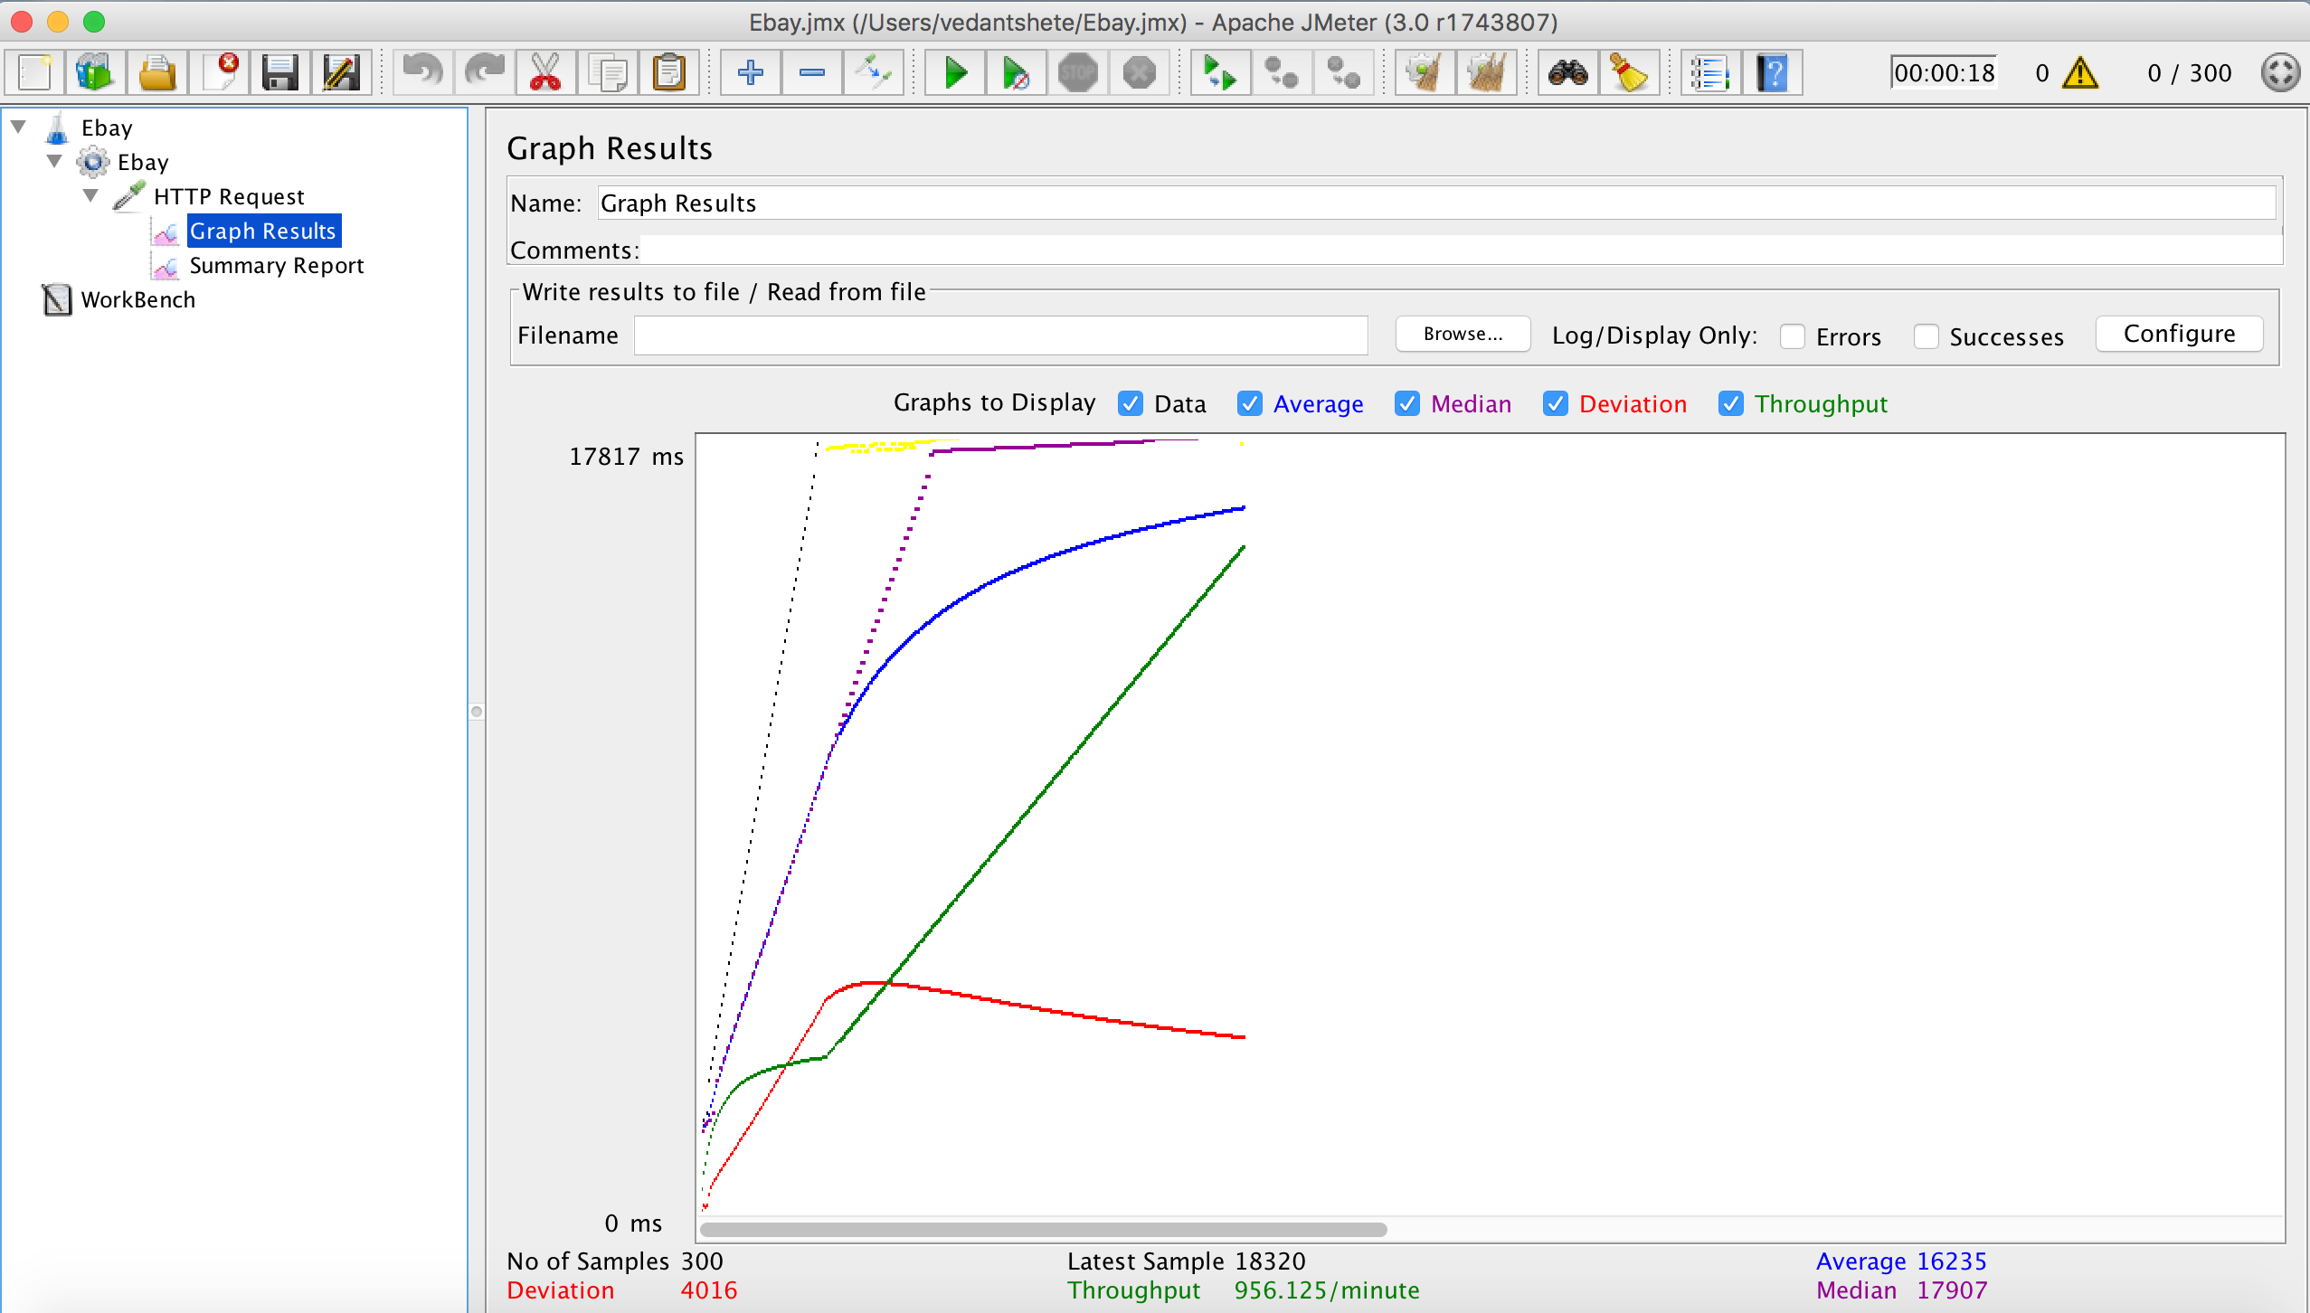

400 concurrent users

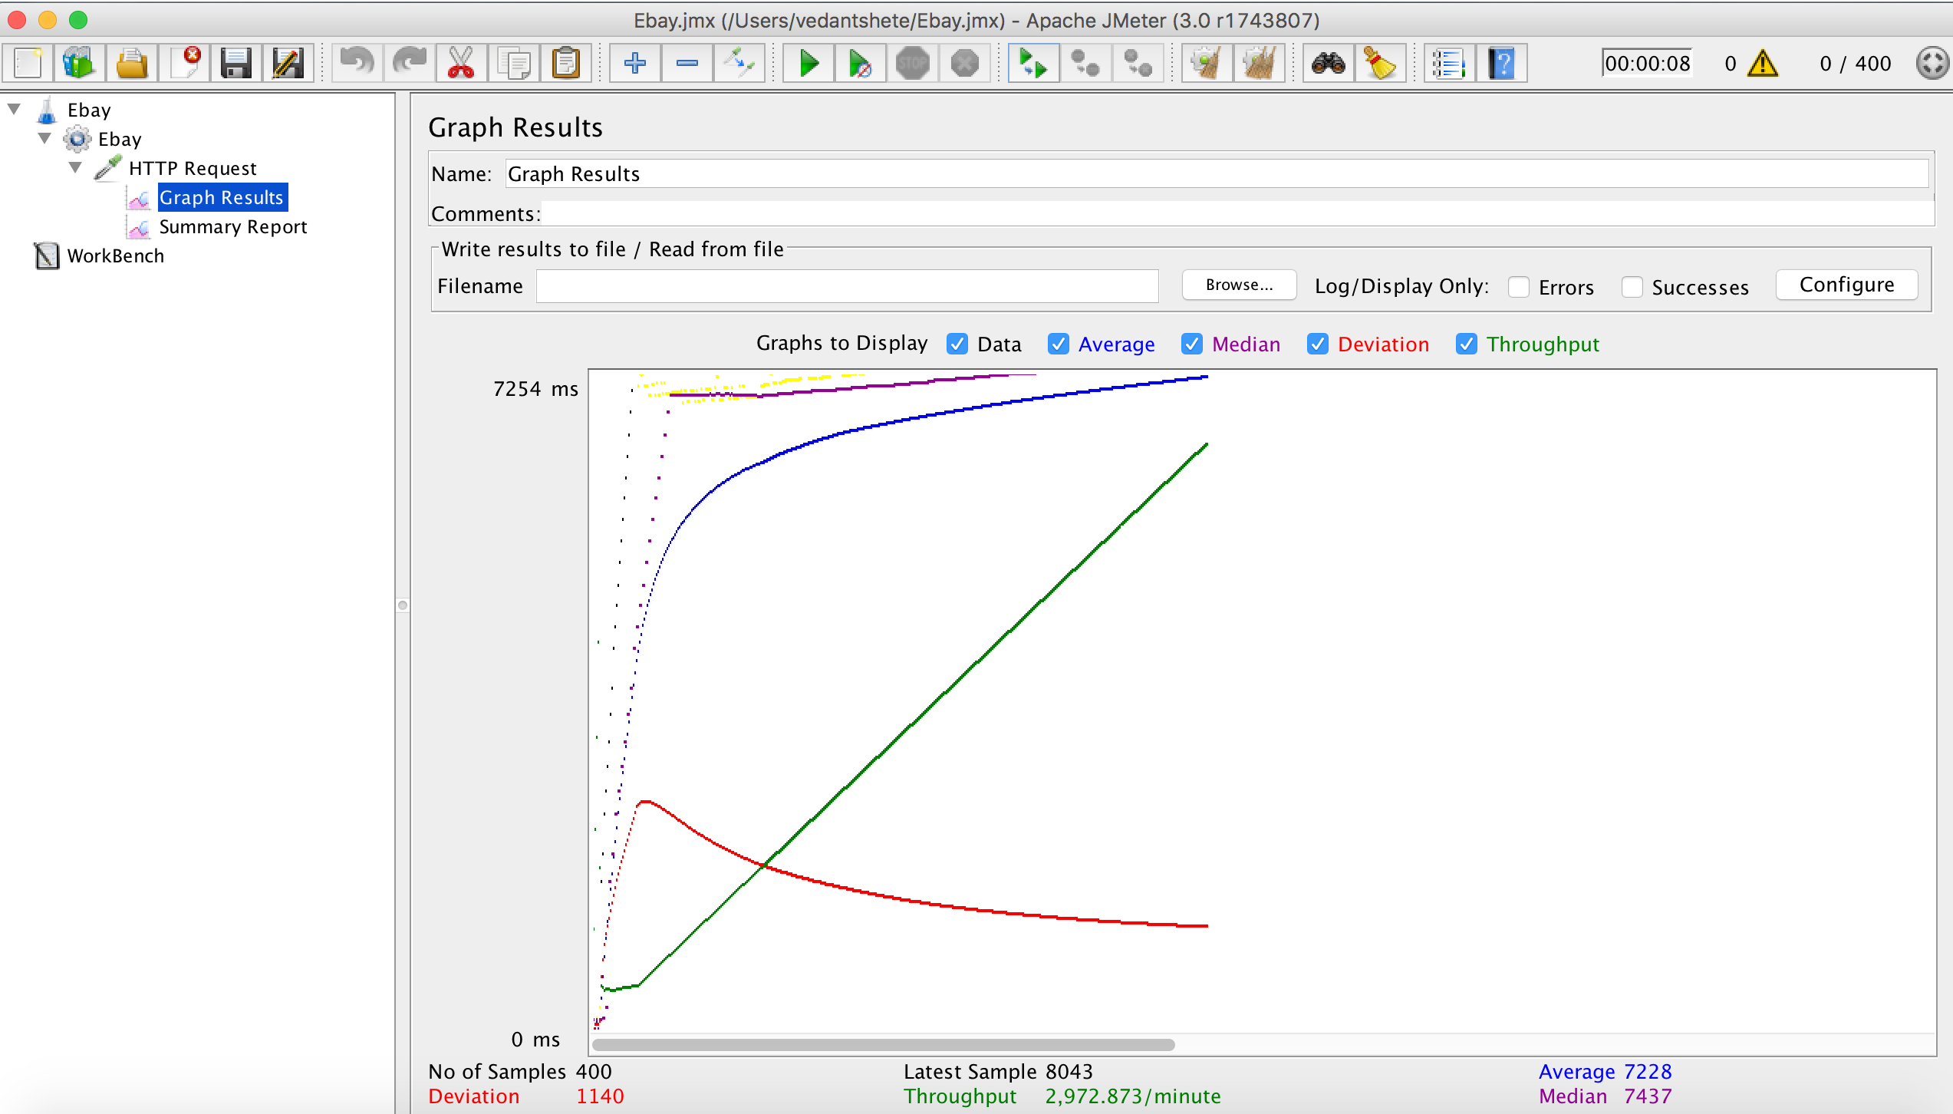

500 concurrent users

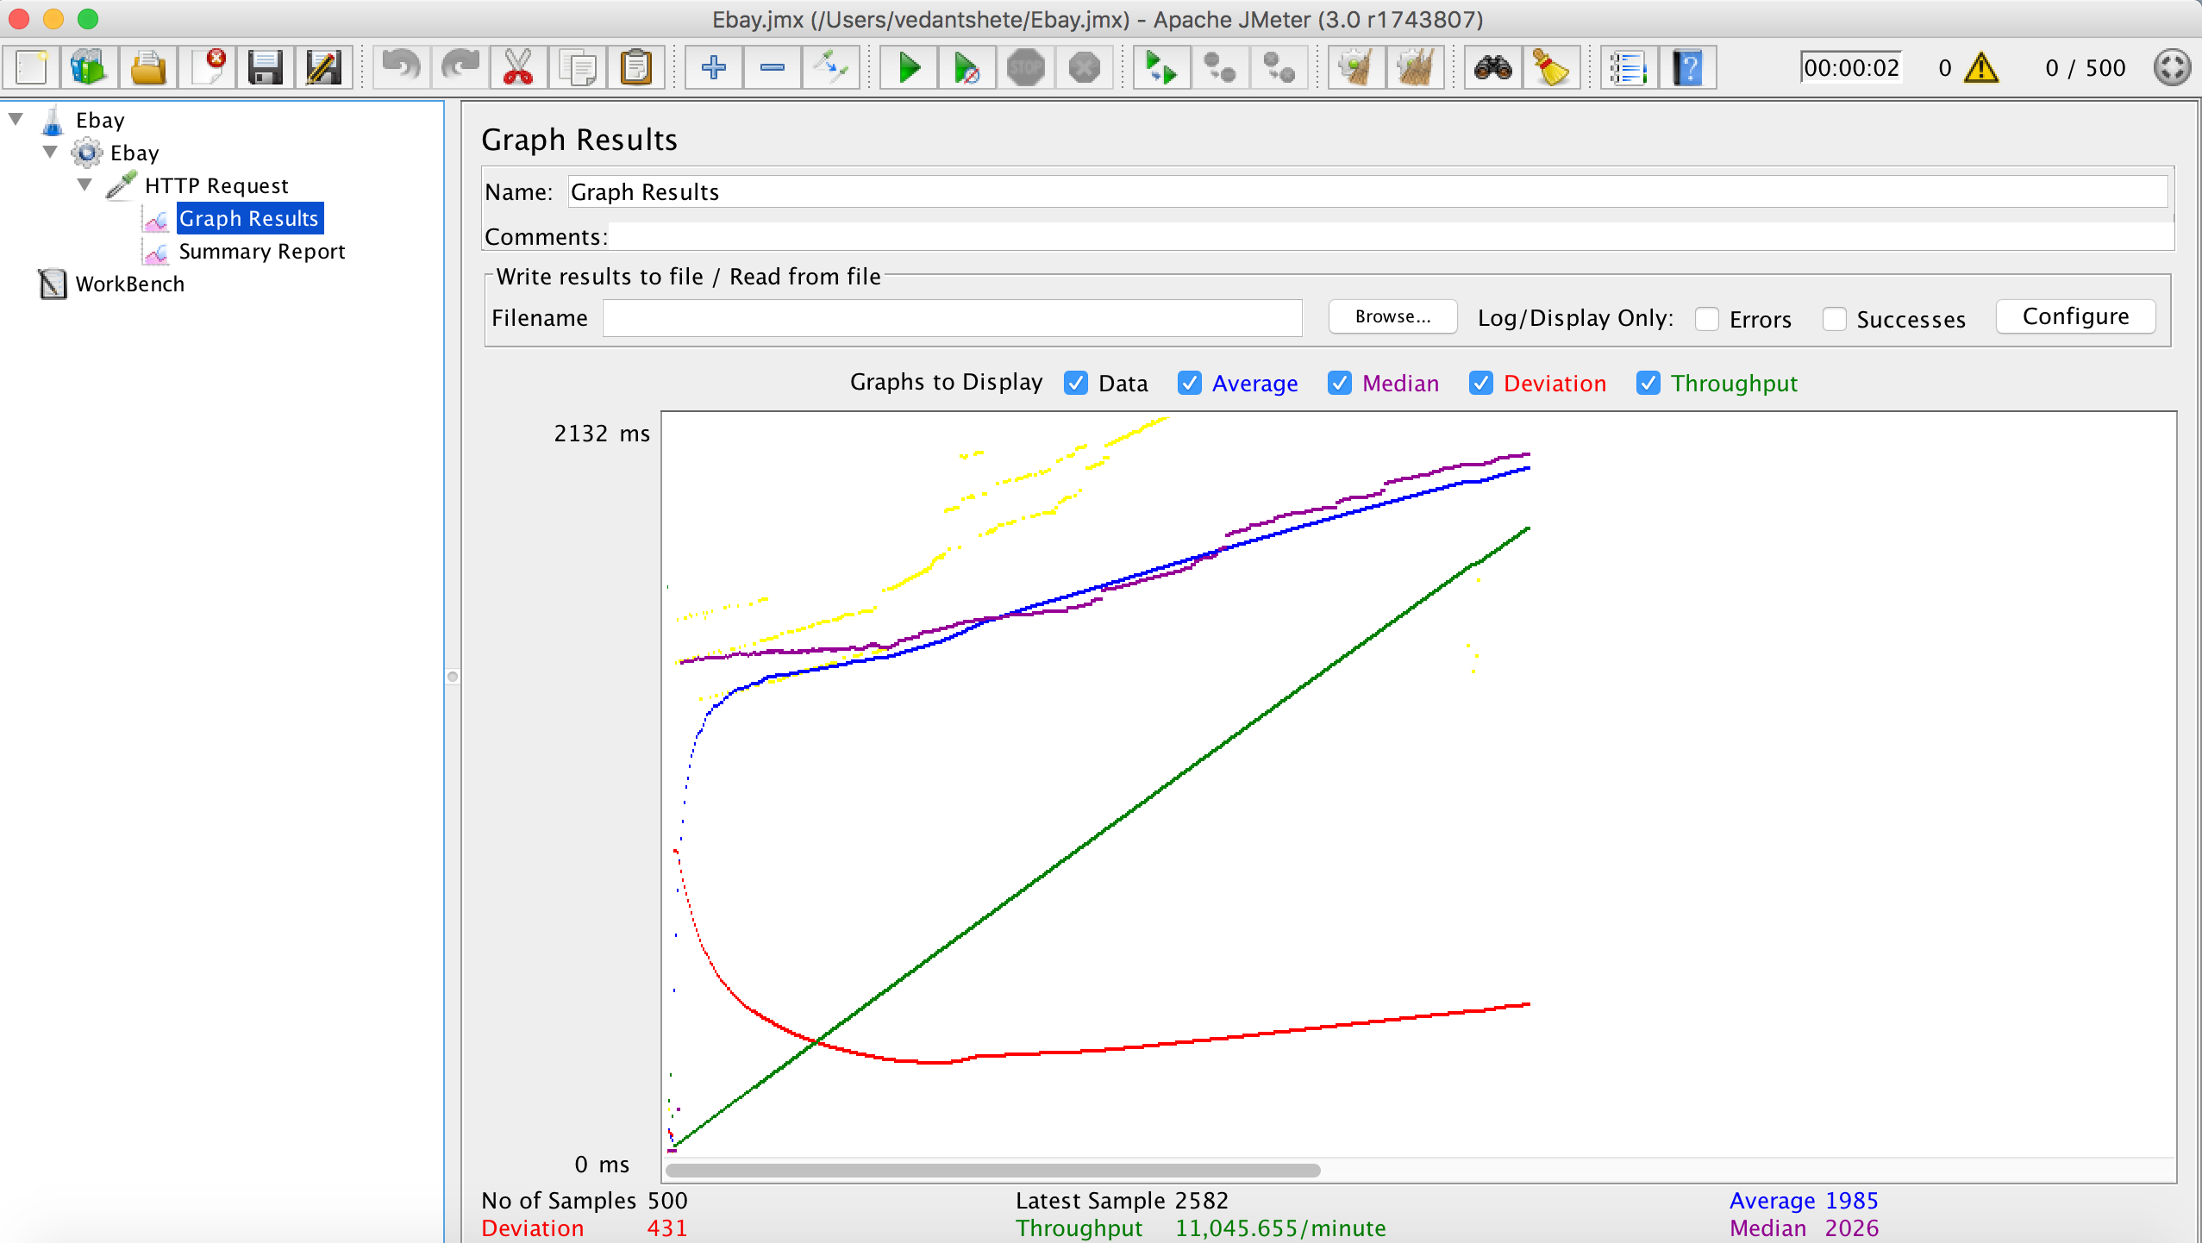

Comparison Performance graphs

So as the graph shows, if we don’t implement connection pooling then the average time for request and response increases. When a large number of users are requesting for resource from the server connection pooling helps to a great extent as it saves the time required for creation of connection threads. Moreover, it can reuse the already created connection threads. Therefore, the process of creating the connection is not required to some extent.

I have kept the pool length as 50. When a new connection is needed it will simply

borrow the connection from the pool and release as soon as it’s work gets completed.

**Without RabbitMQ:**

100 concurrent users

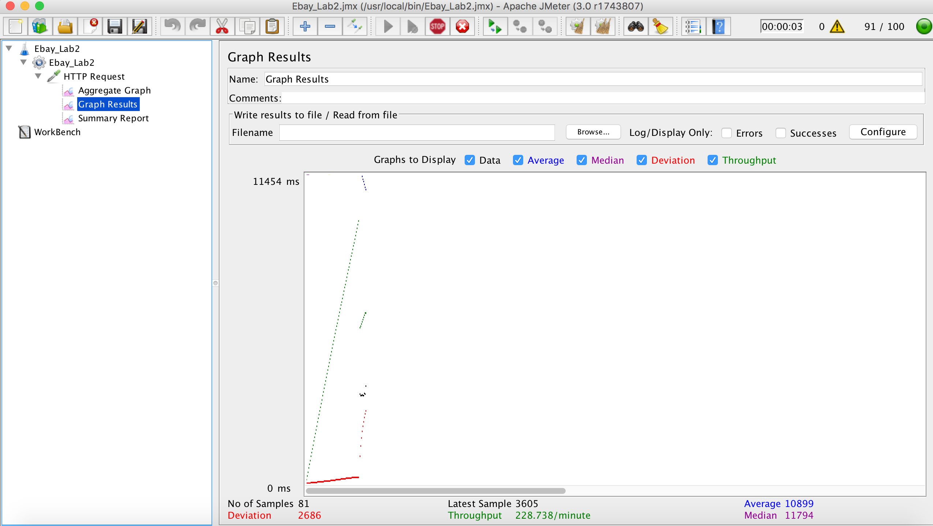

200 concurrent users

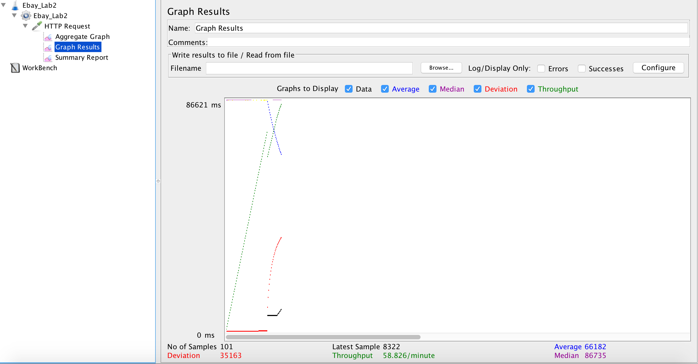

300 concurrent users

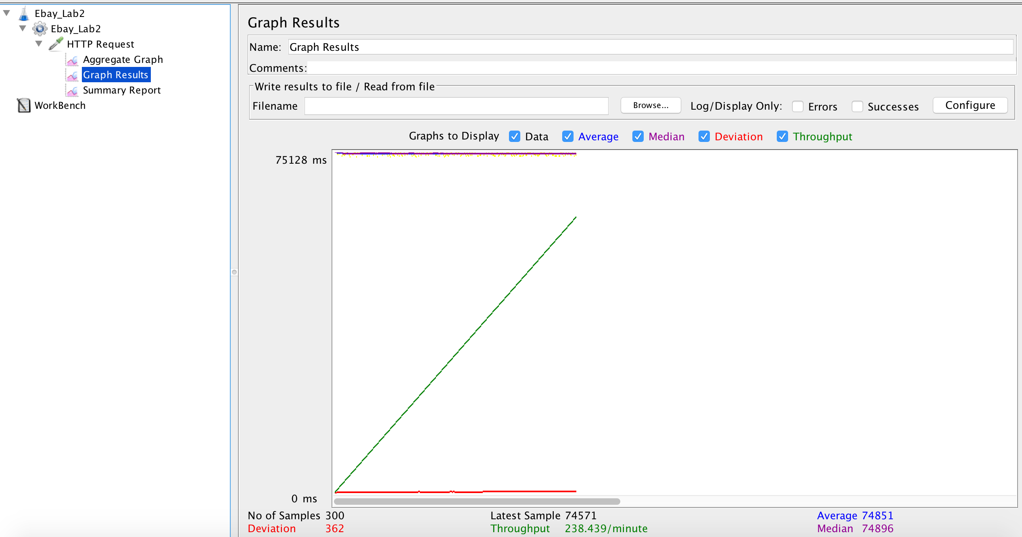

400 concurrent users

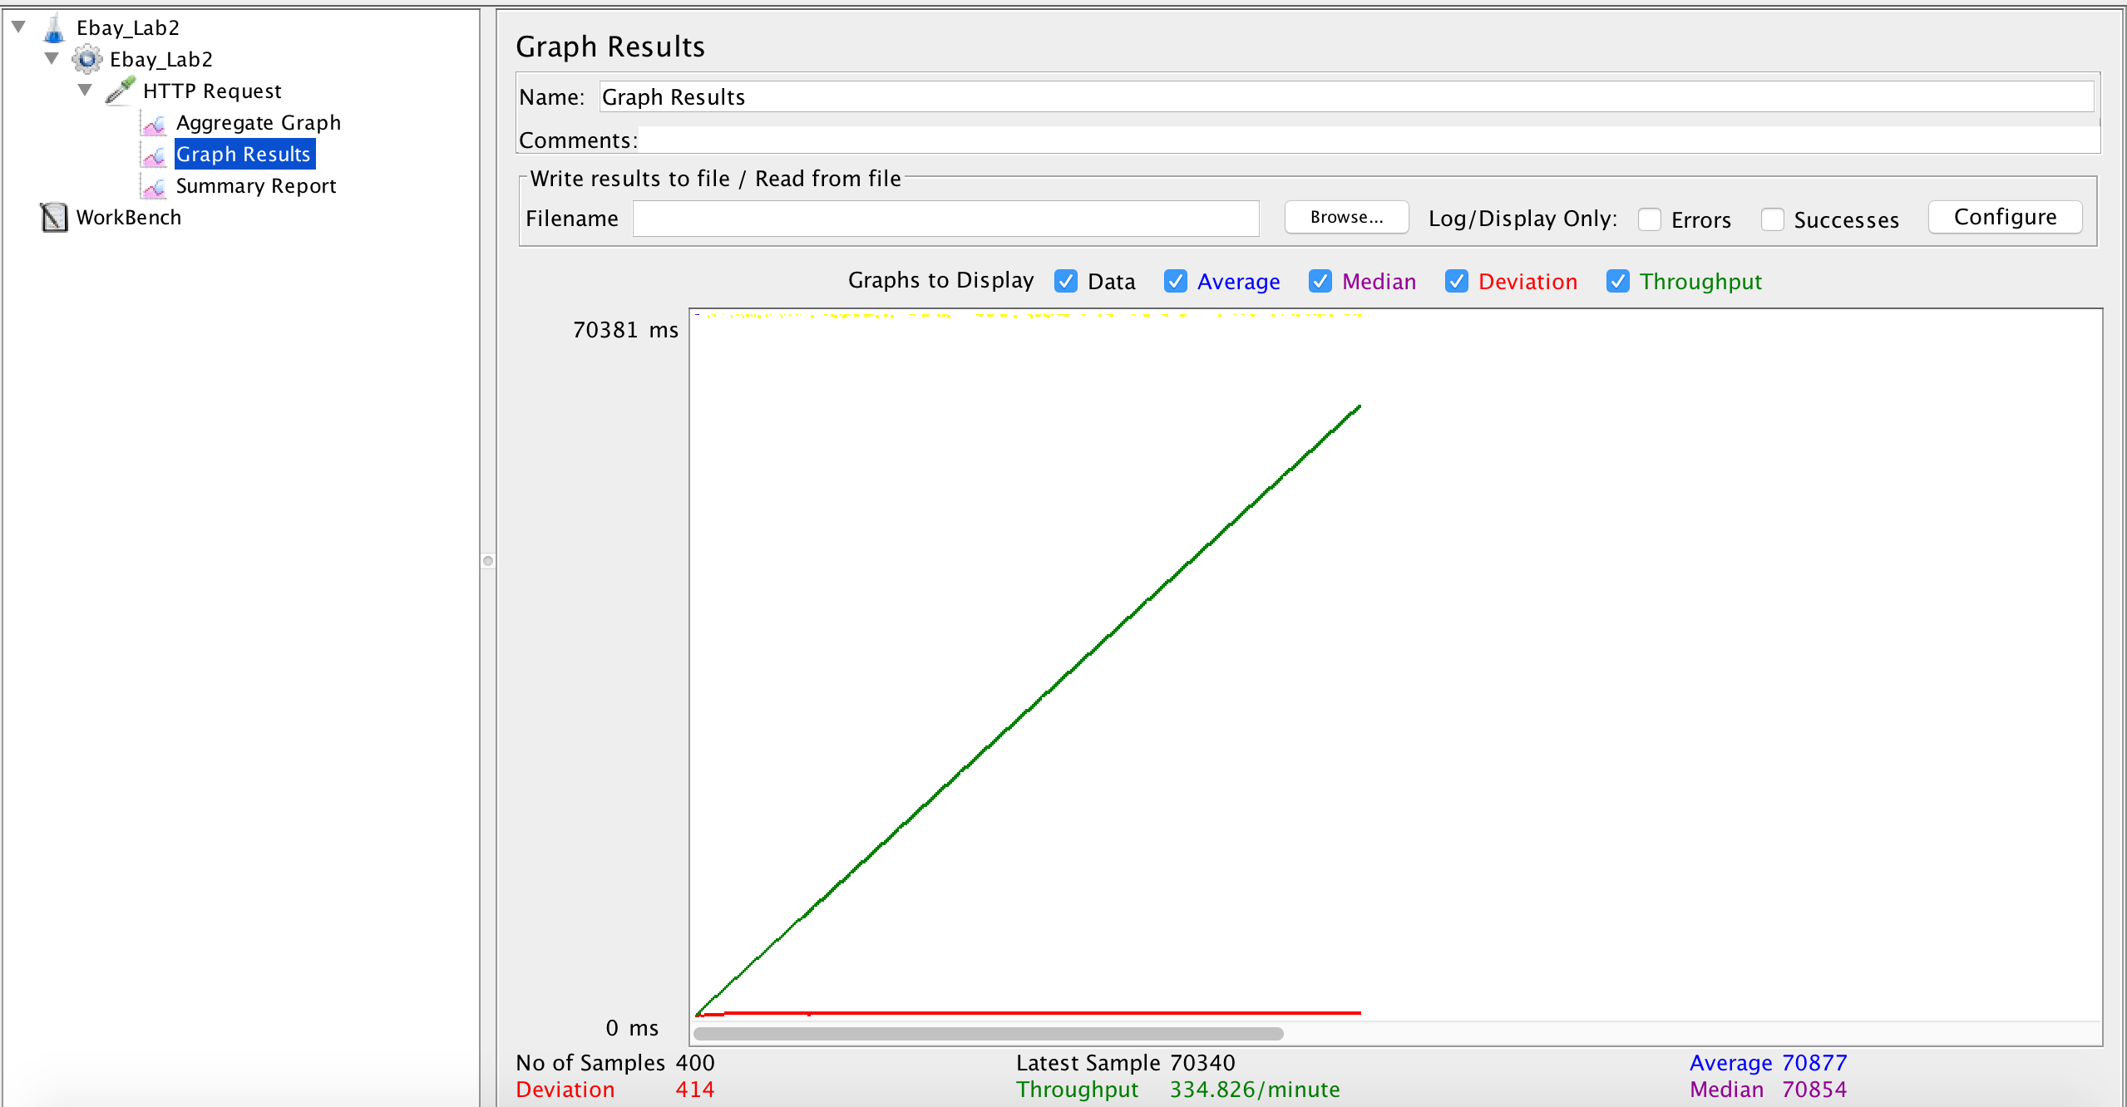

500 concurrent users

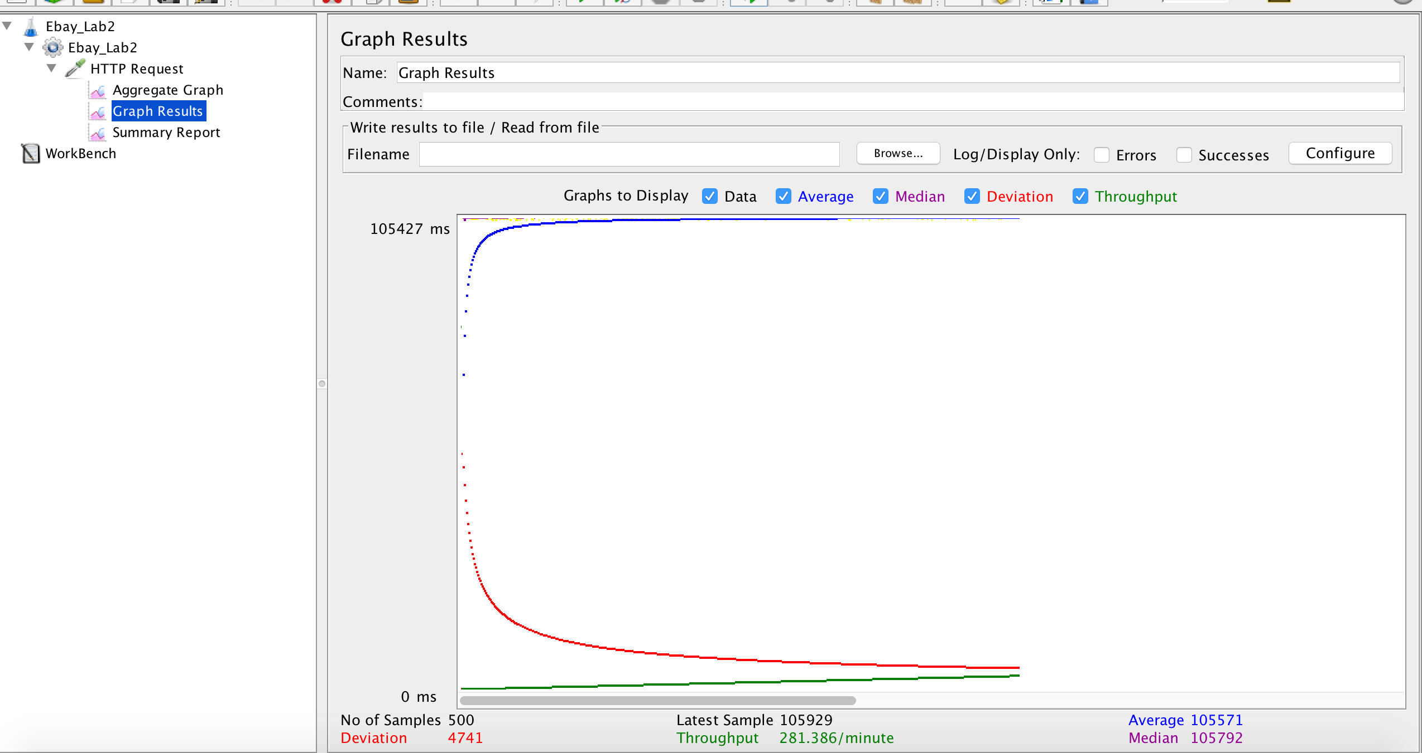

**With RabbitMQ:**

100 concurrent users

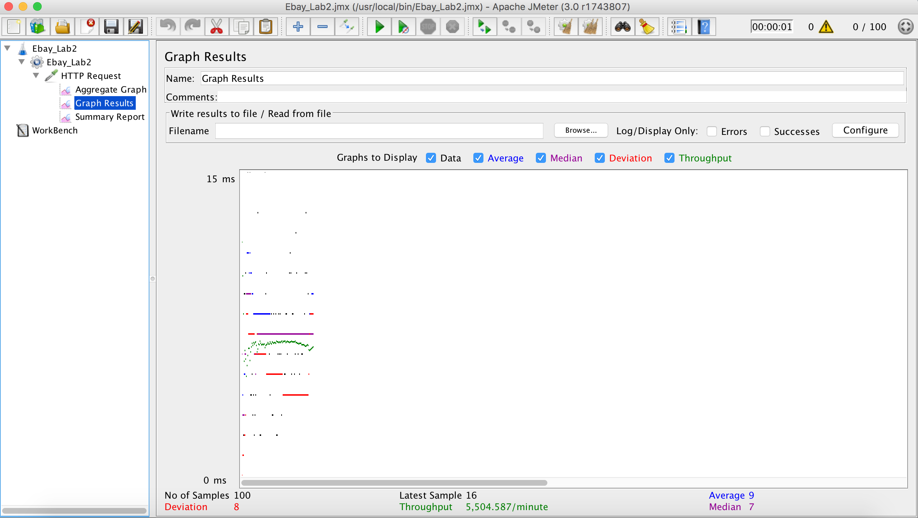

200 concurrent users

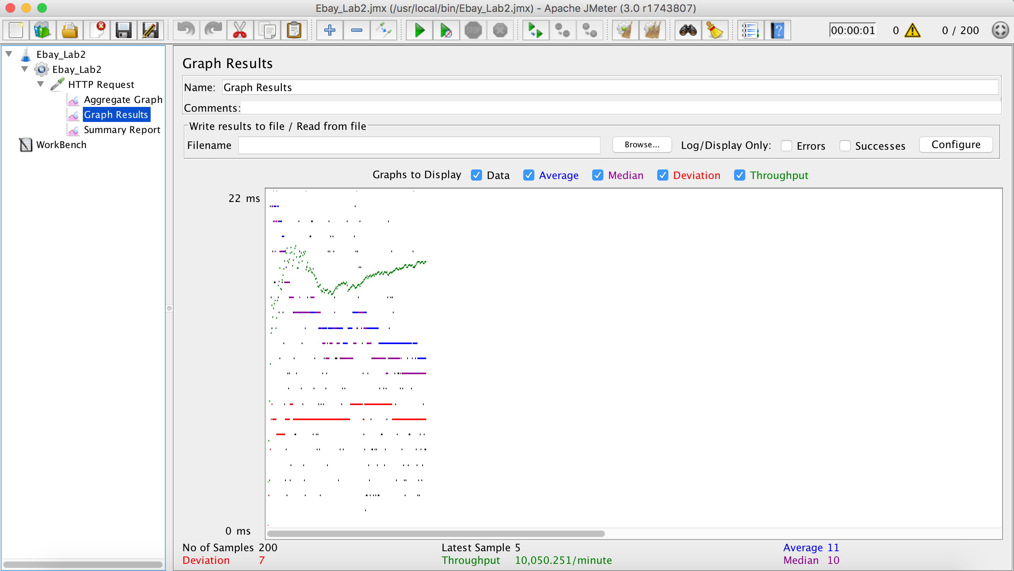

300 concurrent users

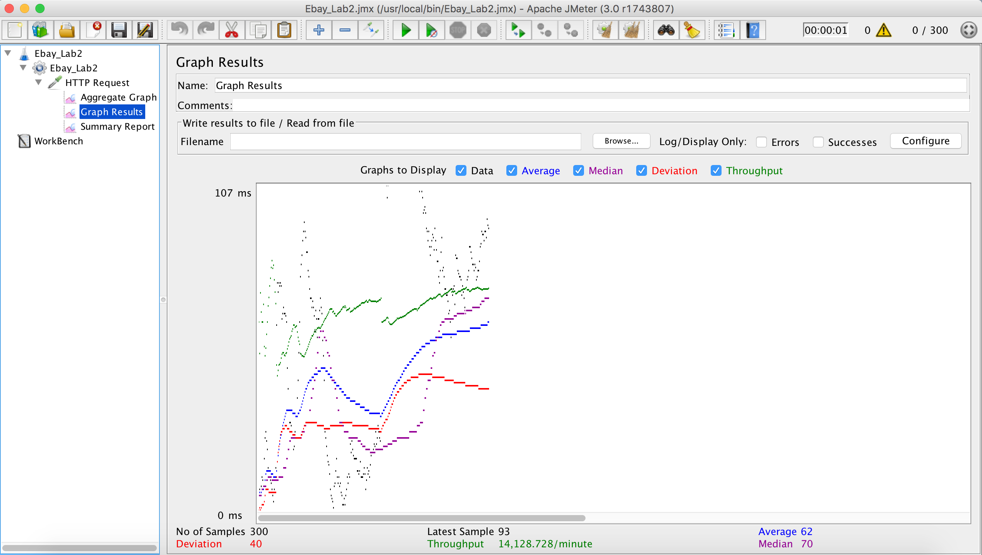

400 Concurrent users

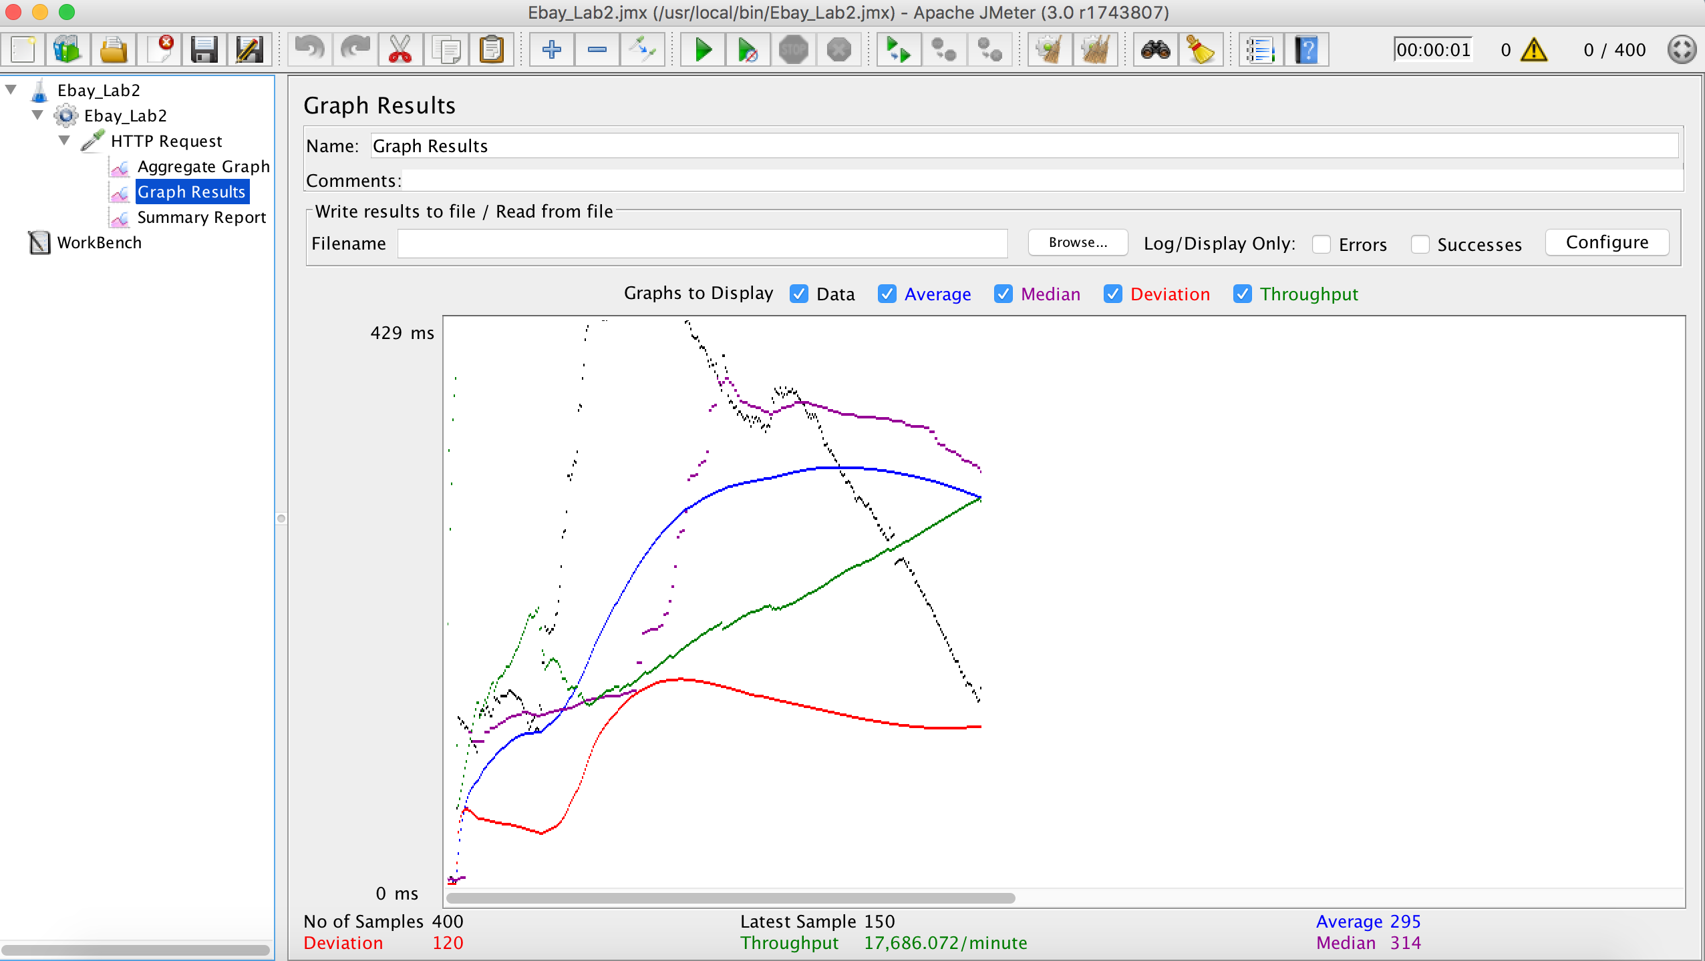

500 concurrent users

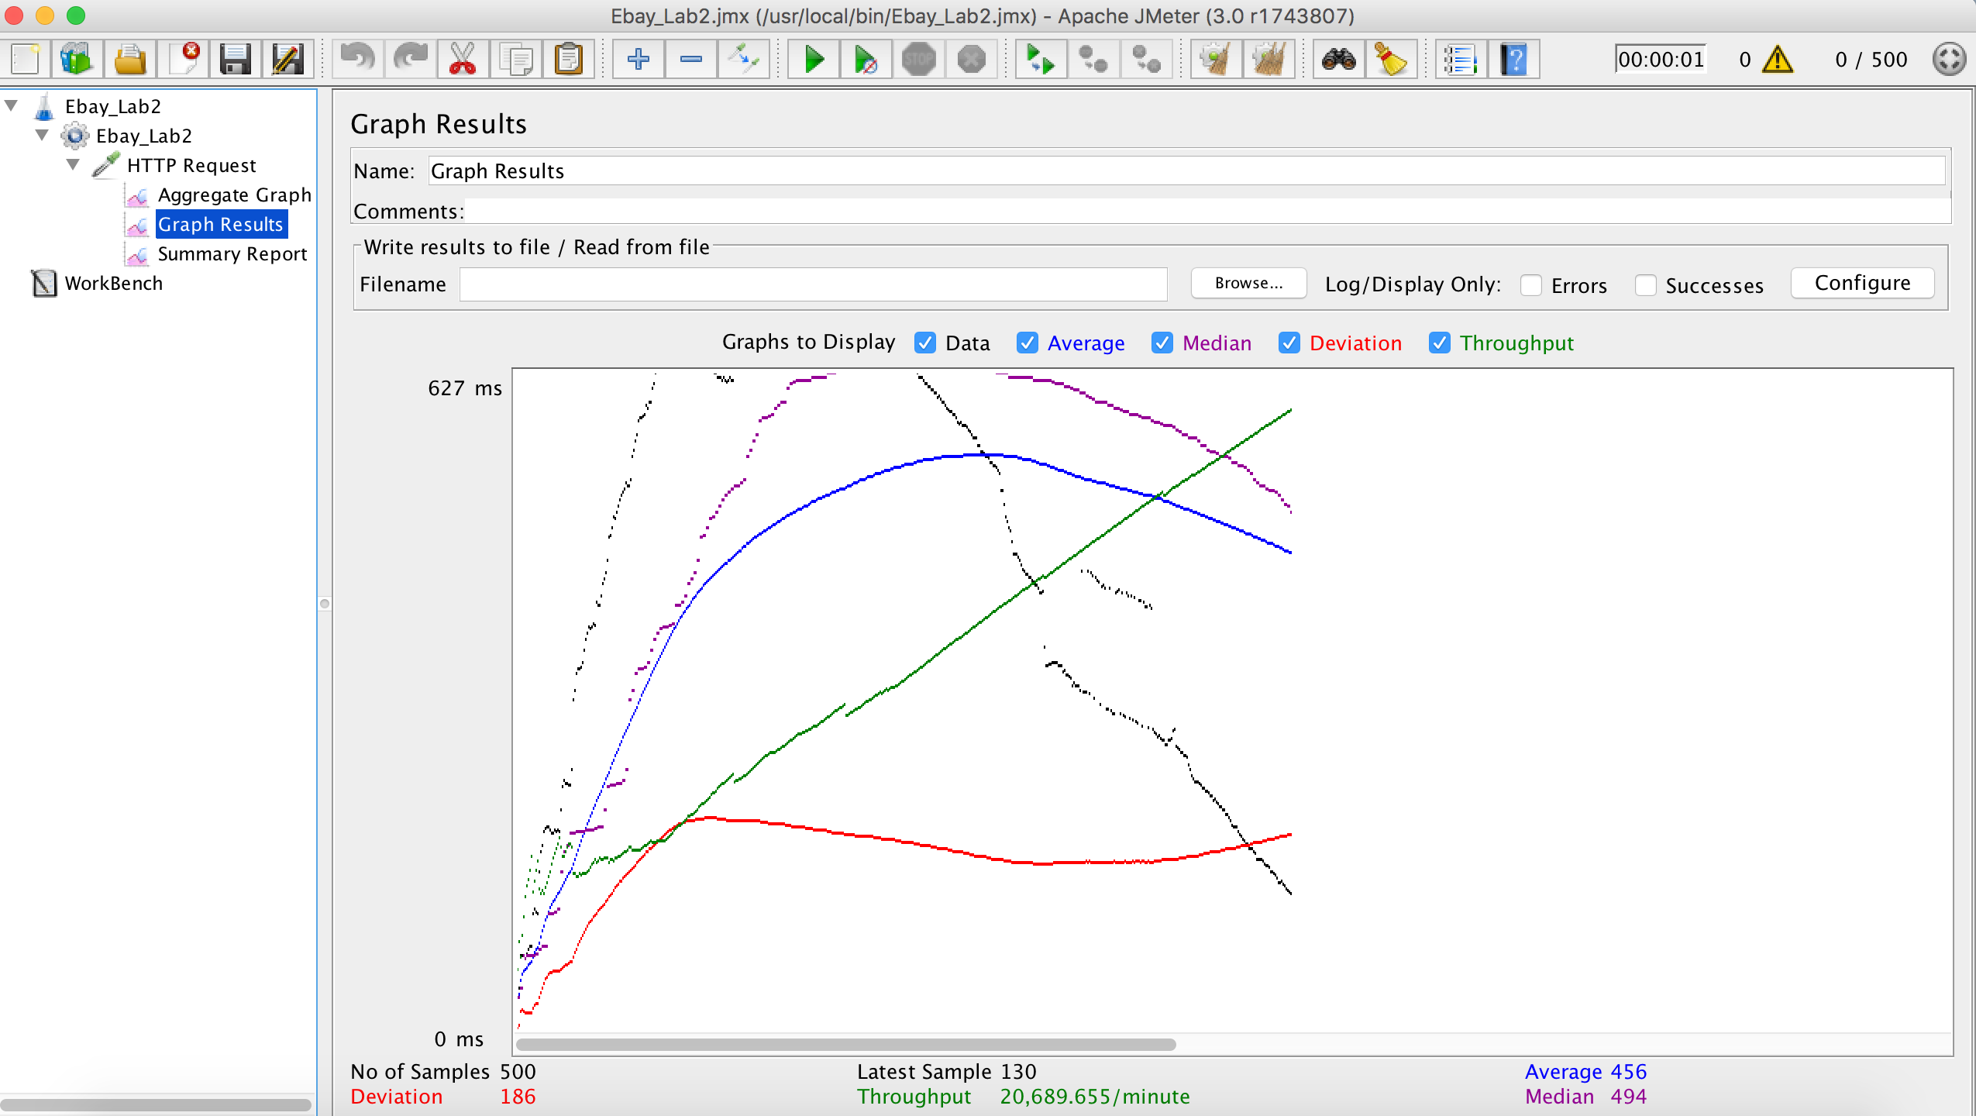

Comparison Performance graphs

From the graph we can see that the average time required for the application with RabbitMQ and with connection pooling is much more lesser than when without RabbitMQ. This is because RabbitMQ assures reliability of the solution and generates an id which it pushes into queue and then sorts the queue requests.

**Mocha Test results output**

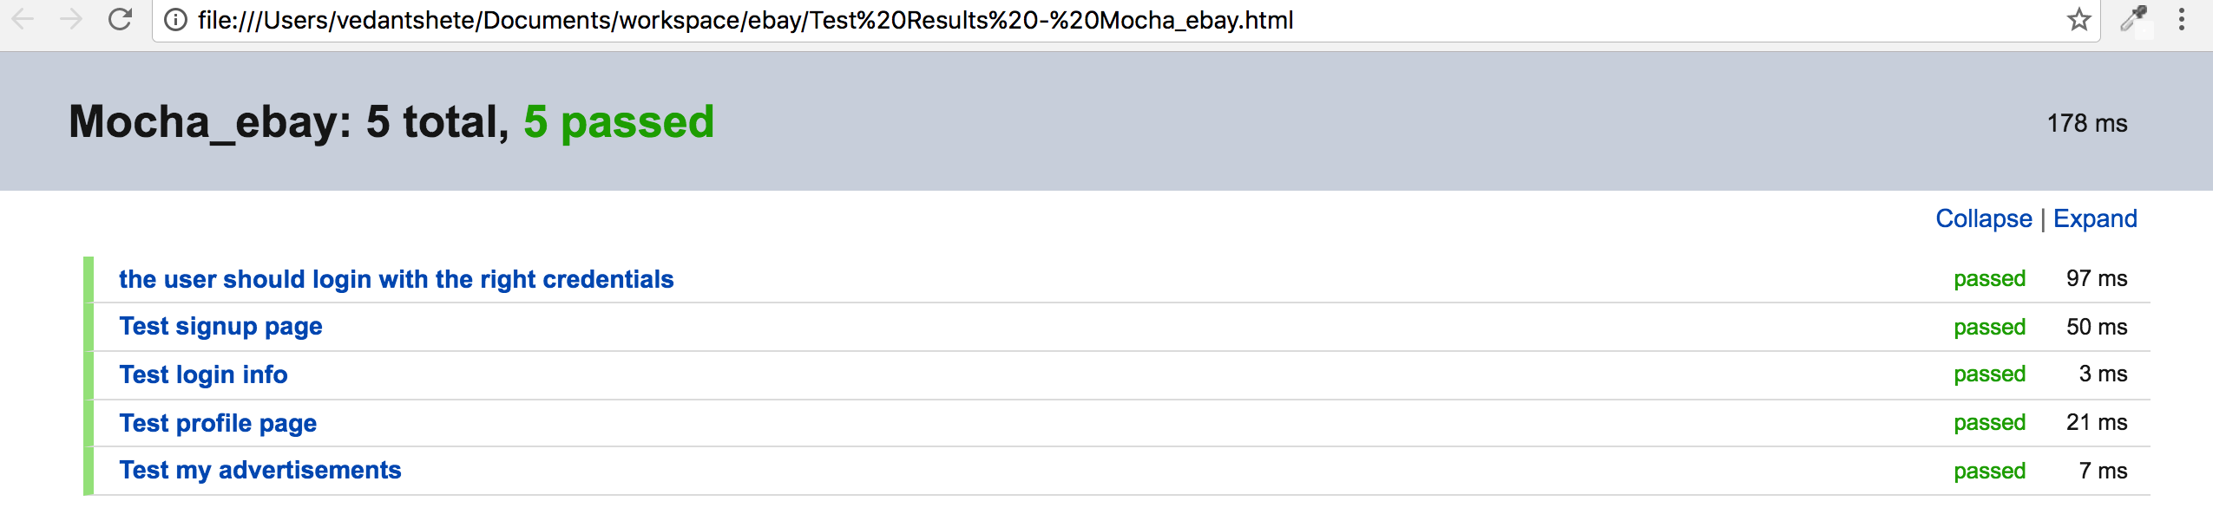

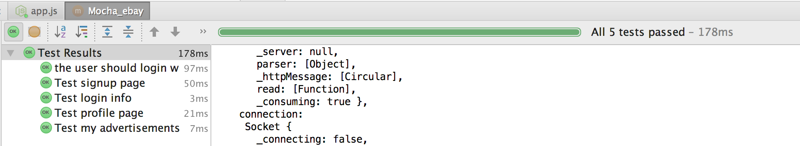

**Architectural Diagram for RabbitMQ interaction with Client/Server**

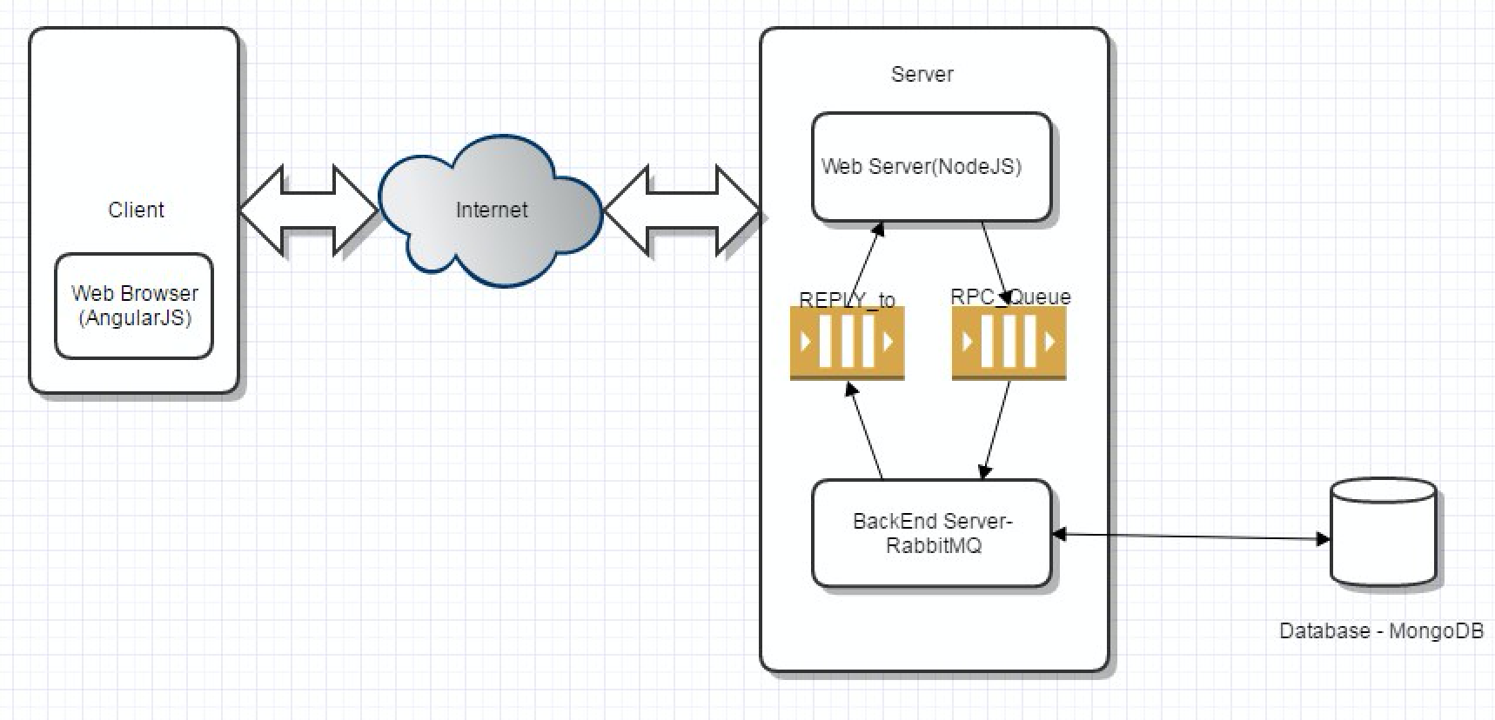

**SYSTEM DESIGN DESCRIPTION**

* The angular JS provides the address to which the app should go.
* This decision is taken by the app.js file. The app.js files has the address and function names for each function to be called depending on users action.
* The app then goes to that particular function.
* I have all the queues written for interactions with different functions. I put all the requests on the queue.
* Then the app goes to the definition of the queue which is written in the server.js file.
* Inside the server.js file the app knows the actual listening part is written in the ebay_services.js for a modular approach.
* The flow reaches the file where the actual part of the request is executing. The connection with mongo is also in this part of the code.
* The generated response is then forwarded to the CALLBACK function.
* This CALLBACK function is sent on the queue as a response and listened by the Ebay Client.
* Ebay client then forwards this response to the angular JS file which in turn forwards the response to the front end.

**Queues implemented using RabbitMQ in my application(Screenshot from RabbitMQ management portal)**

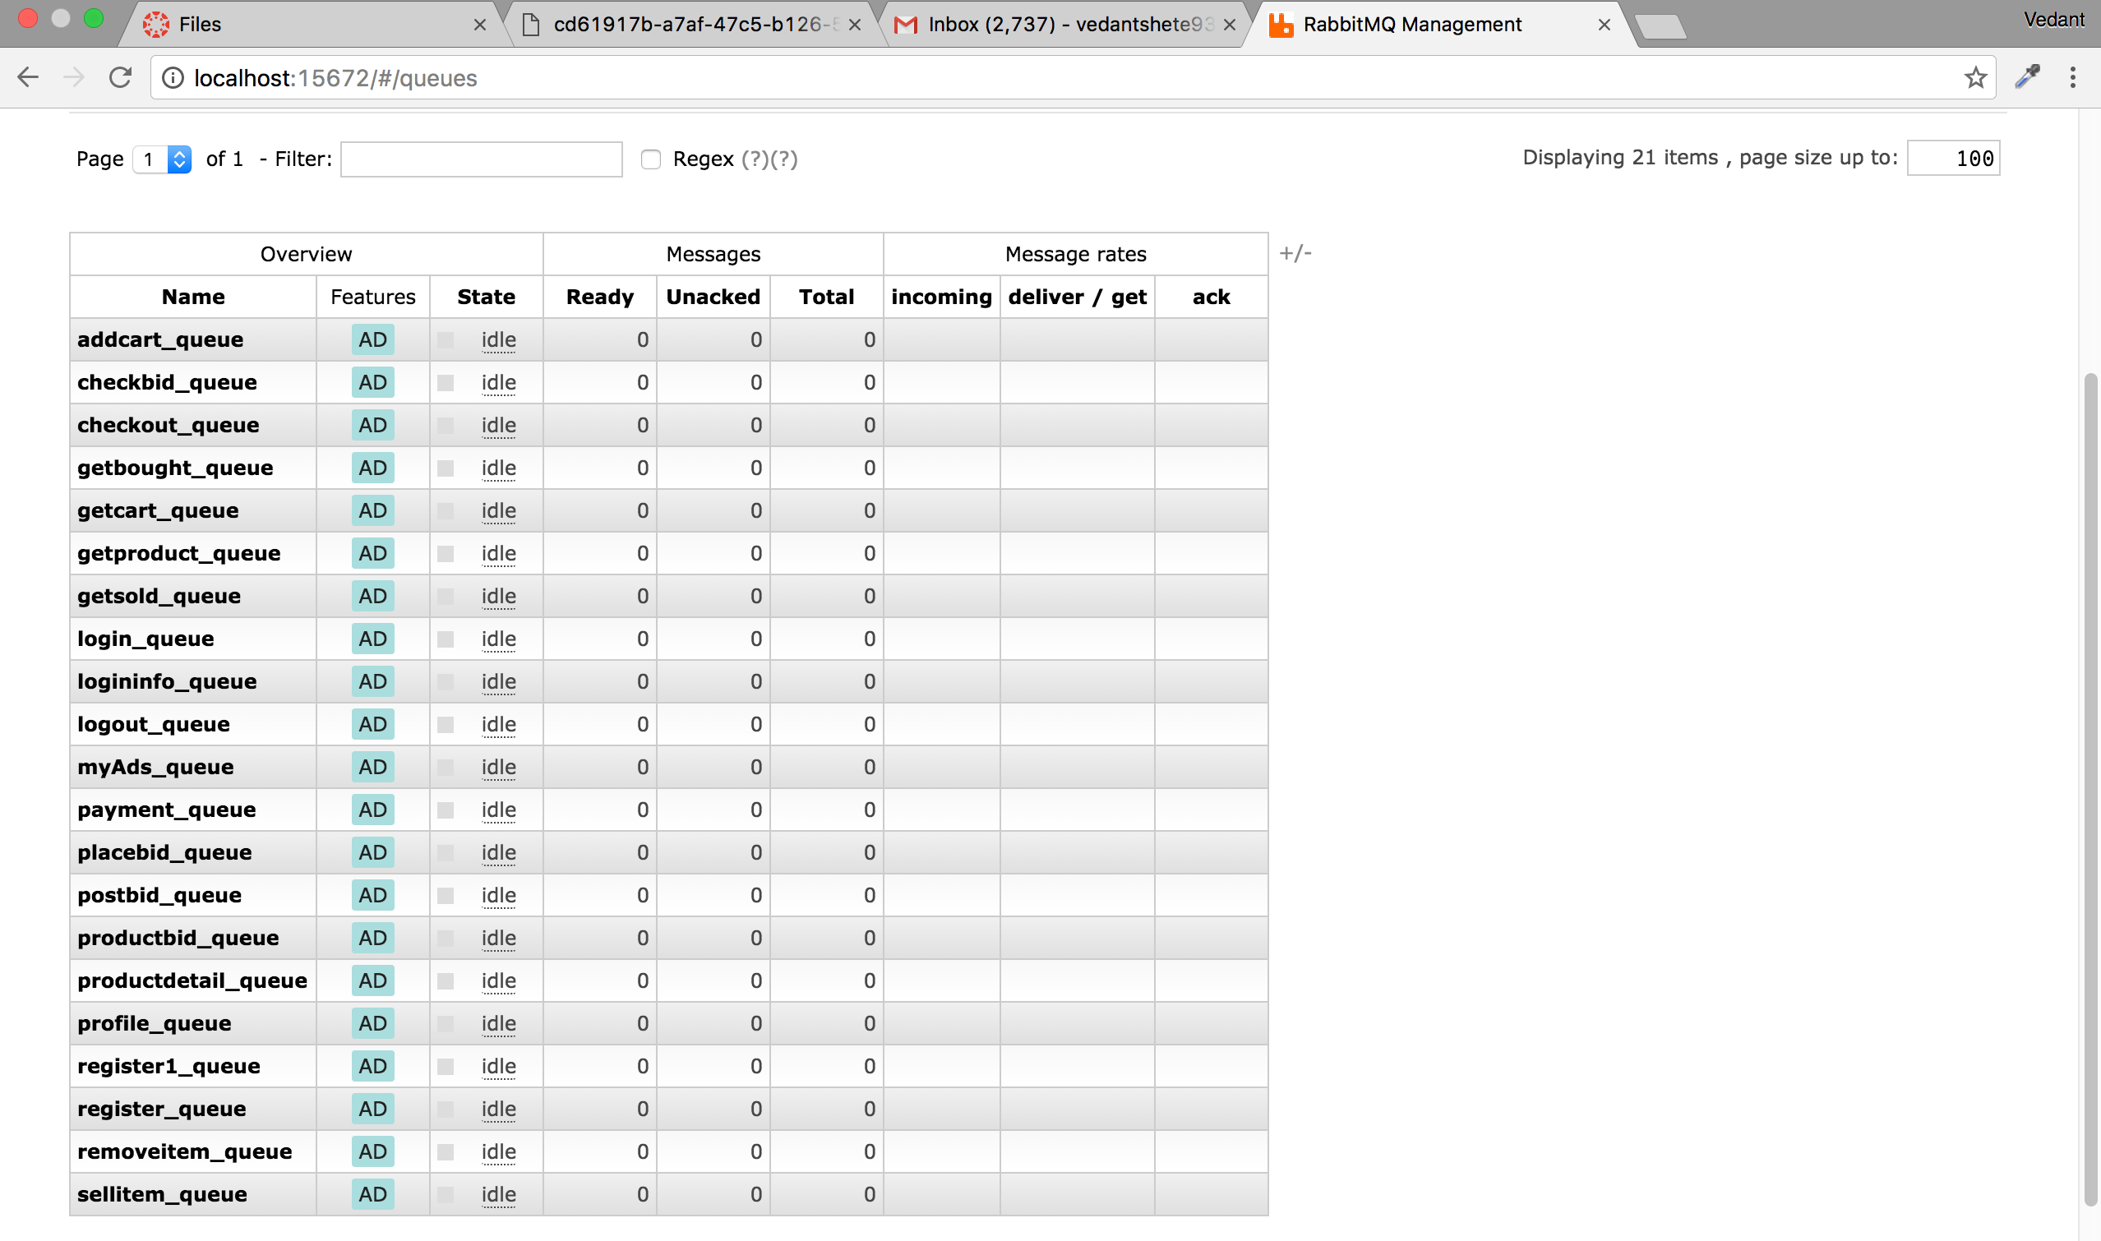

**Part-2: Questions**

**Question 1:**

Explain what performance change RabbitMQ provides? Elaborate on the results of throughput with and without using RabbitMQ. If you find any increase/decrease in the throughput, explain the reason for the same.

**Answer:**

Any application that uses a Message broker protocol like AMQP performs well and it is easier to scale. Because of AMQP applications can connect to each other as a component of some larger application. RabbitMQ is a message broker which gives the application a common platform to send and receive message. Also because of RabbitMQ the messages sent are safe in the queue until the server notices them and serves these requests. RabbitMQ brings characteristics like flexible routing, reliability, clustering, tracing, high availability of queues, etc. It establishes reliability by persistence, delivery acknowledgement, publisher confirmation and high availability.

Throughput without RabbitMQ

500 concurrent users



Throughput with RabbitMQ

500 concurrent users



Clearly it shows that the throughput has increased for the application with RabbitMQ. This example is shown for 500 concurrent users, similarly the throughput found was increased with RabbitMQ for 100, 200, 300 and 400 concurrent users too.

**Question 2:**  
Compare passport authentication process with the authentication process used in Lab1.

**Answer:**

PassportJS provides a unified framework to deal with multiple login platforms which can be easily used for authentication in our system. It is an authentication middleware which can be used to validate login in any Node.js express project. It is very flexible and modular when compared to our traditional authentication project. It provides many different set of strategies to support authentication. The biggest advantage of using PassportJS is the large number of bundles ready for different kinds of logins and we just have to make use of them. In passport authentication strategies are packed as individual modules and then we can use them as per our convenience and our application requirements. There are over 300 authentication strategies available for passport. Our custom authentication strategies can also be used using passport which we have used in our application. It also supports persistent session information.

In my application encryption of password has been done using BCrypt but the encryption can also be done using the already available strategy in PassportJS.

**Question 3:**

If given an option to implement MySQL and MongoDB both in your application, specify which data of the applications will you store in MongoDB and MySQL respectively.

**Answer:**

As we know, there are different advantages of MySQL(relational database) and MongoDB. MongoDB is easy to scale and tune also it is very fast to read and write in MongoDB when compared to MySQL. Whereas in MySQL we can perform complex join queries easily to find data from different tables.

Hence, where ever we have to only read data from a single table I will use MongoDB there since the read speed will be very fast when compared to MySQL. For example, in my application where I am showing the user profile or last login, products on homepage, etc.

But wherever I have to query data from multiple table I will use MySQL. For example, in my application, showing cart, finding products bought by the user, finding products sold by the user, etc.